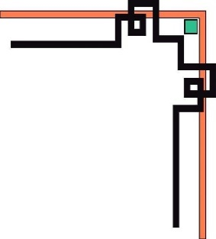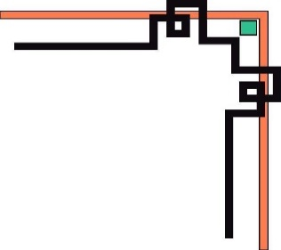

TRƯỜNG ĐẠI HỌC NHA TRANG

KHOA CÔNG NGHỆ THÔNG TIN

**Lập Trình Thiết Bị Nhúng**

**Báo Cáo Môn Học**

Giảng viên hướng dẫn:



* Người thực hiện :

Cao Thái Toàn Phong

# Phần I. Lập trình với Arduino Uno

# Bài 1: Blinking LED

## Mô tả

* Bài này thực hiện việc lập trình điều khiển 1 đèn LED

bật/tắt trong khoảng thời gian 0,2 giây, đèn LED được kết nối vào chân số 13 của board mạch.

## Sơ đồ mạch

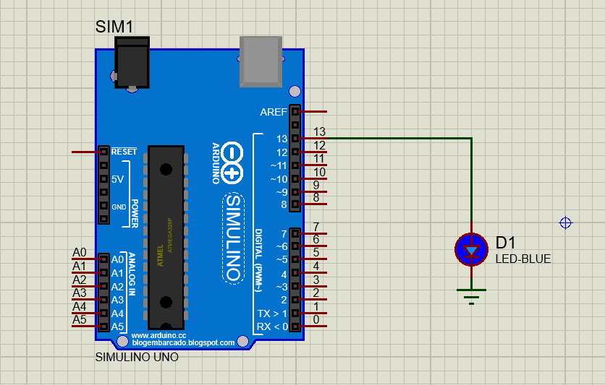

Sơ đồ kết nối của hệ thống

## Linh kiện

#### 1 mạch Arduino Uno

#### 1 đèn LED-BLUE

## Code chương trình

|  |
| --- |
| int pin=13;  void setup() {  // put your setup code here, to run once:  pinMode(pin,OUTPUT);  }  void loop() {  // main code  digitalWrite(pin,HIGH);  delay(200); // 0,2s  digitalWrite(pin,LOW);  delay(200);  } |

## Kết quả chạy chương trình

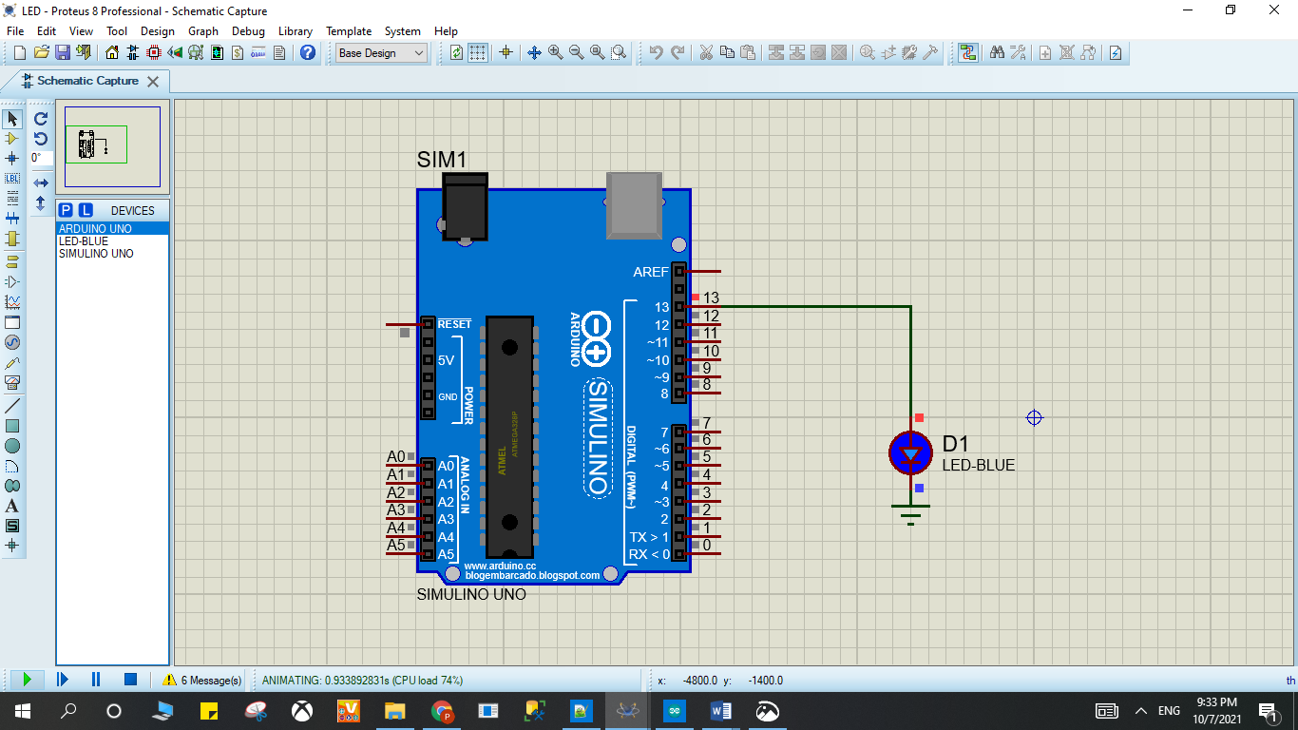

Kết quả

# Bài 2: Turn on LED with button

## Mô tả

* Bài này thực hiện việc bật/tắt 1 đèn LED trong khoảng thời gian 1 giây bằng button, đèn LED được kết nối vào chân số 13 của board mạch, button được kết nối vào chân số 2 của board mạch, đèn sáng khi nút nhấn và ngược lại.

## Sơ đồ mạch

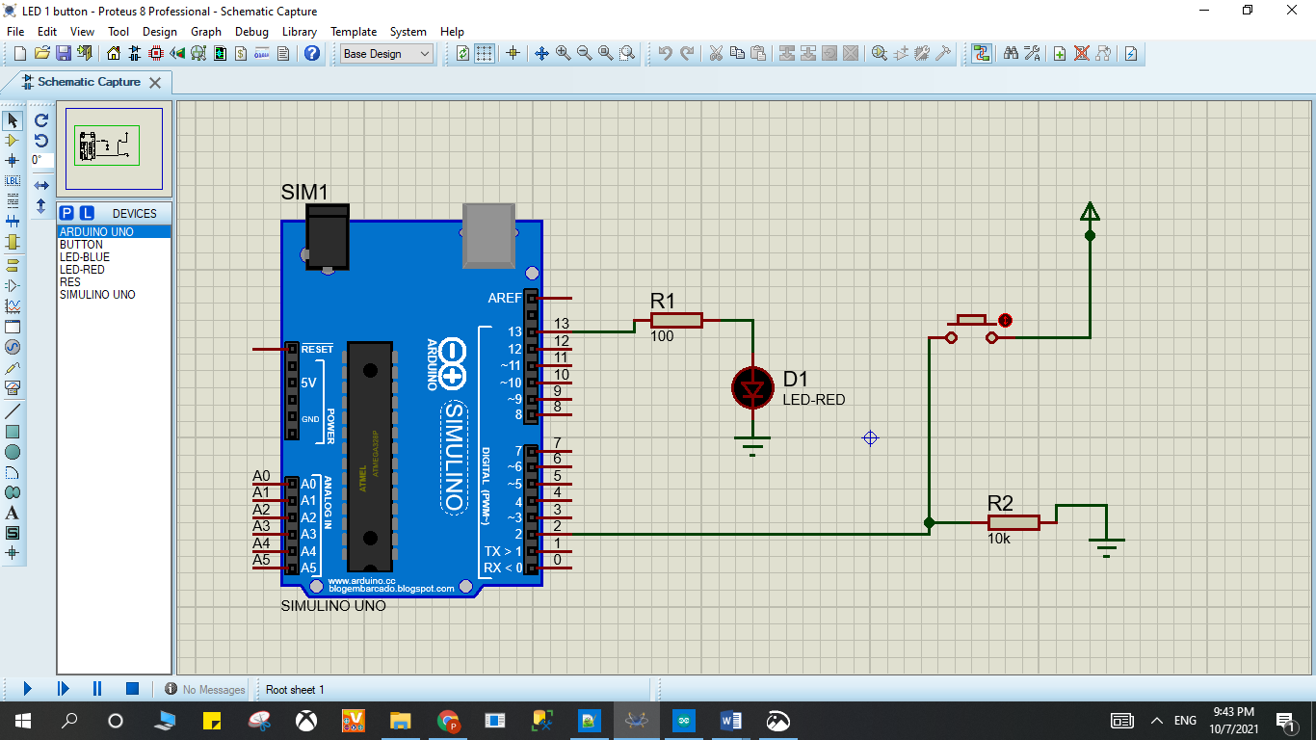

Sơ đồ kết nối của hệ thống 2

## Linh kiện

#### 1 mạch Arduino Uno

#### 1 đèn LED-RED

#### 1 điện trở 100Ω và 1 điện trở 10k Ω

## Code chương trình

|  |
| --- |
| int x = 0;  void setup() {  pinMode(2, INPUT);  pinMode(13, OUTPUT);  }  void loop()  {  // đọc cổng 2  x = digitalRead(2);  if (x == HIGH) {  digitalWrite(13, HIGH); // LED ON  } else {  digitalWrite(13, LOW); //LED OFF  }  delay(1000); // wait 1s  } |

## Kết quả chạy chương trình

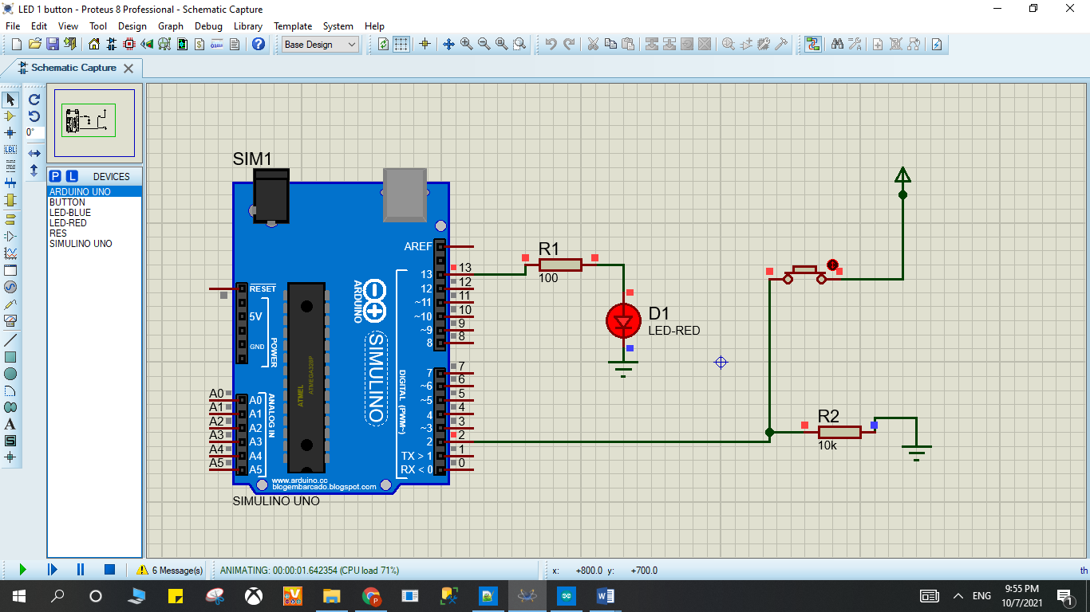

Kết quả

# Bài 3. LED RGB

## Mô tả

* Bài này thực hiện việc lập trình bật 1 đèn LED RGB với 3 điện trở R1, R2 R3, đèn LED được kết nối thông qua điện trở lần lượt vào chân số 9, 10,11 của board mạch.

## Sơ đồ mạch

### 

## Linh kiện

#### 1 mạch Arduino Uno

#### 1 đèn RGBLED-CC

#### 3 điện trở 10k Ω

## Code chương trình

|  |
| --- |
| int counter;  void setup()  {  pinMode(11, OUTPUT);  pinMode(10, OUTPUT);  pinMode(9, OUTPUT);  }  void loop()  {  analogWrite(11, 255);  analogWrite(10, 0);  analogWrite(9, 0);  delay(1000); // Wait for 1000 millisecond(s)  analogWrite(11, 255);  analogWrite(10, 255);  analogWrite(9, 255);  delay(1000); // Wait for 1000 millisecond(s)  for (counter = 0; counter < 10; ++counter) {  analogWrite(11, 255);  analogWrite(10, 255);  analogWrite(9, 0);  delay(1000); // Wait for 1000 millisecond(s)  analogWrite(11, 51);  analogWrite(10, 255);  analogWrite(9, 51);  delay(1000); // Wait for 1000 millisecond(s)  }  } |

## Kết quả chạy chương trình

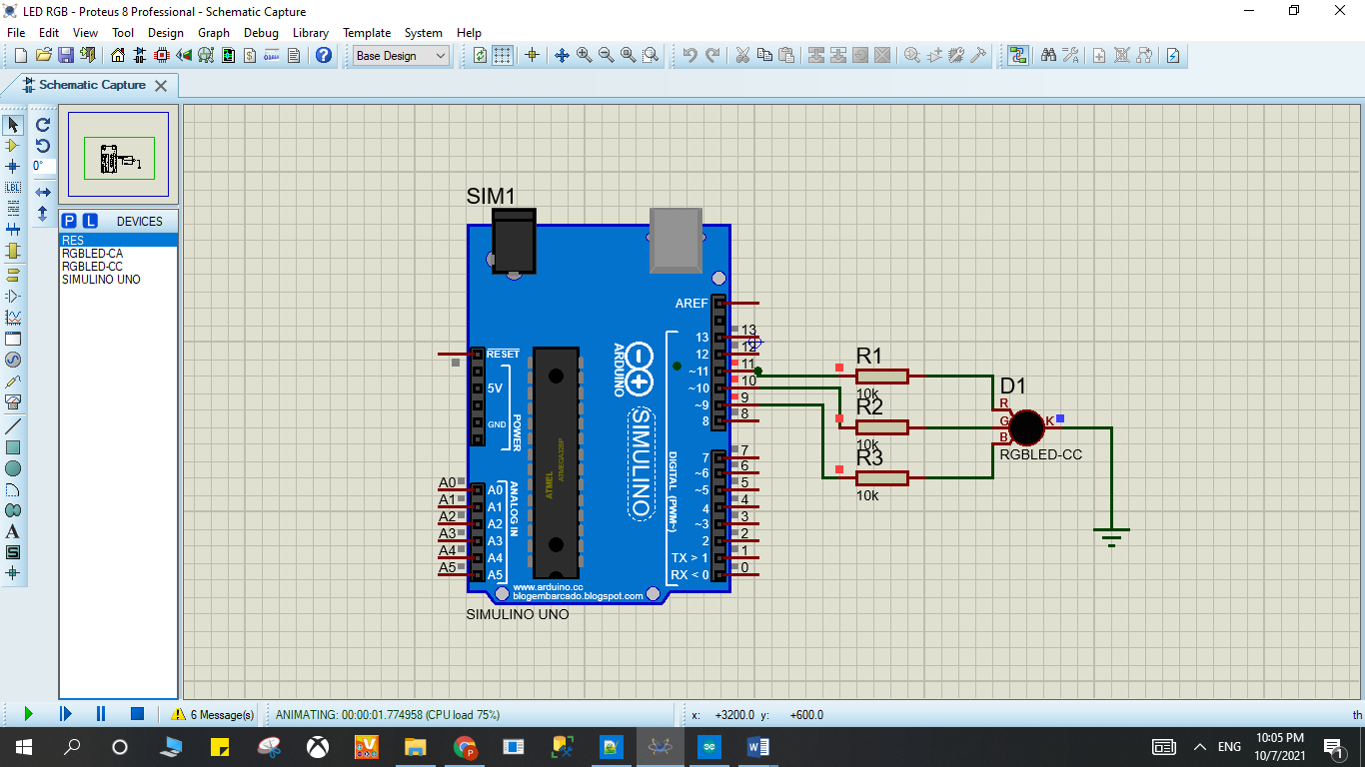

Kết quả

# Bài 4. LED 7-Segment

## Mô tả

* Bài này thực hiện việc lập trình 1 đèn LED 7 đoạn hiển thị các số từ 0 đến 9 trong khoảng thời gian 0,5 giây, đèn LED được kết nối vào các chân số7,8,9,10,11,12,13 của board mạch.

## Sơ đồ mạch

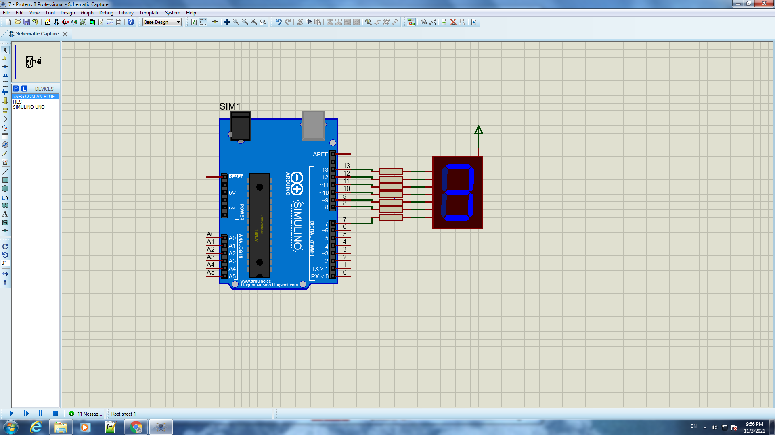

Sơ đồ kết nối của hệ thống 4

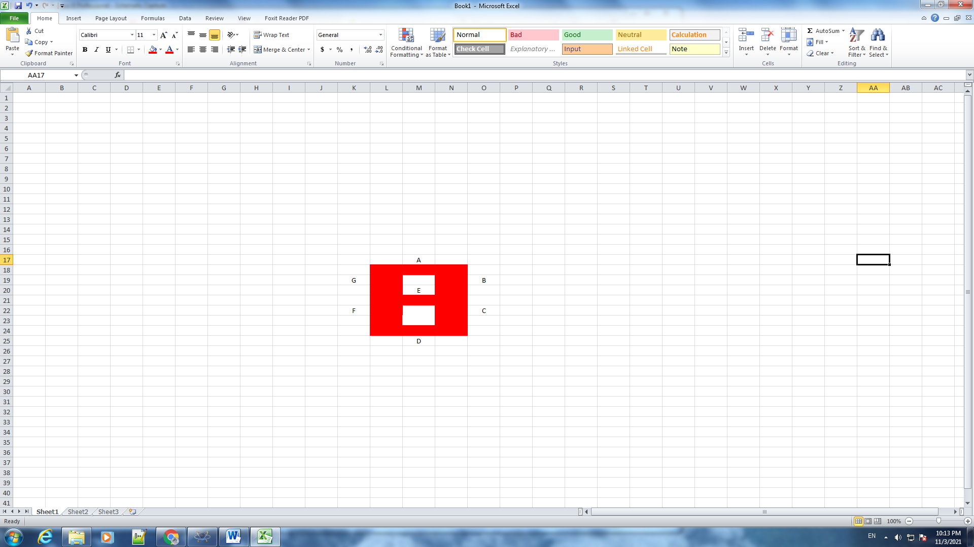

Sơ đồ kết nối của hệ thống 5

## Linh kiện

#### 1 mạch Arduino Uno

#### 1 đèn 7-SEG-COM-ANODE

## Code chương trình

|  |
| --- |
| int f = 7 ;  int g = 8 ;  int e = 9 ;  int d = 10 ;  int c = 11 ;  int b = 12 ;  int a = 13 ;  int hoan = 500 ;  void setup () {  pinMode (f, OUTPUT);  pinMode (g, OUTPUT);  pinMode (e, OUTPUT);  pinMode (d, OUTPUT);  pinMode (c, OUTPUT);  pinMode (b, OUTPUT);  pinMode (a, OUTPUT);  }  void loop ()  {  // 0  digitalWrite (a, 0 );  digitalWrite (b, 0 );  digitalWrite (c, 0 );  digitalWrite (d, 0 );  digitalWrite (e, 0 );  digitalWrite (f, 1 );  digitalWrite (g, 0 );  delay (hoan);  //1  digitalWrite (a, 1 );  digitalWrite (b, 0 );  digitalWrite (c, 0 );  digitalWrite (d, 1 );  digitalWrite (e, 1 );  digitalWrite (f, 1 );  digitalWrite (g, 1 );  delay (hoan);  //2  digitalWrite (a, 0 );  digitalWrite (b, 0 );  digitalWrite (c, 1 );  digitalWrite (d, 0 );  digitalWrite (e, 0 );  digitalWrite (f, 0 );  digitalWrite (g, 1 );  delay (hoan);  //3  digitalWrite (a, 0 );  digitalWrite (b, 0 );  digitalWrite (c, 0 );  digitalWrite (d, 0 );  digitalWrite (e, 1 );  digitalWrite (f, 0 );  digitalWrite (g, 1 );  delay (hoan);  //4  digitalWrite (a, 1 );  digitalWrite (b, 0 );  digitalWrite (c, 0 );  digitalWrite (d, 1 );  digitalWrite (e, 1 );  digitalWrite (f, 0 );  digitalWrite (g, 0 );  delay (hoan);  //5  digitalWrite (a, 0 );  digitalWrite (b, 1 );  digitalWrite (c, 0 );  digitalWrite (d, 0 );  digitalWrite (e, 1 );  digitalWrite (f, 0 );  digitalWrite (g, 0 );  delay (hoan);  //6  digitalWrite (a, 0 );  digitalWrite (b, 1 );  digitalWrite (c, 0 );  digitalWrite (d, 0 );  digitalWrite (e, 0 );  digitalWrite (f, 0 );  digitalWrite (g, 0 );  delay (hoan);  //7  digitalWrite (a, 0 );  digitalWrite (b, 0 );  digitalWrite (c, 0 );  digitalWrite (d, 1 );  digitalWrite (e, 1 );  digitalWrite (f, 1 );  digitalWrite (g, 1 );  delay (hoan);  //8  digitalWrite (a, 0 );  digitalWrite (b, 0 );  digitalWrite (c, 0 );  digitalWrite (d, 0 );  digitalWrite (e, 0 );  digitalWrite (f, 0 );  digitalWrite (g, 0 );  delay (hoan);  //9  digitalWrite (a, 0 );  digitalWrite (b, 0 );  digitalWrite (c, 0 );  digitalWrite (d, 0 );  digitalWrite (e, 1 );  digitalWrite (f, 0 );  digitalWrite (g, 0 );  delay (hoan);  } |

## Kết quả chạy chương trình

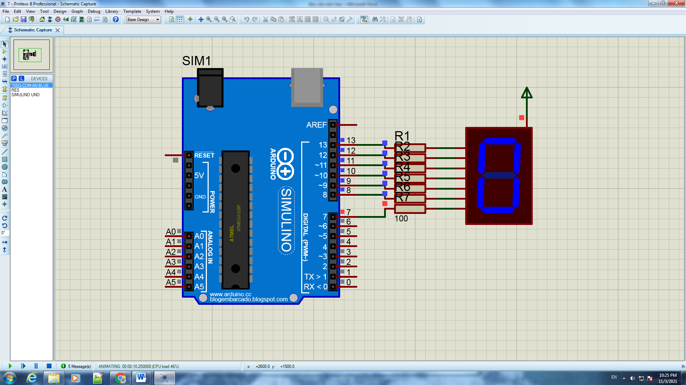

Kết quả

# Bài 5. Temperature Sensor

## Mô tả

* Bài này thực hiện việc lập trình 1 hệ thống cảm biến nhiệt độ sử dụng nhiệt điện trở NCP15XH103

và hiển thị nhiệt độ đo được qua màn hình LCD

## Sơ đồ mạch

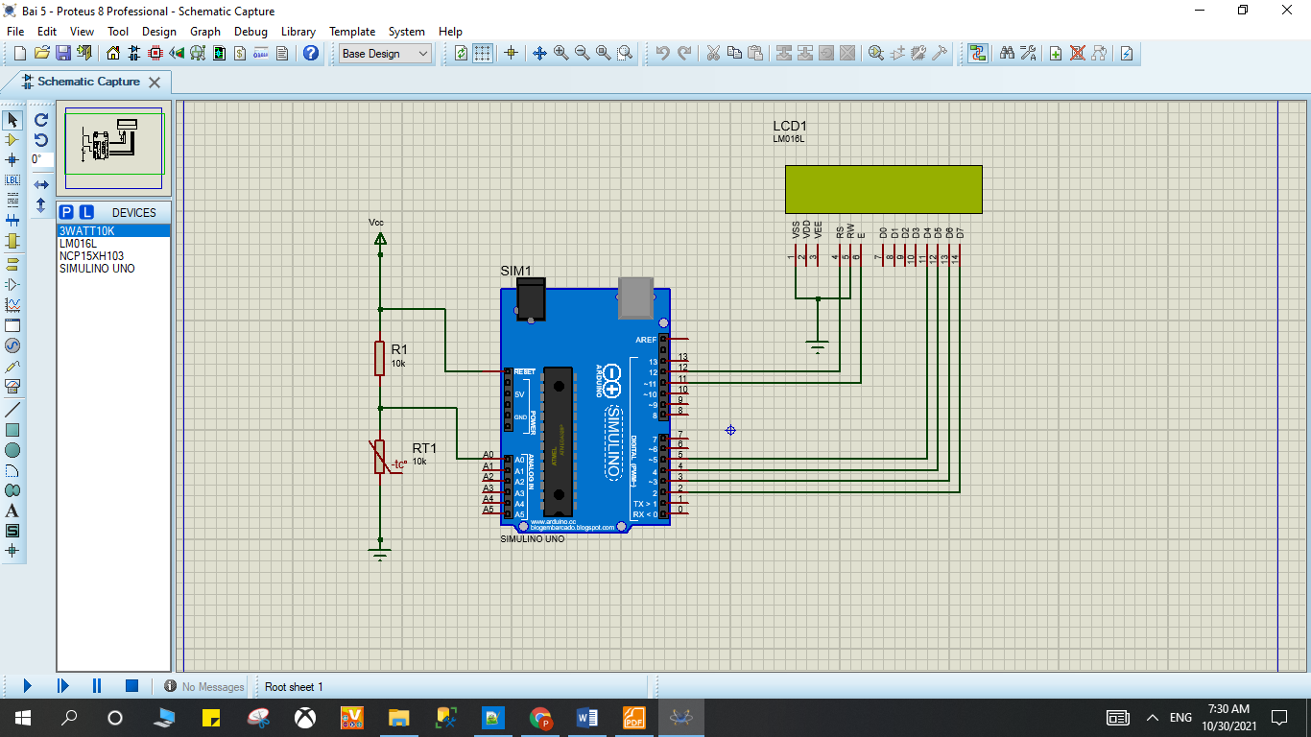

Sơ đồ kết nối của hệ thống 6

## Linh kiện

#### 1 mạch Arduino Uno

#### 1 bảng dữ liệu LM016L LCD

#### 1 nhiệt điện trở NCP15XH103

#### 1 điện trở 3WATT10K

## Code chương trình

|  |
| --- |
| #include <LiquidCrystal.h>  int THERMISTORPIN = 0, BCOEFFICIENT = 3380 ;  float THERMISTORNOMINAL = 10000 , TEMPERATURENOMINAL = 25 , SERIESRESISTOR = 10000 ;  LiquidCrystal lcd(12, 11, 5, 4, 3, 2);  int sample[5];  void setup() {  Serial.begin(9600);  lcd.begin(16, 2);  }  void loop() {  int i;  float average;    // lấy N mẫu liên tiếp  for (i=0; i< 5; i++) {  sample[i] = analogRead(THERMISTORPIN);  delay(10);  }  average = 0;    for (i=0; i< 5; i++) {  average += sample[i];    }  average /= 5;  // chuyển đổi giá trị qua điện trở  average = 1023 / average - 1;  average = SERIESRESISTOR / average;      float steinhart;  steinhart = average / THERMISTORNOMINAL;  steinhart = log(steinhart);  steinhart /= BCOEFFICIENT;  steinhart += 1.0 / (TEMPERATURENOMINAL + 273.15);  steinhart = 1.0 / steinhart;  steinhart -= 273.15; // chuyển đổi sang độ C  lcd.print("Temp = ");  lcd.print((int)steinhart);  lcd.print(" C");  delay(500);  lcd.clear();  } |

## Kết quả chạy chương trình

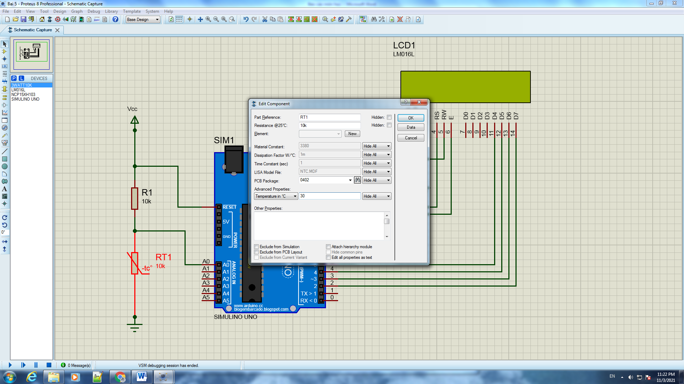

Kết quả điều chỉnh nhiệt độ

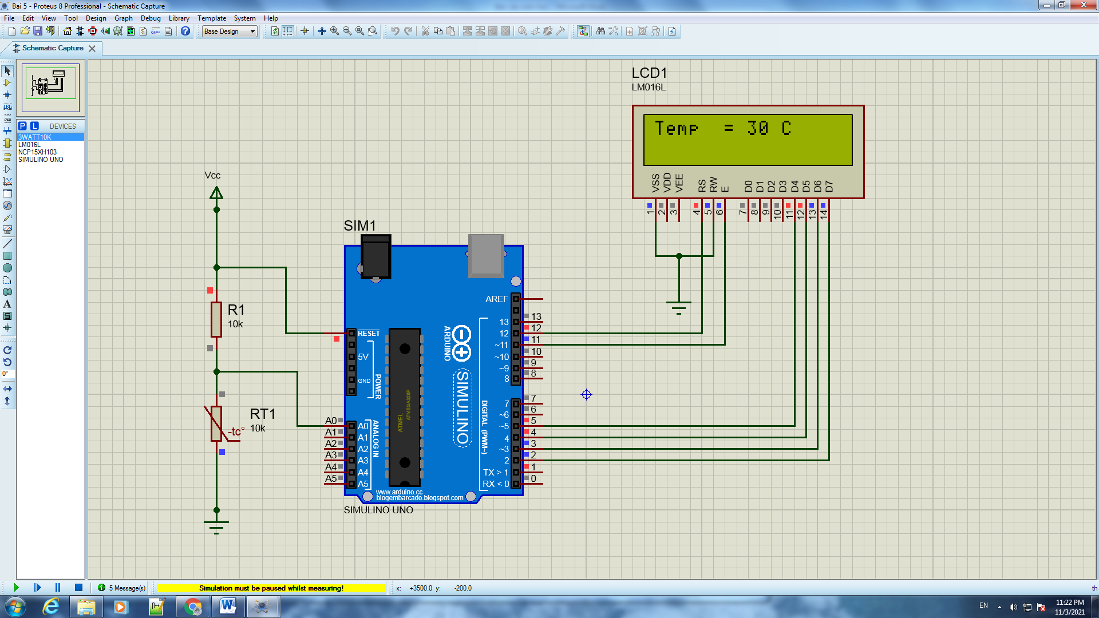

Kết quả

# Bài 6. 8 LED

## Mô tả

* Bài này thực hiện bật sáng 8 đèn led theo một trình tự, sử dụng IC 74HC545.

## Sơ đồ mạch

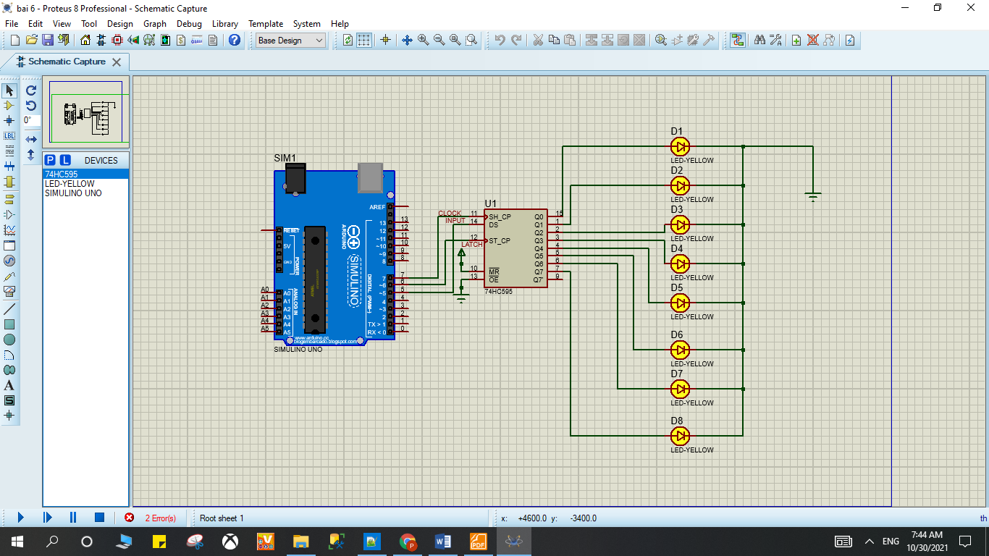

Sơ đồ kết nối của hệ thống 7

## Linh kiện

#### 1 mạch Arduino Uno

#### 8 đèn LED-YELLOW

#### 1 IC 74HC545

## Code chương trình

|  |
| --- |
| #define _latch 6  #define _clock 7  #define _data 5  void setup()  {  pinMode(_latch, OUTPUT);  pinMode(_clock, OUTPUT);  pinMode(_data, OUTPUT);  }  void loop()  {  for (int i =0;i< 256; i++)  //chot IC  {  digitalWrite(_latch,LOW);  //day dl ra IC  int soLieu=255; //B11111111, hoac 0xff  shiftOut(_data, _clock, LSBFIRST,soLieu);  //mo chot, de IC out dl ra  digitalWrite(_latch,HIGH);  delay(500);  }  } |

## Kết quả chạy chương trình



Kết quả

# Bài 7. Keypad

## Mô tả

* Bài này thực hiện hiển thị nút được nhấn ở Keypad 4x4 lên màn hình LCD

## Sơ đồ mạch

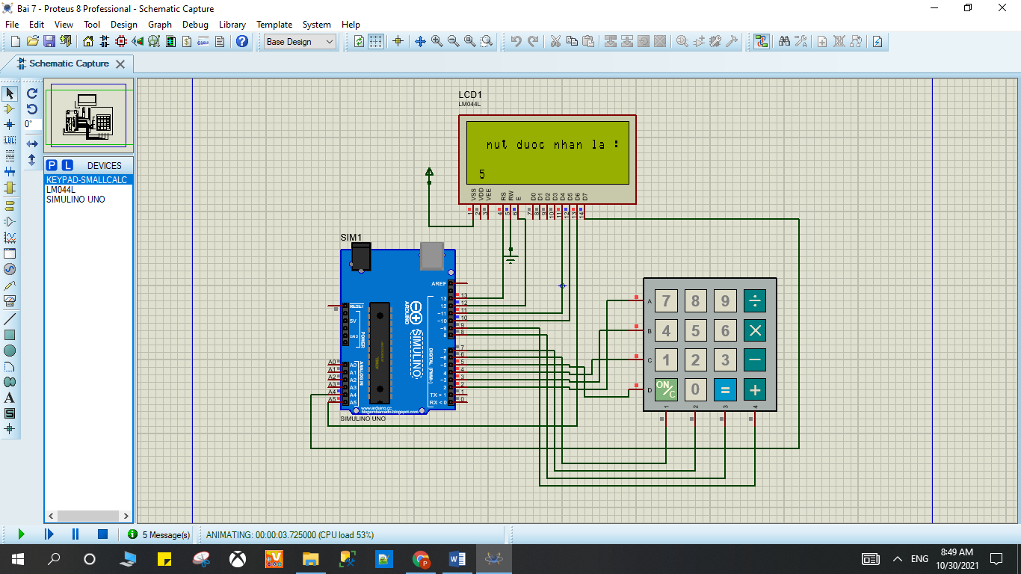

Sơ đồ kết nối của hệ thống 8

## Linh kiện

#### 1 mạch Arduino Uno

#### 1 LCD LM044L

#### 1 Keypad 4x4

## Code chương trình

|  |
| --- |
| #include <LiquidCrystal.h>  #include "Keypad.h"  // LCD Setup  const int rs=13, en=12,d4=11,d5=10, d6=A5, d7=A4;  LiquidCrystal lcd(rs, en, d4, d5, d6, d7);  // Keypad Setup  const byte ROWS = 4; // Four Rows  const byte COLS = 4; // Four Columns  char keys[ROWS][COLS] = {  {'7','8','9','A'},  {'4','5','6','B'},  {'1','2','3','C'},  {'*','0','#','D'}  };  byte rowPins[ROWS] = {2,3,4,5 }; // Arduino pins connected to the row pins of the keypad  byte colPins[COLS] = {6,7,8,9}; // Arduino pins connected to the column pins of the keypad  Keypad keypad_key = Keypad( makeKeymap(keys), rowPins, colPins, ROWS, COLS ); // Keypad Library definition  void setup(void) {  // Hiển thị trên LCD  lcd.begin(16, 4); //LCD columns and rows  lcd.setCursor(0,1);  lcd.print(" Xin chao, ");  lcd.print("Hay nhap vao");  delay(2000);  }  void loop(){  char keypressed = keypad_key.getKey(); // nhận gt được nhấn trên keypad  if (keypressed != NO_KEY){ // check  lcd.clear();  lcd.setCursor(1, 1);  lcd.print(" nut duoc nhan la : ");  lcd.print(keypressed);  }  } |

## Kết quả chạy chương trình



Kết quả

# Bài 8. LED MATRIX 8x8

## Mô tả

Bài này thực hiện việc lập trình 1 dãy đèn LED ma trận 8x8 màu xanh dương kèm 2 IC 78HC595 hiển thị các số và chữ theo lập trình ở các file

file code_test_1 : Tất cả ô đèn trong dãy đèn đều sáng

file code_test_2 : Các đèn trong dãy đèn sẽ sáng từng bit theo hàng dọc từ trái sáng phải

file code_test_3 : sáng từng bit giống câu 2 nhưng chậm hơn để dễ quan sát ( delay sẽ chỉnh từ 100 thành 1000)

file code_test_4 : Hiển thị chữ A trong dãy đèn

file code_test_5 : Chạy tất cả chữ từ a đến z và từ 0 đến 9 trong dãy đèn

file code_test_6 : Hiển thị dòng chữ chứa từ happy new year , dòng chữ chạy từ trái sáng phải

file code_test_7 : Hiển thị dòng chữ chứa tên sinh viên kèm mã số sinh viên, dòng chữ chạy từ trái sáng phải

## Sơ đồ mạch

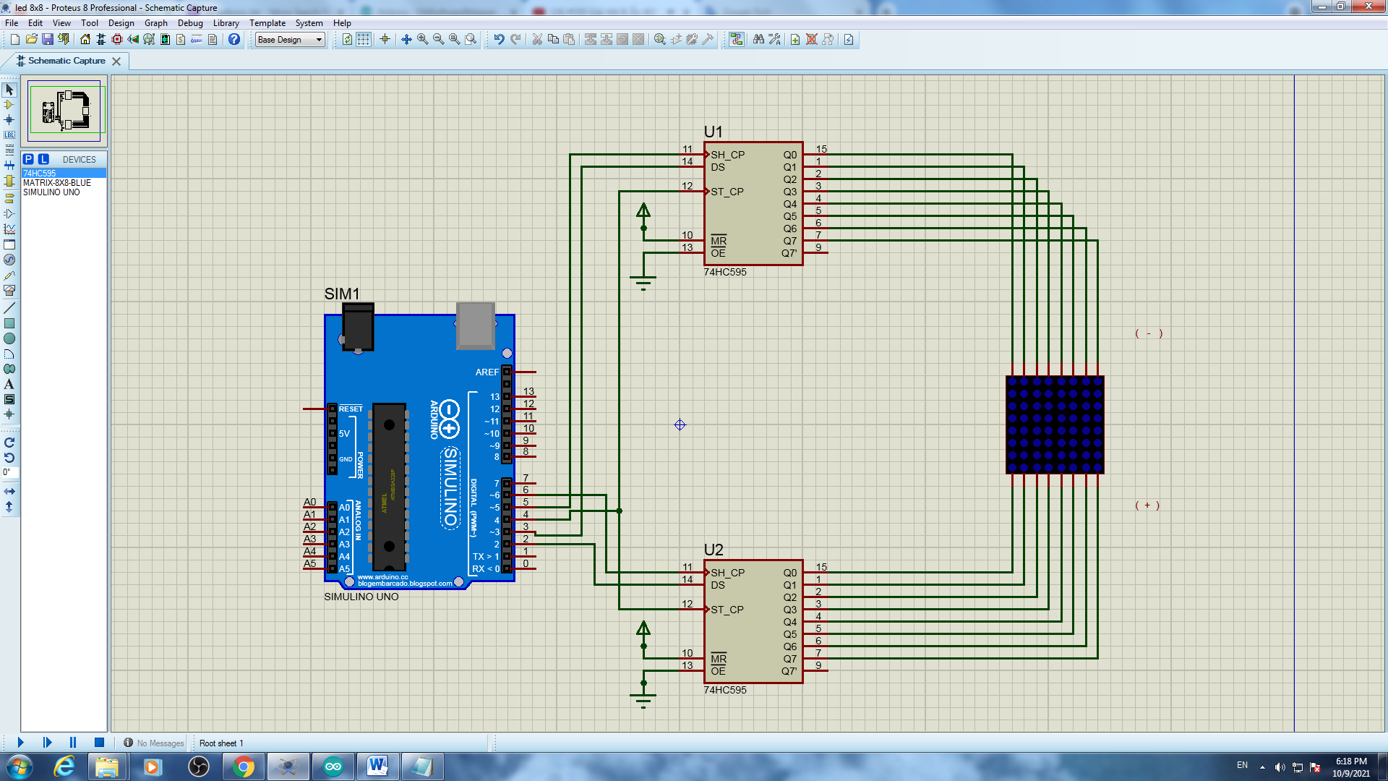

Sơ đồ kết nối của hệ thống 9

## Linh kiện

* 2 IC 78HC595
* 1 bảng đèn LED ma trận 8x8 màu xanh dương
* Mạch Arduino

## Code chương trình

* Code file code_test_1

|  |
| --- |
| #define DS_cot 2  #define DS_hang 3  #define SH_CP_hang 5  #define SH_CP_cot 6  #define ST_CP 4  byte cot = 0b10000000;  void setup() {  pinMode(ST_CP,OUTPUT);//RCLK    pinMode(DS_hang,OUTPUT);//SER hang  pinMode(SH_CP_hang,OUTPUT);//SRCLK hang  pinMode(SH_CP_cot,OUTPUT);//SRCLK cot  pinMode(DS_cot,OUTPUT);//SER cot  digitalWrite(ST_CP,LOW);  shiftOut(DS_hang,SH_CP_hang,LSBFIRST,0b00000000);// hang 8 - hang 1  digitalWrite(ST_CP,HIGH);  }  void loop() {  for(int i = 0; i < 8;i++){  digitalWrite(ST_CP,LOW);  shiftOut(DS_cot,SH_CP_cot,LSBFIRST,cot >> i); // cot 8 - cot 1  digitalWrite(ST_CP,HIGH);  delay(1);  }  } |

* Code file code_test_2

|  |
| --- |
| #define DS_cot 2  #define DS_hang 3  #define SH_CP_hang 5  #define SH_CP_cot 6  #define ST_CP 4  byte cot = 0b10000000;  void setup() {  pinMode(ST_CP,OUTPUT);//RCLK    pinMode(DS_hang,OUTPUT);//SER hang  pinMode(SH_CP_hang,OUTPUT);//SRCLK hang  pinMode(SH_CP_cot,OUTPUT);//SRCLK cot  pinMode(DS_cot,OUTPUT);//SER cot  digitalWrite(ST_CP,LOW);  shiftOut(DS_hang,SH_CP_hang,LSBFIRST,0b00000000);// hang 8 - hang 1  digitalWrite(ST_CP,HIGH);  }  void loop() {  for(int i = 0; i < 8;i++){  digitalWrite(ST_CP,LOW);  shiftOut(DS_cot,SH_CP_cot,LSBFIRST,cot >> i); // cot 8 - cot 1  digitalWrite(ST_CP,HIGH);  delay(100);  }  } |

* Code file code_test_3

|  |
| --- |
| // code giống câu 2 nhưng sửa delay ở câu 2 thành 1000  delay(1000); |

* Code file code_test_4

|  |
| --- |
| #define DS_cot 2  #define DS_hang 3  #define SH_CP_hang 5  #define SH_CP_cot 6  #define ST_CP 4  byte chu[][8] = {  {0xFF,0xC0,0x80,0xB7,0xB7,0x80,0xC0,0xFF} //A  };  byte cot = 0b10000000;  void setup() {  Serial.begin(9600);  pinMode(ST_CP,OUTPUT);//RCLK    pinMode(DS_hang,OUTPUT);//SER hang  pinMode(SH_CP_hang,OUTPUT);//SRCLK hang  pinMode(SH_CP_cot,OUTPUT);//SRCLK cot  pinMode(DS_cot,OUTPUT);//SER cot  }  void loop() {  for(int i = 0; i < 8;i++){  digitalWrite(ST_CP,LOW);  shiftOut(DS_hang,SH_CP_hang,LSBFIRST,chu[0][i]);// hang 8 - hang 1  shiftOut(DS_cot,SH_CP_cot,LSBFIRST,cot >> i); // cot 8 - cot 1  digitalWrite(ST_CP,HIGH);  delay(1);  }  } |

* Code file code_test_5

|  |
| --- |
| #define DS_cot 2  #define DS_hang 3  #define SH_CP_hang 5  #define SH_CP_cot 6  #define ST_CP 4  byte chu[][8] = {  {0xFF,0xC0,0x80,0xB7,0xB7,0x80,0xC0,0xFF}, //A  {0xFF,0x80,0x80,0xB6,0xB6,0x80,0xC9,0xFF}, //B  {0xFF,0xC1,0x80,0xBE,0xBE,0x9C,0xDD,0xFF}, //C  {0xFF,0x80,0x80,0xBE,0xBE,0x80,0xC1,0xFF}, //D  {0xFF,0x80,0x80,0xB6,0xB6,0xBE,0xBE,0xFF},//E  {0xFF,0x80,0x80,0xB7,0xB7,0xBF,0xBF,0xFF},//F  {0xFF,0xC1,0x80,0xBE,0xBA,0x98,0xD9,0xFF},//G  {0xFF,0x80,0x80,0xF7,0xF7,0x80,0x80,0xFF},//H  {0xFF,0xFF,0xBE,0x80,0x80,0xBE,0xFF,0xFF},//I  {0xFF,0xF9,0xF8,0xBE,0x80,0x81,0xBF,0xFF},//J  {0xFF,0x80,0x80,0xE3,0xC9,0x9C,0xBE,0xFF},//K  {0xFF,0x80,0x80,0xFE,0xFE,0xFE,0xFE,0xFF},//L  {0xFF,0x80,0x80,0xCF,0xE7,0xCF,0x80,0x80},//M  {0xFF,0x80,0x80,0xCF,0xE7,0xF3,0x80,0x80},//N  {0xFF,0xC1,0x80,0xBE,0xBE,0x80,0xC1,0xFF},//O  {0xFF,0x80,0x80,0xBB,0xBB,0x83,0xC7,0xFF},//P  {0xFF,0xC3,0x81,0xBD,0xBD,0x80,0xC2,0xFF},//Q  {0xFF,0x80,0x80,0xB3,0xB1,0x84,0xCE,0xFF},//R  {0xFF,0xCD,0x84,0xB6,0xB6,0x90,0xD9,0xFF},//S  {0xFF,0x9F,0xBF,0x80,0x80,0xBF,0x9F,0xFF},//T  {0xFF,0x81,0x80,0xFE,0xFE,0x80,0x80,0xFF},//U  {0xFF,0x83,0x81,0xFC,0xFC,0x81,0x83,0xFF},//V  {0xFF,0x80,0x80,0xF9,0xF3,0xF9,0x80,0x80},//W  {0xFF,0x9C,0x88,0xE3,0xF7,0xE3,0x88,0x9C},//X  {0xFF,0x8F,0x87,0xF0,0xF0,0x87,0x8F,0xFF},//Y  {0xFF,0xBC,0xB8,0xB2,0xA6,0x8E,0x9E,0xFF},//Z  {0xFF,0xFE,0xEE,0x80,0x80,0xFE,0xFE,0xFF},//1  {0xFF,0xDC,0x98,0xBA,0xB6,0x86,0xCE,0xFF},//2  {0xFF,0xDD,0x9C,0xB6,0xB6,0x80,0xC9,0xFF},//3  {0xFF,0xF3,0xEB,0xDB,0x80,0x80,0xFB,0xFF},//4  {0xFF,0x8D,0x8C,0xAE,0xAE,0xA0,0xB1,0xFF},//5  {0xFF,0xC1,0x80,0xB6,0xB6,0x90,0xD9,0xFF},//6  {0xFF,0x9F,0x9F,0xB8,0xA0,0x87,0x9F,0xFF},//7  {0xFF,0xC9,0x80,0xB6,0xB6,0x80,0xC9,0xFF},//8  {0xFF,0xCD,0x84,0xB6,0xB6,0x80,0xC1,0xFF},//9  {0xFF,0xC1,0x80,0xAE,0xB6,0x80,0xC1,0xFF},//0  {0xFF,0xFF,0xFF,0xFF,0xFF,0xFF,0xFF,0xFF},//space    };  byte cot = 0b10000000;  void setup() {  Serial.begin(9600);  pinMode(ST_CP,OUTPUT);//RCLK    pinMode(DS_hang,OUTPUT);//SER hang  pinMode(SH_CP_hang,OUTPUT);//SRCLK hang  pinMode(SH_CP_cot,OUTPUT);//SRCLK cot  pinMode(DS_cot,OUTPUT);//SER cot  }  void loop() {  for(int j = 0; j<37;j++){  for(int z = 0;z<50;z++){  for(int i = 0; i < 8;i++){  digitalWrite(ST_CP,LOW);  shiftOut(DS_hang,SH_CP_hang,LSBFIRST,chu[j][i]);// hang 8 - hang 1  shiftOut(DS_cot,SH_CP_cot,LSBFIRST,cot >> i); // cot 8 - cot 1  digitalWrite(ST_CP,HIGH);  delay(1);  }  }  }  } |

* Code file code_test_6

|  |
| --- |
| #define DS_cot 2  #define DS_hang 3  #define SH_CP_hang 5  #define SH_CP_cot 6  #define ST_CP 4  byte chu[][8] = {  {0xFF,0xC0,0x80,0xB7,0xB7,0x80,0xC0,0xFF}, //A  {0xFF,0x80,0x80,0xB6,0xB6,0x80,0xC9,0xFF}, //B  {0xFF,0xC1,0x80,0xBE,0xBE,0x9C,0xDD,0xFF}, //C  {0xFF,0x80,0x80,0xBE,0xBE,0x80,0xC1,0xFF}, //D  {0xFF,0x80,0x80,0xB6,0xB6,0xBE,0xBE,0xFF},//E  {0xFF,0x80,0x80,0xB7,0xB7,0xBF,0xBF,0xFF},//F  {0xFF,0xC1,0x80,0xBE,0xBA,0x98,0xD9,0xFF},//G  {0xFF,0x80,0x80,0xF7,0xF7,0x80,0x80,0xFF},//H  {0xFF,0xFF,0xBE,0x80,0x80,0xBE,0xFF,0xFF},//I  {0xFF,0xF9,0xF8,0xBE,0x80,0x81,0xBF,0xFF},//J  {0xFF,0x80,0x80,0xE3,0xC9,0x9C,0xBE,0xFF},//K  {0xFF,0x80,0x80,0xFE,0xFE,0xFE,0xFE,0xFF},//L  {0xFF,0x80,0x80,0xCF,0xE7,0xCF,0x80,0x80},//M  {0xFF,0x80,0x80,0xCF,0xE7,0xF3,0x80,0x80},//N  {0xFF,0xC1,0x80,0xBE,0xBE,0x80,0xC1,0xFF},//O  {0xFF,0x80,0x80,0xBB,0xBB,0x83,0xC7,0xFF},//P  {0xFF,0xC3,0x81,0xBD,0xBD,0x80,0xC2,0xFF},//Q  {0xFF,0x80,0x80,0xB3,0xB1,0x84,0xCE,0xFF},//R  {0xFF,0xCD,0x84,0xB6,0xB6,0x90,0xD9,0xFF},//S  {0xFF,0x9F,0xBF,0x80,0x80,0xBF,0x9F,0xFF},//T  {0xFF,0x81,0x80,0xFE,0xFE,0x80,0x80,0xFF},//U  {0xFF,0x83,0x81,0xFC,0xFC,0x81,0x83,0xFF},//V  {0xFF,0x80,0x80,0xF9,0xF3,0xF9,0x80,0x80},//W  {0xFF,0x9C,0x88,0xE3,0xF7,0xE3,0x88,0x9C},//X  {0xFF,0x8F,0x87,0xF0,0xF0,0x87,0x8F,0xFF},//Y  {0xFF,0xBC,0xB8,0xB2,0xA6,0x8E,0x9E,0xFF},//Z  {0xFF,0xFE,0xEE,0x80,0x80,0xFE,0xFE,0xFF},//1  {0xFF,0xDC,0x98,0xBA,0xB6,0x86,0xCE,0xFF},//2  {0xFF,0xDD,0x9C,0xB6,0xB6,0x80,0xC9,0xFF},//3  {0xFF,0xF3,0xEB,0xDB,0x80,0x80,0xFB,0xFF},//4  {0xFF,0x8D,0x8C,0xAE,0xAE,0xA0,0xB1,0xFF},//5  {0xFF,0xC1,0x80,0xB6,0xB6,0x90,0xD9,0xFF},//6  {0xFF,0x9F,0x9F,0xB8,0xA0,0x87,0x9F,0xFF},//7  {0xFF,0xC9,0x80,0xB6,0xB6,0x80,0xC9,0xFF},//8  {0xFF,0xCD,0x84,0xB6,0xB6,0x80,0xC1,0xFF},//9  {0xFF,0xC1,0x80,0xAE,0xB6,0x80,0xC1,0xFF},//0  {0xFF,0xFF,0xFF,0xFF,0xFF,0xFF,0xFF,0xFF},//space    };  byte cot[8]={0b10000000,0b01000000,0b00100000,0b00010000,0b00001000,0b00000100,0b00000010,0b00000001};  char character[]={'A','B','C','D','E','F','G','H','I','J','K','L','M','N','O','P','Q','R','S','T','U','V','W','X','Y','Z','1','2','3','4','5','6','7','8','9','0',' '};  //String hienthi = "HAPPY NEW YEAR";  byte led[][8] = {  {0xFF,0xFF,0xFF,0xFF,0xFF,0xFF,0xFF,0xFF},  {0xFF,0xFF,0xFF,0xFF,0xFF,0xFF,0xFF,0xFF},  {0xFF,0xFF,0xFF,0xFF,0xFF,0xFF,0xFF,0xFF},  };  byte nho;  void setup() {  Serial.begin(9600);  pinMode(ST_CP,OUTPUT);//RCLK    pinMode(DS_hang,OUTPUT);//SER hang  pinMode(SH_CP_hang,OUTPUT);//SRCLK hang  pinMode(SH_CP_cot,OUTPUT);//SRCLK cot  pinMode(DS_cot,OUTPUT);//SER cot  }  void loop() {  hienthi("HAPPY NEW YEAR",20);  }  void hienthi(String tukhoa, unsigned int tocdo){  for(int q=0;q<tukhoa.length();q++){  for(int e=0;e<sizeof(character);e++){  if(tukhoa.charAt(q)==character[e]){  for(byte h=0;h<8;h++){    for(byte j=0;j<7;j++){  led[0][j] = led[0][j+1];  }  led[0][7]=chu[e][h];  for(byte w = 0; w<tocdo;w++){  for(byte i=0;i<8;i++){  digitalWrite(ST_CP,LOW);  shiftOut(DS_hang,SH_CP_hang,LSBFIRST,led[0][i]);// hang 8 - hang 1  shiftOut(DS_hang,SH_CP_hang,LSBFIRST,led[1][i]);// hang 8 - hang 1  shiftOut(DS_hang,SH_CP_hang,LSBFIRST,led[2][i]);// hang 8 - hang 1  shiftOut(DS_cot,SH_CP_cot,LSBFIRST,cot[i]); // cot 8 - cot 1  digitalWrite(ST_CP,HIGH);  }  }  for(byte j=0;j<7;j++){  led[2][j] = led[2][j+1];  }  led[2][7]=led[1][0];  for(byte j=0;j<7;j++){  led[1][j] = led[1][j+1];  }  led[1][7]=led[0][0];    }  if(q==tukhoa.length()-1){ ///// tao khoang trong  for(byte h=0;h<24;h++){  for(byte j=0;j<7;j++){  led[0][j] = led[0][j+1];  }  led[0][7]=0xFF;  for(byte w = 0; w<tocdo;w++){  for(byte i=0;i<8;i++){  digitalWrite(ST_CP,LOW);  shiftOut(DS_hang,SH_CP_hang,LSBFIRST,led[0][i]);// hang 8 - hang 1  shiftOut(DS_hang,SH_CP_hang,LSBFIRST,led[1][i]);// hang 8 - hang 1  shiftOut(DS_hang,SH_CP_hang,LSBFIRST,led[2][i]);// hang 8 - hang 1  shiftOut(DS_cot,SH_CP_cot,LSBFIRST,cot[i]); // cot 8 - cot 1  digitalWrite(ST_CP,HIGH);  }  }  for(byte j=0;j<7;j++){  led[2][j] = led[2][j+1];  }  led[2][7]=led[1][0];  for(byte j=0;j<7;j++){  led[1][j] = led[1][j+1];  }  led[1][7]=led[0][0];  }  }  }  }  }  } |

* Code file code_test_7

|  |
| --- |
| #define DS_cot 2  #define DS_hang 3  #define SH_CP_hang 5  #define SH_CP_cot 6  #define ST_CP 4  byte chu[][8] = {  {0xFF,0xC0,0x80,0xB7,0xB7,0x80,0xC0,0xFF}, //A  {0xFF,0x80,0x80,0xB6,0xB6,0x80,0xC9,0xFF}, //B  {0xFF,0xC1,0x80,0xBE,0xBE,0x9C,0xDD,0xFF}, //C  {0xFF,0x80,0x80,0xBE,0xBE,0x80,0xC1,0xFF}, //D  {0xFF,0x80,0x80,0xB6,0xB6,0xBE,0xBE,0xFF},//E  {0xFF,0x80,0x80,0xB7,0xB7,0xBF,0xBF,0xFF},//F  {0xFF,0xC1,0x80,0xBE,0xBA,0x98,0xD9,0xFF},//G  {0xFF,0x80,0x80,0xF7,0xF7,0x80,0x80,0xFF},//H  {0xFF,0xFF,0xBE,0x80,0x80,0xBE,0xFF,0xFF},//I  {0xFF,0xF9,0xF8,0xBE,0x80,0x81,0xBF,0xFF},//J  {0xFF,0x80,0x80,0xE3,0xC9,0x9C,0xBE,0xFF},//K  {0xFF,0x80,0x80,0xFE,0xFE,0xFE,0xFE,0xFF},//L  {0xFF,0x80,0x80,0xCF,0xE7,0xCF,0x80,0x80},//M  {0xFF,0x80,0x80,0xCF,0xE7,0xF3,0x80,0x80},//N  {0xFF,0xC1,0x80,0xBE,0xBE,0x80,0xC1,0xFF},//O  {0xFF,0x80,0x80,0xBB,0xBB,0x83,0xC7,0xFF},//P  {0xFF,0xC3,0x81,0xBD,0xBD,0x80,0xC2,0xFF},//Q  {0xFF,0x80,0x80,0xB3,0xB1,0x84,0xCE,0xFF},//R  {0xFF,0xCD,0x84,0xB6,0xB6,0x90,0xD9,0xFF},//S  {0xFF,0x9F,0xBF,0x80,0x80,0xBF,0x9F,0xFF},//T  {0xFF,0x81,0x80,0xFE,0xFE,0x80,0x80,0xFF},//U  {0xFF,0x83,0x81,0xFC,0xFC,0x81,0x83,0xFF},//V  {0xFF,0x80,0x80,0xF9,0xF3,0xF9,0x80,0x80},//W  {0xFF,0x9C,0x88,0xE3,0xF7,0xE3,0x88,0x9C},//X  {0xFF,0x8F,0x87,0xF0,0xF0,0x87,0x8F,0xFF},//Y  {0xFF,0xBC,0xB8,0xB2,0xA6,0x8E,0x9E,0xFF},//Z  {0xFF,0xFE,0xEE,0x80,0x80,0xFE,0xFE,0xFF},//1  {0xFF,0xDC,0x98,0xBA,0xB6,0x86,0xCE,0xFF},//2  {0xFF,0xDD,0x9C,0xB6,0xB6,0x80,0xC9,0xFF},//3  {0xFF,0xF3,0xEB,0xDB,0x80,0x80,0xFB,0xFF},//4  {0xFF,0x8D,0x8C,0xAE,0xAE,0xA0,0xB1,0xFF},//5  {0xFF,0xC1,0x80,0xB6,0xB6,0x90,0xD9,0xFF},//6  {0xFF,0x9F,0x9F,0xB8,0xA0,0x87,0x9F,0xFF},//7  {0xFF,0xC9,0x80,0xB6,0xB6,0x80,0xC9,0xFF},//8  {0xFF,0xCD,0x84,0xB6,0xB6,0x80,0xC1,0xFF},//9  {0xFF,0xC1,0x80,0xAE,0xB6,0x80,0xC1,0xFF},//0  {0xFF,0xFF,0xFF,0xFF,0xFF,0xFF,0xFF,0xFF},//space  };  byte cot[8]={0b10000000,0b01000000,0b00100000,0b00010000,0b00001000,0b00000100,0b00000010,0b00000001};  char character[]={'A','B','C','D','E','F','G','H','I','J','K','L','M','N','O','P','Q','R','S','T','U','V','W','X','Y','Z','1','2','3','4','5','6','7','8','9','0',' '};  //String hienthi = "HAPPY NEW YEAR";  byte led[][8] = {  {0xFF,0xFF,0xFF,0xFF,0xFF,0xFF,0xFF,0xFF},  {0xFF,0xFF,0xFF,0xFF,0xFF,0xFF,0xFF,0xFF},  {0xFF,0xFF,0xFF,0xFF,0xFF,0xFF,0xFF,0xFF},  };  byte nho;  void setup() {  Serial.begin(9600);  pinMode(ST_CP,OUTPUT);//RCLK    pinMode(DS_hang,OUTPUT);//SER hang  pinMode(SH_CP_hang,OUTPUT);//SRCLK hang  pinMode(SH_CP_cot,OUTPUT);//SRCLK cot  pinMode(DS_cot,OUTPUT);//SER cot  }  void loop() {  hienthi("CAO THAI TOAN PHONG MSSV 60136530 ",20);  }  void hienthi(String tukhoa, unsigned int tocdo){  for(int q=0;q<tukhoa.length();q++){  for(int e=0;e<sizeof(character);e++){  if(tukhoa.charAt(q)==character[e]){  for(byte h=0;h<8;h++){    for(byte j=0;j<7;j++){  led[0][j] = led[0][j+1];  }  led[0][7]=chu[e][h];  for(byte w = 0; w<tocdo;w++){  for(byte i=0;i<8;i++){  digitalWrite(ST_CP,LOW);  shiftOut(DS_hang,SH_CP_hang,LSBFIRST,led[0][i]);// hang 8 - hang 1  shiftOut(DS_hang,SH_CP_hang,LSBFIRST,led[1][i]);// hang 8 - hang 1  shiftOut(DS_hang,SH_CP_hang,LSBFIRST,led[2][i]);// hang 8 - hang 1  shiftOut(DS_cot,SH_CP_cot,LSBFIRST,cot[i]); // cot 8 - cot 1  digitalWrite(ST_CP,HIGH);  }  }  for(byte j=0;j<7;j++){  led[2][j] = led[2][j+1];  }  led[2][7]=led[1][0];  for(byte j=0;j<7;j++){  led[1][j] = led[1][j+1];  }  led[1][7]=led[0][0];  }  if(q==tukhoa.length()-1){ ///// tao khoang trong  for(byte h=0;h<24;h++){  for(byte j=0;j<7;j++){  led[0][j] = led[0][j+1];  }  led[0][7]=0xFF;  for(byte w = 0; w<tocdo;w++){  for(byte i=0;i<8;i++){  digitalWrite(ST_CP,LOW);  shiftOut(DS_hang,SH_CP_hang,LSBFIRST,led[0][i]);// hang 8 - hang 1  shiftOut(DS_hang,SH_CP_hang,LSBFIRST,led[1][i]);// hang 8 - hang 1  shiftOut(DS_hang,SH_CP_hang,LSBFIRST,led[2][i]);// hang 8 - hang 1  shiftOut(DS_cot,SH_CP_cot,LSBFIRST,cot[i]); // cot 8 - cot 1  digitalWrite(ST_CP,HIGH);  }  }  for(byte j=0;j<7;j++){  led[2][j] = led[2][j+1];  }  led[2][7]=led[1][0];  for(byte j=0;j<7;j++){  led[1][j] = led[1][j+1];  }  led[1][7]=led[0][0];  }  }  }  }  }  } |

## Kết quả chạy chương trình

* Kết quả file Test 1

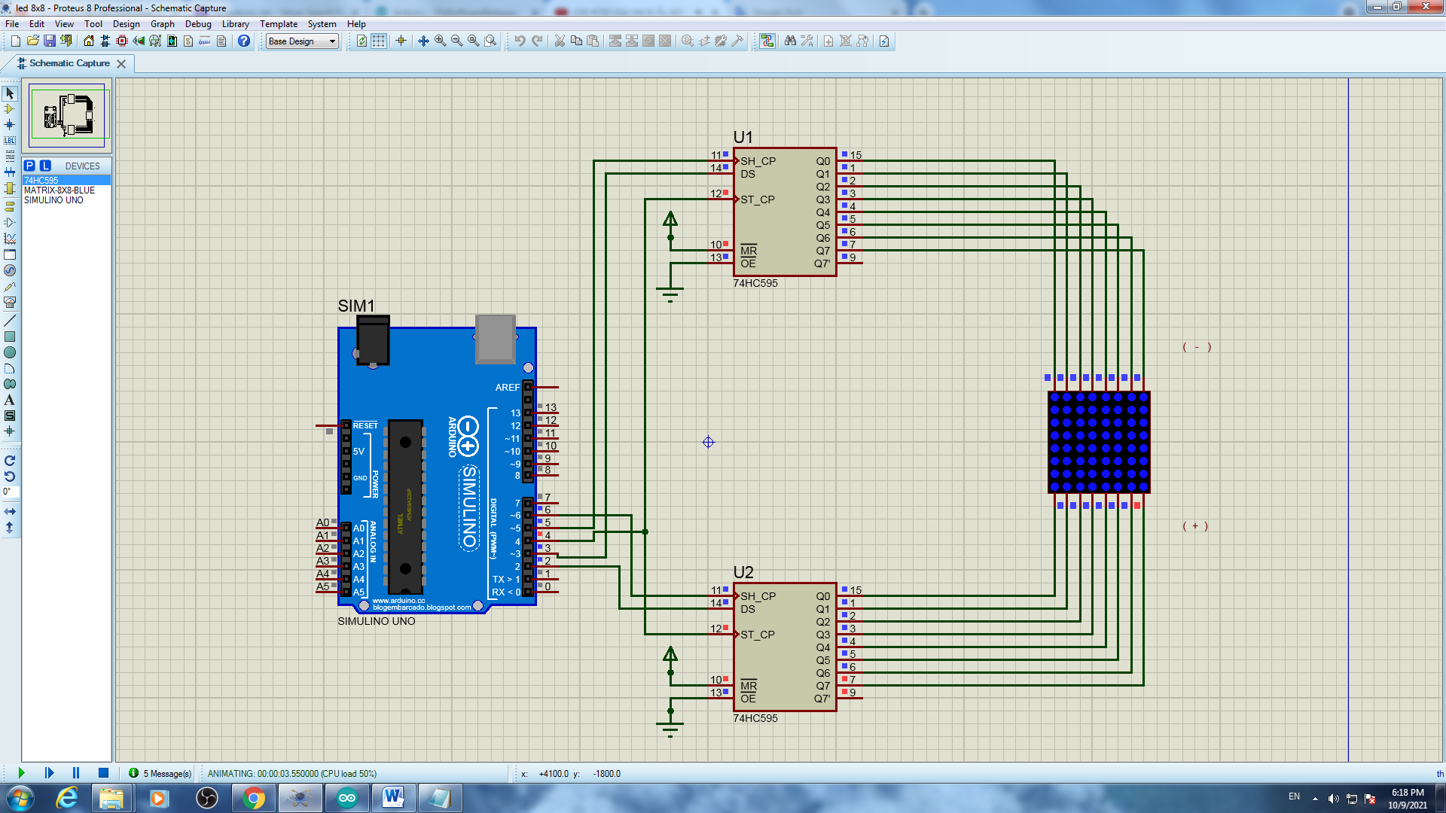

Kết quả KQ test 1

* Kết quả file Test 2

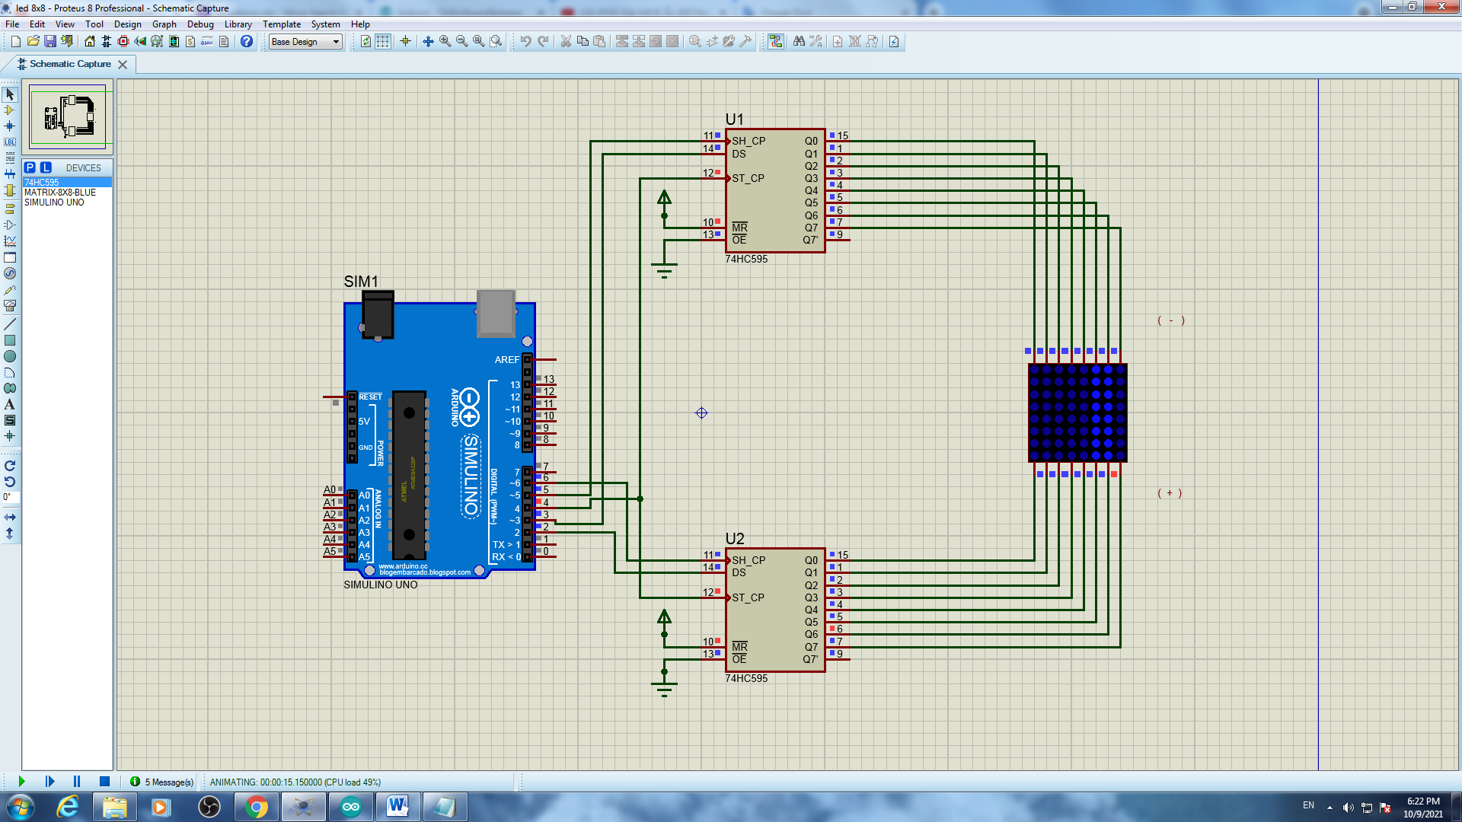

Kết quả

* Kết quả file Test 3

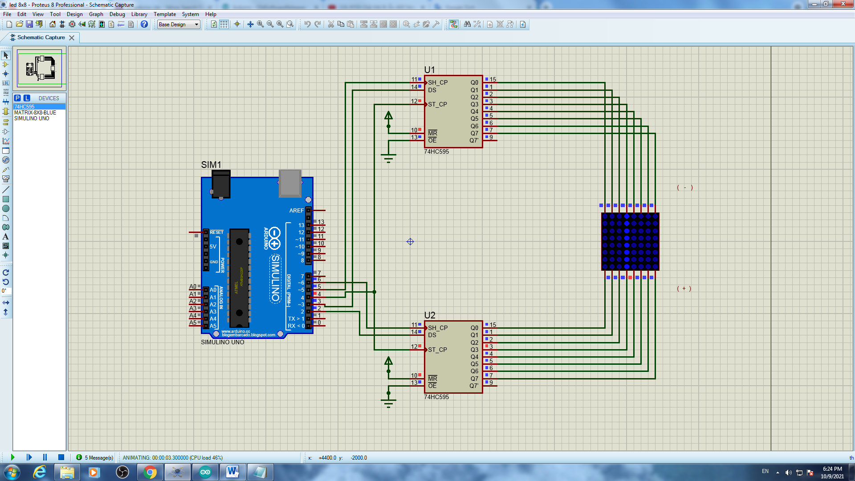

Kết quả

* Kết quả file Test 4

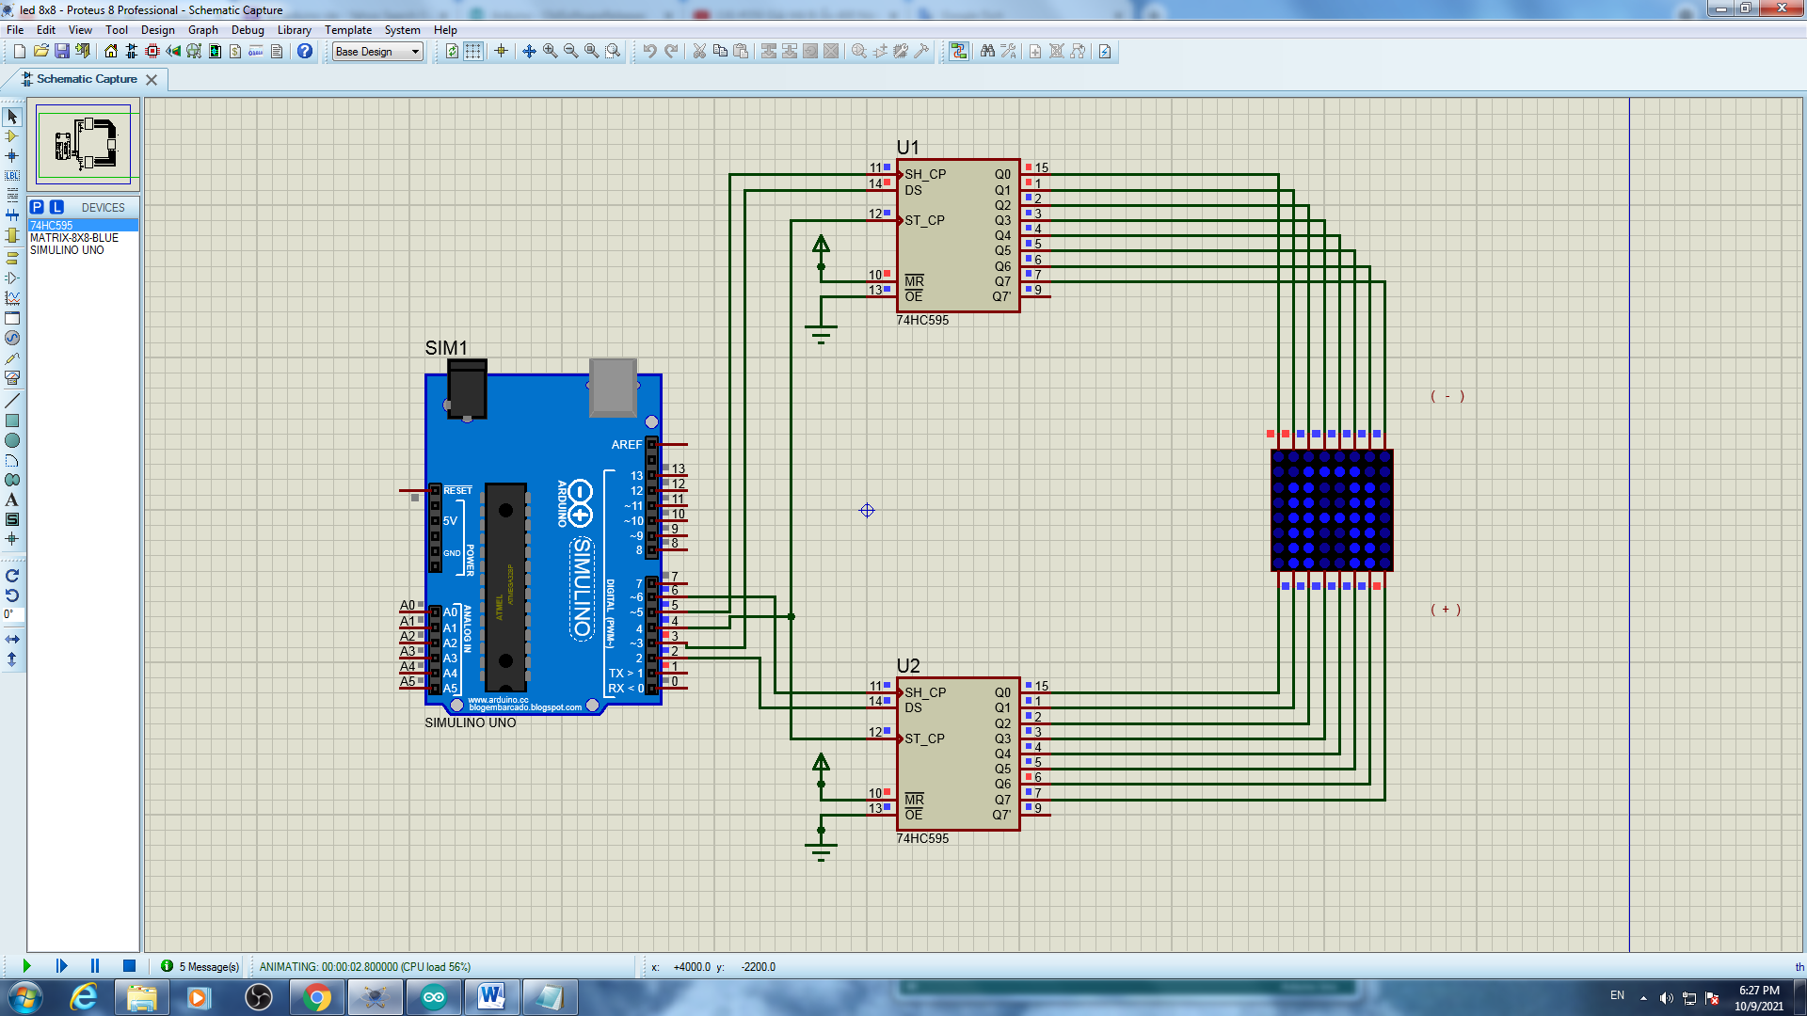

Kết quả

* Kết quả file Test 5

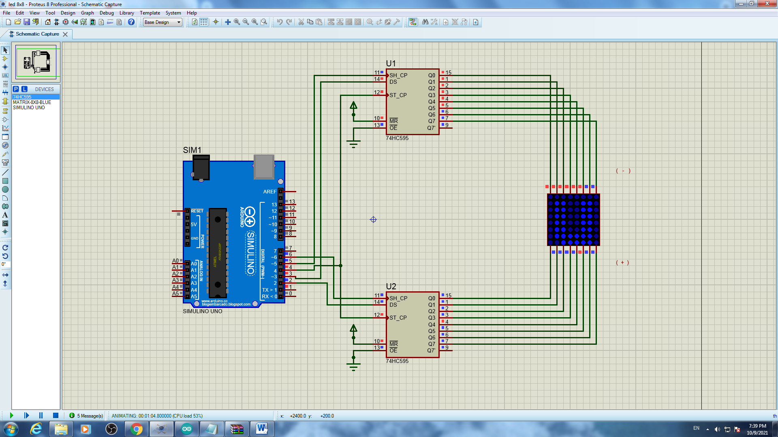

Kết quả

* Kết quả file Test 6

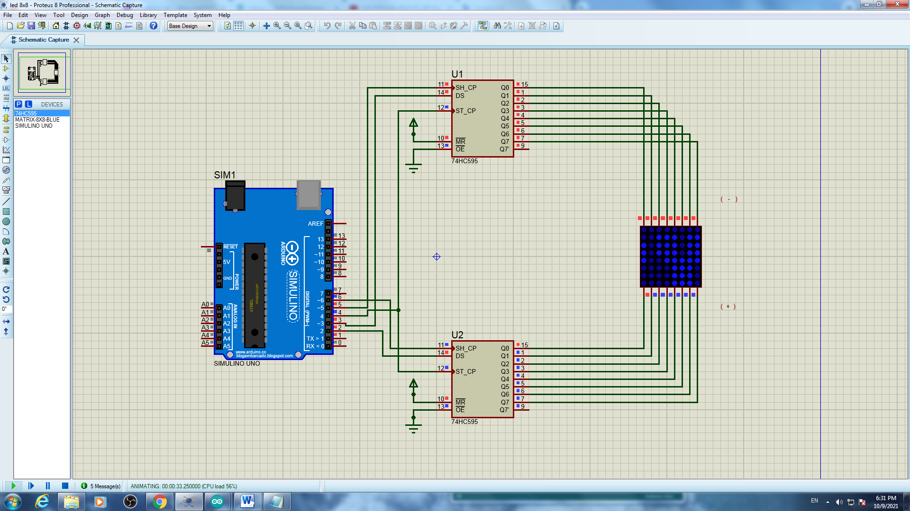

Kết quả

* Kết quả file Test 7

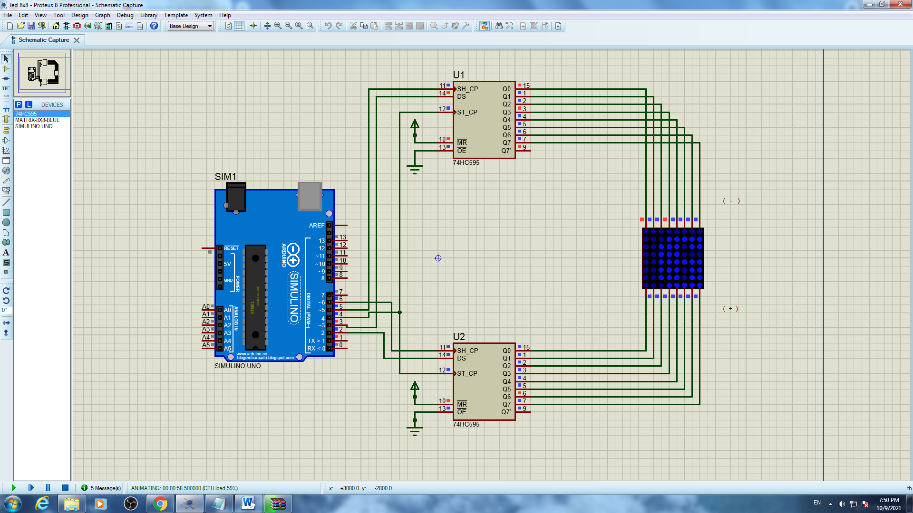

Kết quả

# Bài 9 : LED MATRIX 24x8

## Mô tả

Bài này thực hiện việc lập trình 1 dãy đèn LED ma trận 24x8 màu xanh dương kèm 4 IC 78HC595 hiển thị các số và chữ theo lập trình ở các file

file test_1 : Hiển thị chữ A trong dãy đèn chạy từ trái sang phải và đổi chiều

file test_2 : Hiển thị dòng chữ chứa từ happy new year , dòng chữ chạy từ trái sáng phải

file test_3 : Chạy tất cả chữ từ a đến z và từ 0 đến 9 trong dãy đèn

file test_4 : Hiển thị dòng chữ chứa tên sinh viên kèm mã số sinh viên, dòng chữ chạy từ trái sáng phải

## Linh kiện

#### 4 IC 78HC595

#### 1 bảng đèn LED ma trận 8x8 màu xanh dương

#### Mạch Arduino

## Sơ đồ mạch

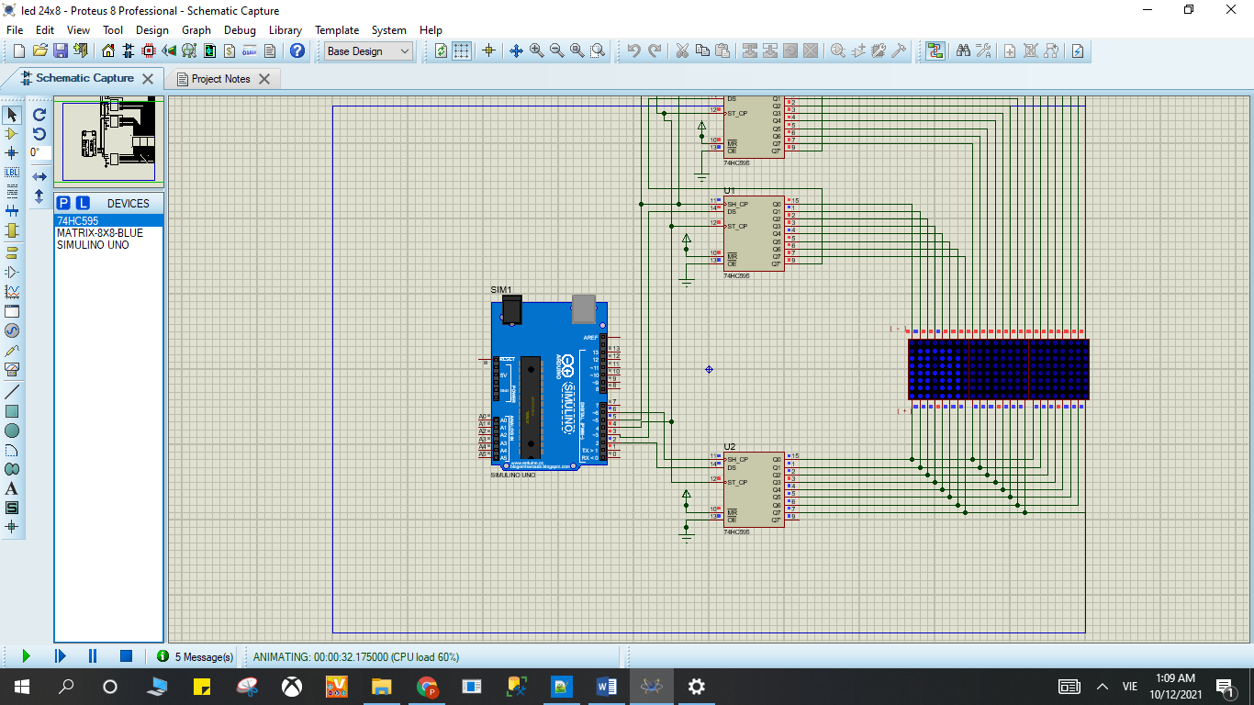

Sơ đồ kết nối của hệ thống 9

## Code chương trình

* Code file test_1:

|  |
| --- |
| #define DS_cot 2  #define DS_hang 3  #define SH_CP_hang 5  #define SH_CP_cot 6  #define ST_CP 4  byte chu[][8] = {  {0xFF,0xC0,0x80,0xB7,0xB7,0x80,0xC0,0xFF}, //A  {0xFF,0x80,0x80,0xB6,0xB6,0x80,0xC9,0xFF}, //B  {0xFF,0xC1,0x80,0xBE,0xBE,0x9C,0xDD,0xFF}, //C  {0xFF,0x80,0x80,0xBE,0xBE,0x80,0xC1,0xFF}, //D  {0xFF,0x80,0x80,0xB6,0xB6,0xBE,0xBE,0xFF},//E  {0xFF,0x80,0x80,0xB7,0xB7,0xBF,0xBF,0xFF},//F  {0xFF,0xC1,0x80,0xBE,0xBA,0x98,0xD9,0xFF},//G  {0xFF,0x80,0x80,0xF7,0xF7,0x80,0x80,0xFF},//H  {0xFF,0xFF,0xBE,0x80,0x80,0xBE,0xFF,0xFF},//I  {0xFF,0xF9,0xF8,0xBE,0x80,0x81,0xBF,0xFF},//J  {0xFF,0x80,0x80,0xE3,0xC9,0x9C,0xBE,0xFF},//K  {0xFF,0x80,0x80,0xFE,0xFE,0xFE,0xFE,0xFF},//L  {0xFF,0x80,0x80,0xCF,0xE7,0xCF,0x80,0x80},//M  {0xFF,0x80,0x80,0xCF,0xE7,0xF3,0x80,0x80},//N  {0xFF,0xC1,0x80,0xBE,0xBE,0x80,0xC1,0xFF},//O  {0xFF,0x80,0x80,0xBB,0xBB,0x83,0xC7,0xFF},//P  {0xFF,0xC3,0x81,0xBD,0xBD,0x80,0xC2,0xFF},//Q  {0xFF,0x80,0x80,0xB3,0xB1,0x84,0xCE,0xFF},//R  {0xFF,0xCD,0x84,0xB6,0xB6,0x90,0xD9,0xFF},//S  {0xFF,0x9F,0xBF,0x80,0x80,0xBF,0x9F,0xFF},//T  {0xFF,0x81,0x80,0xFE,0xFE,0x80,0x80,0xFF},//U  {0xFF,0x83,0x81,0xFC,0xFC,0x81,0x83,0xFF},//V  {0xFF,0x80,0x80,0xF9,0xF3,0xF9,0x80,0x80},//W  {0xFF,0x9C,0x88,0xE3,0xF7,0xE3,0x88,0x9C},//X  {0xFF,0x8F,0x87,0xF0,0xF0,0x87,0x8F,0xFF},//Y  {0xFF,0xBC,0xB8,0xB2,0xA6,0x8E,0x9E,0xFF},//Z  {0xFF,0xFE,0xEE,0x80,0x80,0xFE,0xFE,0xFF},//1  {0xFF,0xDC,0x98,0xBA,0xB6,0x86,0xCE,0xFF},//2  {0xFF,0xDD,0x9C,0xB6,0xB6,0x80,0xC9,0xFF},//3  {0xFF,0xF3,0xEB,0xDB,0x80,0x80,0xFB,0xFF},//4  {0xFF,0x8D,0x8C,0xAE,0xAE,0xA0,0xB1,0xFF},//5  {0xFF,0xC1,0x80,0xB6,0xB6,0x90,0xD9,0xFF},//6  {0xFF,0x9F,0x9F,0xB8,0xA0,0x87,0x9F,0xFF},//7  {0xFF,0xC9,0x80,0xB6,0xB6,0x80,0xC9,0xFF},//8  {0xFF,0xCD,0x84,0xB6,0xB6,0x80,0xC1,0xFF},//9  {0xFF,0xC1,0x80,0xAE,0xB6,0x80,0xC1,0xFF},//0  {0xFF,0xFF,0xFF,0xFF,0xFF,0xFF,0xFF,0xFF},//space    };  byte cot = 0b10000000;  void setup() {  Serial.begin(9600);  pinMode(ST_CP,OUTPUT);//RCLK    pinMode(DS_hang,OUTPUT);//SER hang  pinMode(SH_CP_hang,OUTPUT);//SRCLK hang  pinMode(SH_CP_cot,OUTPUT);//SRCLK cot  pinMode(DS_cot,OUTPUT);//SER cot  }  void loop() {  for(int j = 0;j<10;j++){  digitalWrite(ST_CP,LOW);  shiftOut(DS_hang,SH_CP_hang,LSBFIRST,0b11111111);// hang 8 - hang 1  shiftOut(DS_hang,SH_CP_hang,LSBFIRST,0b11111111);// hang 8 - hang 1  shiftOut(DS_hang,SH_CP_hang,LSBFIRST,0xC0);// hang 8 - hang 1  shiftOut(DS_cot,SH_CP_cot,LSBFIRST,0b10000000); // cot 8 - cot 1  digitalWrite(ST_CP,HIGH);  delay(1);  digitalWrite(ST_CP,LOW);  shiftOut(DS_hang,SH_CP_hang,LSBFIRST,0b11111111);// hang 8 - hang 1  shiftOut(DS_hang,SH_CP_hang,LSBFIRST,0b11111111);// hang 8 - hang 1  shiftOut(DS_hang,SH_CP_hang,LSBFIRST,0xFF);// hang 8 - hang 1  shiftOut(DS_cot,SH_CP_cot,LSBFIRST,0b01000000); // cot 8 - cot 1  digitalWrite(ST_CP,HIGH);  delay(1);    digitalWrite(ST_CP,LOW);  shiftOut(DS_hang,SH_CP_hang,LSBFIRST,0b11111111);// hang 8 - hang 1  shiftOut(DS_hang,SH_CP_hang,LSBFIRST,0b11111111);// hang 8 - hang 1  shiftOut(DS_hang,SH_CP_hang,LSBFIRST,0xFF);// hang 8 - hang 1  shiftOut(DS_cot,SH_CP_cot,LSBFIRST,0b00100000); // cot 8 - cot 1  digitalWrite(ST_CP,HIGH);  delay(1);  digitalWrite(ST_CP,LOW);  shiftOut(DS_hang,SH_CP_hang,LSBFIRST,0b11111111);// hang 8 - hang 1  shiftOut(DS_hang,SH_CP_hang,LSBFIRST,0b11111111);// hang 8 - hang 1  shiftOut(DS_hang,SH_CP_hang,LSBFIRST,0xFF);// hang 8 - hang 1  shiftOut(DS_cot,SH_CP_cot,LSBFIRST,0b00010000); // cot 8 - cot 1  digitalWrite(ST_CP,HIGH);  delay(1);  digitalWrite(ST_CP,LOW);  shiftOut(DS_hang,SH_CP_hang,LSBFIRST,0b11111111);// hang 8 - hang 1  shiftOut(DS_hang,SH_CP_hang,LSBFIRST,0b11111111);// hang 8 - hang 1  shiftOut(DS_hang,SH_CP_hang,LSBFIRST,0xFF);// hang 8 - hang 1  shiftOut(DS_cot,SH_CP_cot,LSBFIRST,0b00001000); // cot 8 - cot 1  digitalWrite(ST_CP,HIGH);  delay(1);    digitalWrite(ST_CP,LOW);  shiftOut(DS_hang,SH_CP_hang,LSBFIRST,0b11111111);// hang 8 - hang 1  shiftOut(DS_hang,SH_CP_hang,LSBFIRST,0b11111111);// hang 8 - hang 1  shiftOut(DS_hang,SH_CP_hang,LSBFIRST,0xFF);// hang 8 - hang 1  shiftOut(DS_cot,SH_CP_cot,LSBFIRST,0b00000100); // cot 8 - cot 1  digitalWrite(ST_CP,HIGH);  delay(1);  digitalWrite(ST_CP,LOW);  shiftOut(DS_hang,SH_CP_hang,LSBFIRST,0b11111111);// hang 8 - hang 1  shiftOut(DS_hang,SH_CP_hang,LSBFIRST,0b11111111);// hang 8 - hang 1  shiftOut(DS_hang,SH_CP_hang,LSBFIRST,0xFF);// hang 8 - hang 1  shiftOut(DS_cot,SH_CP_cot,LSBFIRST,0b00000010); // cot 8 - cot 1  digitalWrite(ST_CP,HIGH);  delay(1);  digitalWrite(ST_CP,LOW);  shiftOut(DS_hang,SH_CP_hang,LSBFIRST,0b11111111);// hang 8 - hang 1  shiftOut(DS_hang,SH_CP_hang,LSBFIRST,0b11111111);// hang 8 - hang 1  shiftOut(DS_hang,SH_CP_hang,LSBFIRST,0xFF);// hang 8 - hang 1  shiftOut(DS_cot,SH_CP_cot,LSBFIRST,0b00000001); // cot 8 - cot 1  digitalWrite(ST_CP,HIGH);  delay(1);  }  for(int j = 0;j<10;j++){  digitalWrite(ST_CP,LOW);  shiftOut(DS_hang,SH_CP_hang,LSBFIRST,0b11111111);// hang 8 - hang 1  shiftOut(DS_hang,SH_CP_hang,LSBFIRST,0b11111111);// hang 8 - hang 1  shiftOut(DS_hang,SH_CP_hang,LSBFIRST,0x80);// hang 8 - hang 1  shiftOut(DS_cot,SH_CP_cot,LSBFIRST,0b10000000); // cot 8 - cot 1  digitalWrite(ST_CP,HIGH);  delay(1);  digitalWrite(ST_CP,LOW);  shiftOut(DS_hang,SH_CP_hang,LSBFIRST,0b11111111);// hang 8 - hang 1  shiftOut(DS_hang,SH_CP_hang,LSBFIRST,0b11111111);// hang 8 - hang 1  shiftOut(DS_hang,SH_CP_hang,LSBFIRST,0xC0);// hang 8 - hang 1  shiftOut(DS_cot,SH_CP_cot,LSBFIRST,0b01000000); // cot 8 - cot 1  digitalWrite(ST_CP,HIGH);  delay(1);    digitalWrite(ST_CP,LOW);  shiftOut(DS_hang,SH_CP_hang,LSBFIRST,0b11111111);// hang 8 - hang 1  shiftOut(DS_hang,SH_CP_hang,LSBFIRST,0b11111111);// hang 8 - hang 1  shiftOut(DS_hang,SH_CP_hang,LSBFIRST,0xFF);// hang 8 - hang 1  shiftOut(DS_cot,SH_CP_cot,LSBFIRST,0b00100000); // cot 8 - cot 1  digitalWrite(ST_CP,HIGH);  delay(1);  digitalWrite(ST_CP,LOW);  shiftOut(DS_hang,SH_CP_hang,LSBFIRST,0b11111111);// hang 8 - hang 1  shiftOut(DS_hang,SH_CP_hang,LSBFIRST,0b11111111);// hang 8 - hang 1  shiftOut(DS_hang,SH_CP_hang,LSBFIRST,0xFF);// hang 8 - hang 1  shiftOut(DS_cot,SH_CP_cot,LSBFIRST,0b00010000); // cot 8 - cot 1  digitalWrite(ST_CP,HIGH);  delay(1);  digitalWrite(ST_CP,LOW);  shiftOut(DS_hang,SH_CP_hang,LSBFIRST,0b11111111);// hang 8 - hang 1  shiftOut(DS_hang,SH_CP_hang,LSBFIRST,0b11111111);// hang 8 - hang 1  shiftOut(DS_hang,SH_CP_hang,LSBFIRST,0xFF);// hang 8 - hang 1  shiftOut(DS_cot,SH_CP_cot,LSBFIRST,0b00001000); // cot 8 - cot 1  digitalWrite(ST_CP,HIGH);  delay(1);    digitalWrite(ST_CP,LOW);  shiftOut(DS_hang,SH_CP_hang,LSBFIRST,0b11111111);// hang 8 - hang 1  shiftOut(DS_hang,SH_CP_hang,LSBFIRST,0b11111111);// hang 8 - hang 1  shiftOut(DS_hang,SH_CP_hang,LSBFIRST,0xFF);// hang 8 - hang 1  shiftOut(DS_cot,SH_CP_cot,LSBFIRST,0b00000100); // cot 8 - cot 1  digitalWrite(ST_CP,HIGH);  delay(1);  digitalWrite(ST_CP,LOW);  shiftOut(DS_hang,SH_CP_hang,LSBFIRST,0b11111111);// hang 8 - hang 1  shiftOut(DS_hang,SH_CP_hang,LSBFIRST,0b11111111);// hang 8 - hang 1  shiftOut(DS_hang,SH_CP_hang,LSBFIRST,0xFF);// hang 8 - hang 1  shiftOut(DS_cot,SH_CP_cot,LSBFIRST,0b00000010); // cot 8 - cot 1  digitalWrite(ST_CP,HIGH);  delay(1);  digitalWrite(ST_CP,LOW);  shiftOut(DS_hang,SH_CP_hang,LSBFIRST,0b11111111);// hang 8 - hang 1  shiftOut(DS_hang,SH_CP_hang,LSBFIRST,0b11111111);// hang 8 - hang 1  shiftOut(DS_hang,SH_CP_hang,LSBFIRST,0xFF);// hang 8 - hang 1  shiftOut(DS_cot,SH_CP_cot,LSBFIRST,0b00000001); // cot 8 - cot 1  digitalWrite(ST_CP,HIGH);  delay(1);  }  for(int j = 0;j<10;j++){  digitalWrite(ST_CP,LOW);  shiftOut(DS_hang,SH_CP_hang,LSBFIRST,0b11111111);// hang 8 - hang 1  shiftOut(DS_hang,SH_CP_hang,LSBFIRST,0b11111111);// hang 8 - hang 1  shiftOut(DS_hang,SH_CP_hang,LSBFIRST,0xB7);// hang 8 - hang 1  shiftOut(DS_cot,SH_CP_cot,LSBFIRST,0b10000000); // cot 8 - cot 1  digitalWrite(ST_CP,HIGH);  delay(1);  digitalWrite(ST_CP,LOW);  shiftOut(DS_hang,SH_CP_hang,LSBFIRST,0b11111111);// hang 8 - hang 1  shiftOut(DS_hang,SH_CP_hang,LSBFIRST,0b11111111);// hang 8 - hang 1  shiftOut(DS_hang,SH_CP_hang,LSBFIRST,0x80);// hang 8 - hang 1  shiftOut(DS_cot,SH_CP_cot,LSBFIRST,0b01000000); // cot 8 - cot 1  digitalWrite(ST_CP,HIGH);  delay(1);    digitalWrite(ST_CP,LOW);  shiftOut(DS_hang,SH_CP_hang,LSBFIRST,0b11111111);// hang 8 - hang 1  shiftOut(DS_hang,SH_CP_hang,LSBFIRST,0b11111111);// hang 8 - hang 1  shiftOut(DS_hang,SH_CP_hang,LSBFIRST,0xC0);// hang 8 - hang 1  shiftOut(DS_cot,SH_CP_cot,LSBFIRST,0b00100000); // cot 8 - cot 1  digitalWrite(ST_CP,HIGH);  delay(1);  digitalWrite(ST_CP,LOW);  shiftOut(DS_hang,SH_CP_hang,LSBFIRST,0b11111111);// hang 8 - hang 1  shiftOut(DS_hang,SH_CP_hang,LSBFIRST,0b11111111);// hang 8 - hang 1  shiftOut(DS_hang,SH_CP_hang,LSBFIRST,0xFF);// hang 8 - hang 1  shiftOut(DS_cot,SH_CP_cot,LSBFIRST,0b00010000); // cot 8 - cot 1  digitalWrite(ST_CP,HIGH);  delay(1);  digitalWrite(ST_CP,LOW);  shiftOut(DS_hang,SH_CP_hang,LSBFIRST,0b11111111);// hang 8 - hang 1  shiftOut(DS_hang,SH_CP_hang,LSBFIRST,0b11111111);// hang 8 - hang 1  shiftOut(DS_hang,SH_CP_hang,LSBFIRST,0xFF);// hang 8 - hang 1  shiftOut(DS_cot,SH_CP_cot,LSBFIRST,0b00001000); // cot 8 - cot 1  digitalWrite(ST_CP,HIGH);  delay(1);    digitalWrite(ST_CP,LOW);  shiftOut(DS_hang,SH_CP_hang,LSBFIRST,0b11111111);// hang 8 - hang 1  shiftOut(DS_hang,SH_CP_hang,LSBFIRST,0b11111111);// hang 8 - hang 1  shiftOut(DS_hang,SH_CP_hang,LSBFIRST,0xFF);// hang 8 - hang 1  shiftOut(DS_cot,SH_CP_cot,LSBFIRST,0b00000100); // cot 8 - cot 1  digitalWrite(ST_CP,HIGH);  delay(1);  digitalWrite(ST_CP,LOW);  shiftOut(DS_hang,SH_CP_hang,LSBFIRST,0b11111111);// hang 8 - hang 1  shiftOut(DS_hang,SH_CP_hang,LSBFIRST,0b11111111);// hang 8 - hang 1  shiftOut(DS_hang,SH_CP_hang,LSBFIRST,0xFF);// hang 8 - hang 1  shiftOut(DS_cot,SH_CP_cot,LSBFIRST,0b00000010); // cot 8 - cot 1  digitalWrite(ST_CP,HIGH);  delay(1);  digitalWrite(ST_CP,LOW);  shiftOut(DS_hang,SH_CP_hang,LSBFIRST,0b11111111);// hang 8 - hang 1  shiftOut(DS_hang,SH_CP_hang,LSBFIRST,0b11111111);// hang 8 - hang 1  shiftOut(DS_hang,SH_CP_hang,LSBFIRST,0xFF);// hang 8 - hang 1  shiftOut(DS_cot,SH_CP_cot,LSBFIRST,0b00000001); // cot 8 - cot 1  digitalWrite(ST_CP,HIGH);  delay(1);  }  for(int j = 0;j<10;j++){  digitalWrite(ST_CP,LOW);  shiftOut(DS_hang,SH_CP_hang,LSBFIRST,0b11111111);// hang 8 - hang 1  shiftOut(DS_hang,SH_CP_hang,LSBFIRST,0b11111111);// hang 8 - hang 1  shiftOut(DS_hang,SH_CP_hang,LSBFIRST,0xB7);// hang 8 - hang 1  shiftOut(DS_cot,SH_CP_cot,LSBFIRST,0b10000000); // cot 8 - cot 1  digitalWrite(ST_CP,HIGH);  delay(1);  digitalWrite(ST_CP,LOW);  shiftOut(DS_hang,SH_CP_hang,LSBFIRST,0b11111111);// hang 8 - hang 1  shiftOut(DS_hang,SH_CP_hang,LSBFIRST,0b11111111);// hang 8 - hang 1  shiftOut(DS_hang,SH_CP_hang,LSBFIRST,0xB7);// hang 8 - hang 1  shiftOut(DS_cot,SH_CP_cot,LSBFIRST,0b01000000); // cot 8 - cot 1  digitalWrite(ST_CP,HIGH);  delay(1);    digitalWrite(ST_CP,LOW);  shiftOut(DS_hang,SH_CP_hang,LSBFIRST,0b11111111);// hang 8 - hang 1  shiftOut(DS_hang,SH_CP_hang,LSBFIRST,0b11111111);// hang 8 - hang 1  shiftOut(DS_hang,SH_CP_hang,LSBFIRST,0x80);// hang 8 - hang 1  shiftOut(DS_cot,SH_CP_cot,LSBFIRST,0b00100000); // cot 8 - cot 1  digitalWrite(ST_CP,HIGH);  delay(1);  digitalWrite(ST_CP,LOW);  shiftOut(DS_hang,SH_CP_hang,LSBFIRST,0b11111111);// hang 8 - hang 1  shiftOut(DS_hang,SH_CP_hang,LSBFIRST,0b11111111);// hang 8 - hang 1  shiftOut(DS_hang,SH_CP_hang,LSBFIRST,0xC0);// hang 8 - hang 1  shiftOut(DS_cot,SH_CP_cot,LSBFIRST,0b00010000); // cot 8 - cot 1  digitalWrite(ST_CP,HIGH);  delay(1);  digitalWrite(ST_CP,LOW);  shiftOut(DS_hang,SH_CP_hang,LSBFIRST,0b11111111);// hang 8 - hang 1  shiftOut(DS_hang,SH_CP_hang,LSBFIRST,0b11111111);// hang 8 - hang 1  shiftOut(DS_hang,SH_CP_hang,LSBFIRST,0xFF);// hang 8 - hang 1  shiftOut(DS_cot,SH_CP_cot,LSBFIRST,0b00001000); // cot 8 - cot 1  digitalWrite(ST_CP,HIGH);  delay(1);    digitalWrite(ST_CP,LOW);  shiftOut(DS_hang,SH_CP_hang,LSBFIRST,0b11111111);// hang 8 - hang 1  shiftOut(DS_hang,SH_CP_hang,LSBFIRST,0b11111111);// hang 8 - hang 1  shiftOut(DS_hang,SH_CP_hang,LSBFIRST,0xFF);// hang 8 - hang 1  shiftOut(DS_cot,SH_CP_cot,LSBFIRST,0b00000100); // cot 8 - cot 1  digitalWrite(ST_CP,HIGH);  delay(1);  digitalWrite(ST_CP,LOW);  shiftOut(DS_hang,SH_CP_hang,LSBFIRST,0b11111111);// hang 8 - hang 1  shiftOut(DS_hang,SH_CP_hang,LSBFIRST,0b11111111);// hang 8 - hang 1  shiftOut(DS_hang,SH_CP_hang,LSBFIRST,0xFF);// hang 8 - hang 1  shiftOut(DS_cot,SH_CP_cot,LSBFIRST,0b00000010); // cot 8 - cot 1  digitalWrite(ST_CP,HIGH);  delay(1);  digitalWrite(ST_CP,LOW);  shiftOut(DS_hang,SH_CP_hang,LSBFIRST,0b11111111);// hang 8 - hang 1  shiftOut(DS_hang,SH_CP_hang,LSBFIRST,0b11111111);// hang 8 - hang 1  shiftOut(DS_hang,SH_CP_hang,LSBFIRST,0xFF);// hang 8 - hang 1  shiftOut(DS_cot,SH_CP_cot,LSBFIRST,0b00000001); // cot 8 - cot 1  digitalWrite(ST_CP,HIGH);  delay(1);  }  /////////////////////////////////////////////////  for(int j = 0;j<10;j++){  digitalWrite(ST_CP,LOW);  shiftOut(DS_hang,SH_CP_hang,LSBFIRST,0b11111111);// hang 8 - hang 1  shiftOut(DS_hang,SH_CP_hang,LSBFIRST,0b11111111);// hang 8 - hang 1  shiftOut(DS_hang,SH_CP_hang,LSBFIRST,0x80);// hang 8 - hang 1  shiftOut(DS_cot,SH_CP_cot,LSBFIRST,0b10000000); // cot 8 - cot 1  digitalWrite(ST_CP,HIGH);  delay(1);  digitalWrite(ST_CP,LOW);  shiftOut(DS_hang,SH_CP_hang,LSBFIRST,0b11111111);// hang 8 - hang 1  shiftOut(DS_hang,SH_CP_hang,LSBFIRST,0b11111111);// hang 8 - hang 1  shiftOut(DS_hang,SH_CP_hang,LSBFIRST,0xB7);// hang 8 - hang 1  shiftOut(DS_cot,SH_CP_cot,LSBFIRST,0b01000000); // cot 8 - cot 1  digitalWrite(ST_CP,HIGH);  delay(1);    digitalWrite(ST_CP,LOW);  shiftOut(DS_hang,SH_CP_hang,LSBFIRST,0b11111111);// hang 8 - hang 1  shiftOut(DS_hang,SH_CP_hang,LSBFIRST,0b11111111);// hang 8 - hang 1  shiftOut(DS_hang,SH_CP_hang,LSBFIRST,0xB7);// hang 8 - hang 1  shiftOut(DS_cot,SH_CP_cot,LSBFIRST,0b00100000); // cot 8 - cot 1  digitalWrite(ST_CP,HIGH);  delay(1);  digitalWrite(ST_CP,LOW);  shiftOut(DS_hang,SH_CP_hang,LSBFIRST,0b11111111);// hang 8 - hang 1  shiftOut(DS_hang,SH_CP_hang,LSBFIRST,0b11111111);// hang 8 - hang 1  shiftOut(DS_hang,SH_CP_hang,LSBFIRST,0x80);// hang 8 - hang 1  shiftOut(DS_cot,SH_CP_cot,LSBFIRST,0b00010000); // cot 8 - cot 1  digitalWrite(ST_CP,HIGH);  delay(1);  digitalWrite(ST_CP,LOW);  shiftOut(DS_hang,SH_CP_hang,LSBFIRST,0b11111111);// hang 8 - hang 1  shiftOut(DS_hang,SH_CP_hang,LSBFIRST,0b11111111);// hang 8 - hang 1  shiftOut(DS_hang,SH_CP_hang,LSBFIRST,0xC0);// hang 8 - hang 1  shiftOut(DS_cot,SH_CP_cot,LSBFIRST,0b00001000); // cot 8 - cot 1  digitalWrite(ST_CP,HIGH);  delay(1);    digitalWrite(ST_CP,LOW);  shiftOut(DS_hang,SH_CP_hang,LSBFIRST,0b11111111);// hang 8 - hang 1  shiftOut(DS_hang,SH_CP_hang,LSBFIRST,0b11111111);// hang 8 - hang 1  shiftOut(DS_hang,SH_CP_hang,LSBFIRST,0xFF);// hang 8 - hang 1  shiftOut(DS_cot,SH_CP_cot,LSBFIRST,0b00000100); // cot 8 - cot 1  digitalWrite(ST_CP,HIGH);  delay(1);  digitalWrite(ST_CP,LOW);  shiftOut(DS_hang,SH_CP_hang,LSBFIRST,0b11111111);// hang 8 - hang 1  shiftOut(DS_hang,SH_CP_hang,LSBFIRST,0b11111111);// hang 8 - hang 1  shiftOut(DS_hang,SH_CP_hang,LSBFIRST,0xFF);// hang 8 - hang 1  shiftOut(DS_cot,SH_CP_cot,LSBFIRST,0b00000010); // cot 8 - cot 1  digitalWrite(ST_CP,HIGH);  delay(1);  digitalWrite(ST_CP,LOW);  shiftOut(DS_hang,SH_CP_hang,LSBFIRST,0b11111111);// hang 8 - hang 1  shiftOut(DS_hang,SH_CP_hang,LSBFIRST,0b11111111);// hang 8 - hang 1  shiftOut(DS_hang,SH_CP_hang,LSBFIRST,0xFF);// hang 8 - hang 1  shiftOut(DS_cot,SH_CP_cot,LSBFIRST,0b00000001); // cot 8 - cot 1  digitalWrite(ST_CP,HIGH);  delay(1);  }  /////////////////////////////////////////////////////////////////////  for(int j = 0;j<10;j++){  digitalWrite(ST_CP,LOW);  shiftOut(DS_hang,SH_CP_hang,LSBFIRST,0b11111111);// hang 8 - hang 1  shiftOut(DS_hang,SH_CP_hang,LSBFIRST,0b11111111);// hang 8 - hang 1  shiftOut(DS_hang,SH_CP_hang,LSBFIRST,0xC0);// hang 8 - hang 1  shiftOut(DS_cot,SH_CP_cot,LSBFIRST,0b10000000); // cot 8 - cot 1  digitalWrite(ST_CP,HIGH);  delay(1);  digitalWrite(ST_CP,LOW);  shiftOut(DS_hang,SH_CP_hang,LSBFIRST,0b11111111);// hang 8 - hang 1  shiftOut(DS_hang,SH_CP_hang,LSBFIRST,0b11111111);// hang 8 - hang 1  shiftOut(DS_hang,SH_CP_hang,LSBFIRST,0x80);// hang 8 - hang 1  shiftOut(DS_cot,SH_CP_cot,LSBFIRST,0b01000000); // cot 8 - cot 1  digitalWrite(ST_CP,HIGH);  delay(1);    digitalWrite(ST_CP,LOW);  shiftOut(DS_hang,SH_CP_hang,LSBFIRST,0b11111111);// hang 8 - hang 1  shiftOut(DS_hang,SH_CP_hang,LSBFIRST,0b11111111);// hang 8 - hang 1  shiftOut(DS_hang,SH_CP_hang,LSBFIRST,0xB7);// hang 8 - hang 1  shiftOut(DS_cot,SH_CP_cot,LSBFIRST,0b00100000); // cot 8 - cot 1  digitalWrite(ST_CP,HIGH);  delay(1);  digitalWrite(ST_CP,LOW);  shiftOut(DS_hang,SH_CP_hang,LSBFIRST,0b11111111);// hang 8 - hang 1  shiftOut(DS_hang,SH_CP_hang,LSBFIRST,0b11111111);// hang 8 - hang 1  shiftOut(DS_hang,SH_CP_hang,LSBFIRST,0xB7);// hang 8 - hang 1  shiftOut(DS_cot,SH_CP_cot,LSBFIRST,0b00010000); // cot 8 - cot 1  digitalWrite(ST_CP,HIGH);  delay(1);  digitalWrite(ST_CP,LOW);  shiftOut(DS_hang,SH_CP_hang,LSBFIRST,0b11111111);// hang 8 - hang 1  shiftOut(DS_hang,SH_CP_hang,LSBFIRST,0b11111111);// hang 8 - hang 1  shiftOut(DS_hang,SH_CP_hang,LSBFIRST,0x80);// hang 8 - hang 1  shiftOut(DS_cot,SH_CP_cot,LSBFIRST,0b00001000); // cot 8 - cot 1  digitalWrite(ST_CP,HIGH);  delay(1);    digitalWrite(ST_CP,LOW);  shiftOut(DS_hang,SH_CP_hang,LSBFIRST,0b11111111);// hang 8 - hang 1  shiftOut(DS_hang,SH_CP_hang,LSBFIRST,0b11111111);// hang 8 - hang 1  shiftOut(DS_hang,SH_CP_hang,LSBFIRST,0xC0);// hang 8 - hang 1  shiftOut(DS_cot,SH_CP_cot,LSBFIRST,0b00000100); // cot 8 - cot 1  digitalWrite(ST_CP,HIGH);  delay(1);  digitalWrite(ST_CP,LOW);  shiftOut(DS_hang,SH_CP_hang,LSBFIRST,0b11111111);// hang 8 - hang 1  shiftOut(DS_hang,SH_CP_hang,LSBFIRST,0b11111111);// hang 8 - hang 1  shiftOut(DS_hang,SH_CP_hang,LSBFIRST,0xFF);// hang 8 - hang 1  shiftOut(DS_cot,SH_CP_cot,LSBFIRST,0b00000010); // cot 8 - cot 1  digitalWrite(ST_CP,HIGH);  delay(1);  digitalWrite(ST_CP,LOW);  shiftOut(DS_hang,SH_CP_hang,LSBFIRST,0b11111111);// hang 8 - hang 1  shiftOut(DS_hang,SH_CP_hang,LSBFIRST,0b11111111);// hang 8 - hang 1  shiftOut(DS_hang,SH_CP_hang,LSBFIRST,0xFF);// hang 8 - hang 1  shiftOut(DS_cot,SH_CP_cot,LSBFIRST,0b00000001); // cot 8 - cot 1  digitalWrite(ST_CP,HIGH);  delay(1);  }  //////////////////////////////  for(int j = 0;j<10;j++){  digitalWrite(ST_CP,LOW);  shiftOut(DS_hang,SH_CP_hang,LSBFIRST,0b11111111);// hang 8 - hang 1  shiftOut(DS_hang,SH_CP_hang,LSBFIRST,0b11111111);// hang 8 - hang 1  shiftOut(DS_hang,SH_CP_hang,LSBFIRST,0xFF);// hang 8 - hang 1  shiftOut(DS_cot,SH_CP_cot,LSBFIRST,0b10000000); // cot 8 - cot 1  digitalWrite(ST_CP,HIGH);  delay(1);  digitalWrite(ST_CP,LOW);  shiftOut(DS_hang,SH_CP_hang,LSBFIRST,0b11111111);// hang 8 - hang 1  shiftOut(DS_hang,SH_CP_hang,LSBFIRST,0b11111111);// hang 8 - hang 1  shiftOut(DS_hang,SH_CP_hang,LSBFIRST,0xC0);// hang 8 - hang 1  shiftOut(DS_cot,SH_CP_cot,LSBFIRST,0b01000000); // cot 8 - cot 1  digitalWrite(ST_CP,HIGH);  delay(1);    digitalWrite(ST_CP,LOW);  shiftOut(DS_hang,SH_CP_hang,LSBFIRST,0b11111111);// hang 8 - hang 1  shiftOut(DS_hang,SH_CP_hang,LSBFIRST,0b11111111);// hang 8 - hang 1  shiftOut(DS_hang,SH_CP_hang,LSBFIRST,0x80);// hang 8 - hang 1  shiftOut(DS_cot,SH_CP_cot,LSBFIRST,0b00100000); // cot 8 - cot 1  digitalWrite(ST_CP,HIGH);  delay(1);  digitalWrite(ST_CP,LOW);  shiftOut(DS_hang,SH_CP_hang,LSBFIRST,0b11111111);// hang 8 - hang 1  shiftOut(DS_hang,SH_CP_hang,LSBFIRST,0b11111111);// hang 8 - hang 1  shiftOut(DS_hang,SH_CP_hang,LSBFIRST,0xB7);// hang 8 - hang 1  shiftOut(DS_cot,SH_CP_cot,LSBFIRST,0b00010000); // cot 8 - cot 1  digitalWrite(ST_CP,HIGH);  delay(1);  digitalWrite(ST_CP,LOW);  shiftOut(DS_hang,SH_CP_hang,LSBFIRST,0b11111111);// hang 8 - hang 1  shiftOut(DS_hang,SH_CP_hang,LSBFIRST,0b11111111);// hang 8 - hang 1  shiftOut(DS_hang,SH_CP_hang,LSBFIRST,0xB7);// hang 8 - hang 1  shiftOut(DS_cot,SH_CP_cot,LSBFIRST,0b00001000); // cot 8 - cot 1  digitalWrite(ST_CP,HIGH);  delay(1);    digitalWrite(ST_CP,LOW);  shiftOut(DS_hang,SH_CP_hang,LSBFIRST,0b11111111);// hang 8 - hang 1  shiftOut(DS_hang,SH_CP_hang,LSBFIRST,0b11111111);// hang 8 - hang 1  shiftOut(DS_hang,SH_CP_hang,LSBFIRST,0x80);// hang 8 - hang 1  shiftOut(DS_cot,SH_CP_cot,LSBFIRST,0b00000100); // cot 8 - cot 1  digitalWrite(ST_CP,HIGH);  delay(1);  digitalWrite(ST_CP,LOW);  shiftOut(DS_hang,SH_CP_hang,LSBFIRST,0b11111111);// hang 8 - hang 1  shiftOut(DS_hang,SH_CP_hang,LSBFIRST,0b11111111);// hang 8 - hang 1  shiftOut(DS_hang,SH_CP_hang,LSBFIRST,0xC0);// hang 8 - hang 1  shiftOut(DS_cot,SH_CP_cot,LSBFIRST,0b00000010); // cot 8 - cot 1  digitalWrite(ST_CP,HIGH);  delay(1);  digitalWrite(ST_CP,LOW);  shiftOut(DS_hang,SH_CP_hang,LSBFIRST,0b11111111);// hang 8 - hang 1  shiftOut(DS_hang,SH_CP_hang,LSBFIRST,0b11111111);// hang 8 - hang 1  shiftOut(DS_hang,SH_CP_hang,LSBFIRST,0xFF);// hang 8 - hang 1  shiftOut(DS_cot,SH_CP_cot,LSBFIRST,0b00000001); // cot 8 - cot 1  digitalWrite(ST_CP,HIGH);  delay(1);  }  /////////////////////////////  for(int j = 0;j<10;j++){  digitalWrite(ST_CP,LOW);  shiftOut(DS_hang,SH_CP_hang,LSBFIRST,0b11111111);// hang 8 - hang 1  shiftOut(DS_hang,SH_CP_hang,LSBFIRST,0b11111111);// hang 8 - hang 1  shiftOut(DS_hang,SH_CP_hang,LSBFIRST,0xFF);// hang 8 - hang 1  shiftOut(DS_cot,SH_CP_cot,LSBFIRST,0b10000000); // cot 8 - cot 1  digitalWrite(ST_CP,HIGH);  delay(1);  digitalWrite(ST_CP,LOW);  shiftOut(DS_hang,SH_CP_hang,LSBFIRST,0b11111111);// hang 8 - hang 1  shiftOut(DS_hang,SH_CP_hang,LSBFIRST,0b11111111);// hang 8 - hang 1  shiftOut(DS_hang,SH_CP_hang,LSBFIRST,0xFF);// hang 8 - hang 1  shiftOut(DS_cot,SH_CP_cot,LSBFIRST,0b01000000); // cot 8 - cot 1  digitalWrite(ST_CP,HIGH);  delay(1);    digitalWrite(ST_CP,LOW);  shiftOut(DS_hang,SH_CP_hang,LSBFIRST,0b11111111);// hang 8 - hang 1  shiftOut(DS_hang,SH_CP_hang,LSBFIRST,0b11111111);// hang 8 - hang 1  shiftOut(DS_hang,SH_CP_hang,LSBFIRST,0xC0);// hang 8 - hang 1  shiftOut(DS_cot,SH_CP_cot,LSBFIRST,0b00100000); // cot 8 - cot 1  digitalWrite(ST_CP,HIGH);  delay(1);  digitalWrite(ST_CP,LOW);  shiftOut(DS_hang,SH_CP_hang,LSBFIRST,0b11111111);// hang 8 - hang 1  shiftOut(DS_hang,SH_CP_hang,LSBFIRST,0b11111111);// hang 8 - hang 1  shiftOut(DS_hang,SH_CP_hang,LSBFIRST,0x80);// hang 8 - hang 1  shiftOut(DS_cot,SH_CP_cot,LSBFIRST,0b00010000); // cot 8 - cot 1  digitalWrite(ST_CP,HIGH);  delay(1);  digitalWrite(ST_CP,LOW);  shiftOut(DS_hang,SH_CP_hang,LSBFIRST,0b11111111);// hang 8 - hang 1  shiftOut(DS_hang,SH_CP_hang,LSBFIRST,0b11111111);// hang 8 - hang 1  shiftOut(DS_hang,SH_CP_hang,LSBFIRST,0xB7);// hang 8 - hang 1  shiftOut(DS_cot,SH_CP_cot,LSBFIRST,0b00001000); // cot 8 - cot 1  digitalWrite(ST_CP,HIGH);  delay(1);    digitalWrite(ST_CP,LOW);  shiftOut(DS_hang,SH_CP_hang,LSBFIRST,0b11111111);// hang 8 - hang 1  shiftOut(DS_hang,SH_CP_hang,LSBFIRST,0b11111111);// hang 8 - hang 1  shiftOut(DS_hang,SH_CP_hang,LSBFIRST,0xB7);// hang 8 - hang 1  shiftOut(DS_cot,SH_CP_cot,LSBFIRST,0b00000100); // cot 8 - cot 1  digitalWrite(ST_CP,HIGH);  delay(1);  digitalWrite(ST_CP,LOW);  shiftOut(DS_hang,SH_CP_hang,LSBFIRST,0b11111111);// hang 8 - hang 1  shiftOut(DS_hang,SH_CP_hang,LSBFIRST,0b11111111);// hang 8 - hang 1  shiftOut(DS_hang,SH_CP_hang,LSBFIRST,0x80);// hang 8 - hang 1  shiftOut(DS_cot,SH_CP_cot,LSBFIRST,0b00000010); // cot 8 - cot 1  digitalWrite(ST_CP,HIGH);  delay(1);  digitalWrite(ST_CP,LOW);  shiftOut(DS_hang,SH_CP_hang,LSBFIRST,0b11111111);// hang 8 - hang 1  shiftOut(DS_hang,SH_CP_hang,LSBFIRST,0b11111111);// hang 8 - hang 1  shiftOut(DS_hang,SH_CP_hang,LSBFIRST,0xC0);// hang 8 - hang 1  shiftOut(DS_cot,SH_CP_cot,LSBFIRST,0b00000001); // cot 8 - cot 1  digitalWrite(ST_CP,HIGH);  delay(1);  }  //////////////////////////////////////    for(int j = 0;j<10;j++){  digitalWrite(ST_CP,LOW);  shiftOut(DS_hang,SH_CP_hang,LSBFIRST,0b11111111);// hang 8 - hang 1  shiftOut(DS_hang,SH_CP_hang,LSBFIRST,0xC0);// hang 8 - hang 1  shiftOut(DS_hang,SH_CP_hang,LSBFIRST,0xFF);// hang 8 - hang 1  shiftOut(DS_cot,SH_CP_cot,LSBFIRST,0b10000000); // cot 8 - cot 1  digitalWrite(ST_CP,HIGH);  delay(1);  digitalWrite(ST_CP,LOW);  shiftOut(DS_hang,SH_CP_hang,LSBFIRST,0b11111111);// hang 8 - hang 1  shiftOut(DS_hang,SH_CP_hang,LSBFIRST,0b11111111);// hang 8 - hang 1  shiftOut(DS_hang,SH_CP_hang,LSBFIRST,0xFF);// hang 8 - hang 1  shiftOut(DS_cot,SH_CP_cot,LSBFIRST,0b01000000); // cot 8 - cot 1  digitalWrite(ST_CP,HIGH);  delay(1);    digitalWrite(ST_CP,LOW);  shiftOut(DS_hang,SH_CP_hang,LSBFIRST,0b11111111);// hang 8 - hang 1  shiftOut(DS_hang,SH_CP_hang,LSBFIRST,0b11111111);// hang 8 - hang 1  shiftOut(DS_hang,SH_CP_hang,LSBFIRST,0xFF);// hang 8 - hang 1  shiftOut(DS_cot,SH_CP_cot,LSBFIRST,0b00100000); // cot 8 - cot 1  digitalWrite(ST_CP,HIGH);  delay(1);  digitalWrite(ST_CP,LOW);  shiftOut(DS_hang,SH_CP_hang,LSBFIRST,0b11111111);// hang 8 - hang 1  shiftOut(DS_hang,SH_CP_hang,LSBFIRST,0b11111111);// hang 8 - hang 1  shiftOut(DS_hang,SH_CP_hang,LSBFIRST,0xC0);// hang 8 - hang 1  shiftOut(DS_cot,SH_CP_cot,LSBFIRST,0b00010000); // cot 8 - cot 1  digitalWrite(ST_CP,HIGH);  delay(1);  digitalWrite(ST_CP,LOW);  shiftOut(DS_hang,SH_CP_hang,LSBFIRST,0b11111111);// hang 8 - hang 1  shiftOut(DS_hang,SH_CP_hang,LSBFIRST,0b11111111);// hang 8 - hang 1  shiftOut(DS_hang,SH_CP_hang,LSBFIRST,0x80);// hang 8 - hang 1  shiftOut(DS_cot,SH_CP_cot,LSBFIRST,0b00001000); // cot 8 - cot 1  digitalWrite(ST_CP,HIGH);  delay(1);    digitalWrite(ST_CP,LOW);  shiftOut(DS_hang,SH_CP_hang,LSBFIRST,0b11111111);// hang 8 - hang 1  shiftOut(DS_hang,SH_CP_hang,LSBFIRST,0b11111111);// hang 8 - hang 1  shiftOut(DS_hang,SH_CP_hang,LSBFIRST,0xB7);// hang 8 - hang 1  shiftOut(DS_cot,SH_CP_cot,LSBFIRST,0b00000100); // cot 8 - cot 1  digitalWrite(ST_CP,HIGH);  delay(1);  digitalWrite(ST_CP,LOW);  shiftOut(DS_hang,SH_CP_hang,LSBFIRST,0b11111111);// hang 8 - hang 1  shiftOut(DS_hang,SH_CP_hang,LSBFIRST,0b11111111);// hang 8 - hang 1  shiftOut(DS_hang,SH_CP_hang,LSBFIRST,0xB7);// hang 8 - hang 1  shiftOut(DS_cot,SH_CP_cot,LSBFIRST,0b00000010); // cot 8 - cot 1  digitalWrite(ST_CP,HIGH);  delay(1);  digitalWrite(ST_CP,LOW);  shiftOut(DS_hang,SH_CP_hang,LSBFIRST,0b11111111);// hang 8 - hang 1  shiftOut(DS_hang,SH_CP_hang,LSBFIRST,0b11111111);// hang 8 - hang 1  shiftOut(DS_hang,SH_CP_hang,LSBFIRST,0x80);// hang 8 - hang 1  shiftOut(DS_cot,SH_CP_cot,LSBFIRST,0b00000001); // cot 8 - cot 1  digitalWrite(ST_CP,HIGH);  delay(1);  }  /////////////////////////////////  for(int j = 0;j<10;j++){  digitalWrite(ST_CP,LOW);  shiftOut(DS_hang,SH_CP_hang,LSBFIRST,0b11111111);// hang 8 - hang 1  shiftOut(DS_hang,SH_CP_hang,LSBFIRST,0x80);// hang 8 - hang 1  shiftOut(DS_hang,SH_CP_hang,LSBFIRST,0xFF);// hang 8 - hang 1  shiftOut(DS_cot,SH_CP_cot,LSBFIRST,0b10000000); // cot 8 - cot 1  digitalWrite(ST_CP,HIGH);  delay(1);  digitalWrite(ST_CP,LOW);  shiftOut(DS_hang,SH_CP_hang,LSBFIRST,0b11111111);// hang 8 - hang 1  shiftOut(DS_hang,SH_CP_hang,LSBFIRST,0xC0);// hang 8 - hang 1  shiftOut(DS_hang,SH_CP_hang,LSBFIRST,0xFF);// hang 8 - hang 1  shiftOut(DS_cot,SH_CP_cot,LSBFIRST,0b01000000); // cot 8 - cot 1  digitalWrite(ST_CP,HIGH);  delay(1);    digitalWrite(ST_CP,LOW);  shiftOut(DS_hang,SH_CP_hang,LSBFIRST,0b11111111);// hang 8 - hang 1  shiftOut(DS_hang,SH_CP_hang,LSBFIRST,0b11111111);// hang 8 - hang 1  shiftOut(DS_hang,SH_CP_hang,LSBFIRST,0xFF);// hang 8 - hang 1  shiftOut(DS_cot,SH_CP_cot,LSBFIRST,0b00100000); // cot 8 - cot 1  digitalWrite(ST_CP,HIGH);  delay(1);  digitalWrite(ST_CP,LOW);  shiftOut(DS_hang,SH_CP_hang,LSBFIRST,0b11111111);// hang 8 - hang 1  shiftOut(DS_hang,SH_CP_hang,LSBFIRST,0b11111111);// hang 8 - hang 1  shiftOut(DS_hang,SH_CP_hang,LSBFIRST,0xFF);// hang 8 - hang 1  shiftOut(DS_cot,SH_CP_cot,LSBFIRST,0b00010000); // cot 8 - cot 1  digitalWrite(ST_CP,HIGH);  delay(1);  digitalWrite(ST_CP,LOW);  shiftOut(DS_hang,SH_CP_hang,LSBFIRST,0b11111111);// hang 8 - hang 1  shiftOut(DS_hang,SH_CP_hang,LSBFIRST,0b11111111);// hang 8 - hang 1  shiftOut(DS_hang,SH_CP_hang,LSBFIRST,0xC0);// hang 8 - hang 1  shiftOut(DS_cot,SH_CP_cot,LSBFIRST,0b00001000); // cot 8 - cot 1  digitalWrite(ST_CP,HIGH);  delay(1);    digitalWrite(ST_CP,LOW);  shiftOut(DS_hang,SH_CP_hang,LSBFIRST,0b11111111);// hang 8 - hang 1  shiftOut(DS_hang,SH_CP_hang,LSBFIRST,0b11111111);// hang 8 - hang 1  shiftOut(DS_hang,SH_CP_hang,LSBFIRST,0x80);// hang 8 - hang 1  shiftOut(DS_cot,SH_CP_cot,LSBFIRST,0b00000100); // cot 8 - cot 1  digitalWrite(ST_CP,HIGH);  delay(1);  digitalWrite(ST_CP,LOW);  shiftOut(DS_hang,SH_CP_hang,LSBFIRST,0b11111111);// hang 8 - hang 1  shiftOut(DS_hang,SH_CP_hang,LSBFIRST,0b11111111);// hang 8 - hang 1  shiftOut(DS_hang,SH_CP_hang,LSBFIRST,0xB7);// hang 8 - hang 1  shiftOut(DS_cot,SH_CP_cot,LSBFIRST,0b00000010); // cot 8 - cot 1  digitalWrite(ST_CP,HIGH);  delay(1);  digitalWrite(ST_CP,LOW);  shiftOut(DS_hang,SH_CP_hang,LSBFIRST,0b11111111);// hang 8 - hang 1  shiftOut(DS_hang,SH_CP_hang,LSBFIRST,0b11111111);// hang 8 - hang 1  shiftOut(DS_hang,SH_CP_hang,LSBFIRST,0xB7);// hang 8 - hang 1  shiftOut(DS_cot,SH_CP_cot,LSBFIRST,0b00000001); // cot 8 - cot 1  digitalWrite(ST_CP,HIGH);  delay(1);  }  ////  for(int j = 0;j<10;j++){  digitalWrite(ST_CP,LOW);  shiftOut(DS_hang,SH_CP_hang,LSBFIRST,0b11111111);// hang 8 - hang 1  shiftOut(DS_hang,SH_CP_hang,LSBFIRST,0xB7);// hang 8 - hang 1  shiftOut(DS_hang,SH_CP_hang,LSBFIRST,0xFF);// hang 8 - hang 1  shiftOut(DS_cot,SH_CP_cot,LSBFIRST,0b10000000); // cot 8 - cot 1  digitalWrite(ST_CP,HIGH);  delay(1);  digitalWrite(ST_CP,LOW);  shiftOut(DS_hang,SH_CP_hang,LSBFIRST,0b11111111);// hang 8 - hang 1  shiftOut(DS_hang,SH_CP_hang,LSBFIRST,0x80);// hang 8 - hang 1  shiftOut(DS_hang,SH_CP_hang,LSBFIRST,0xFF);// hang 8 - hang 1  shiftOut(DS_cot,SH_CP_cot,LSBFIRST,0b01000000); // cot 8 - cot 1  digitalWrite(ST_CP,HIGH);  delay(1);    digitalWrite(ST_CP,LOW);  shiftOut(DS_hang,SH_CP_hang,LSBFIRST,0b11111111);// hang 8 - hang 1  shiftOut(DS_hang,SH_CP_hang,LSBFIRST,0xC0);// hang 8 - hang 1  shiftOut(DS_hang,SH_CP_hang,LSBFIRST,0xFF);// hang 8 - hang 1  shiftOut(DS_cot,SH_CP_cot,LSBFIRST,0b00100000); // cot 8 - cot 1  digitalWrite(ST_CP,HIGH);  delay(1);  digitalWrite(ST_CP,LOW);  shiftOut(DS_hang,SH_CP_hang,LSBFIRST,0b11111111);// hang 8 - hang 1  shiftOut(DS_hang,SH_CP_hang,LSBFIRST,0b11111111);// hang 8 - hang 1  shiftOut(DS_hang,SH_CP_hang,LSBFIRST,0xFF);// hang 8 - hang 1  shiftOut(DS_cot,SH_CP_cot,LSBFIRST,0b00010000); // cot 8 - cot 1  digitalWrite(ST_CP,HIGH);  delay(1);  digitalWrite(ST_CP,LOW);  shiftOut(DS_hang,SH_CP_hang,LSBFIRST,0b11111111);// hang 8 - hang 1  shiftOut(DS_hang,SH_CP_hang,LSBFIRST,0b11111111);// hang 8 - hang 1  shiftOut(DS_hang,SH_CP_hang,LSBFIRST,0xFF);// hang 8 - hang 1  shiftOut(DS_cot,SH_CP_cot,LSBFIRST,0b00001000); // cot 8 - cot 1  digitalWrite(ST_CP,HIGH);  delay(1);    digitalWrite(ST_CP,LOW);  shiftOut(DS_hang,SH_CP_hang,LSBFIRST,0b11111111);// hang 8 - hang 1  shiftOut(DS_hang,SH_CP_hang,LSBFIRST,0b11111111);// hang 8 - hang 1  shiftOut(DS_hang,SH_CP_hang,LSBFIRST,0xC0);// hang 8 - hang 1  shiftOut(DS_cot,SH_CP_cot,LSBFIRST,0b00000100); // cot 8 - cot 1  digitalWrite(ST_CP,HIGH);  delay(1);  digitalWrite(ST_CP,LOW);  shiftOut(DS_hang,SH_CP_hang,LSBFIRST,0b11111111);// hang 8 - hang 1  shiftOut(DS_hang,SH_CP_hang,LSBFIRST,0b11111111);// hang 8 - hang 1  shiftOut(DS_hang,SH_CP_hang,LSBFIRST,0x80);// hang 8 - hang 1  shiftOut(DS_cot,SH_CP_cot,LSBFIRST,0b00000010); // cot 8 - cot 1  digitalWrite(ST_CP,HIGH);  delay(1);  digitalWrite(ST_CP,LOW);  shiftOut(DS_hang,SH_CP_hang,LSBFIRST,0b11111111);// hang 8 - hang 1  shiftOut(DS_hang,SH_CP_hang,LSBFIRST,0b11111111);// hang 8 - hang 1  shiftOut(DS_hang,SH_CP_hang,LSBFIRST,0xB7);// hang 8 - hang 1  shiftOut(DS_cot,SH_CP_cot,LSBFIRST,0b00000001); // cot 8 - cot 1  digitalWrite(ST_CP,HIGH);  delay(1);  }  ////  for(int j = 0;j<10;j++){  digitalWrite(ST_CP,LOW);  shiftOut(DS_hang,SH_CP_hang,LSBFIRST,0b11111111);// hang 8 - hang 1  shiftOut(DS_hang,SH_CP_hang,LSBFIRST,0xB7);// hang 8 - hang 1  shiftOut(DS_hang,SH_CP_hang,LSBFIRST,0xFF);// hang 8 - hang 1  shiftOut(DS_cot,SH_CP_cot,LSBFIRST,0b10000000); // cot 8 - cot 1  digitalWrite(ST_CP,HIGH);  delay(1);  digitalWrite(ST_CP,LOW);  shiftOut(DS_hang,SH_CP_hang,LSBFIRST,0b11111111);// hang 8 - hang 1  shiftOut(DS_hang,SH_CP_hang,LSBFIRST,0xB7);// hang 8 - hang 1  shiftOut(DS_hang,SH_CP_hang,LSBFIRST,0xFF);// hang 8 - hang 1  shiftOut(DS_cot,SH_CP_cot,LSBFIRST,0b01000000); // cot 8 - cot 1  digitalWrite(ST_CP,HIGH);  delay(1);    digitalWrite(ST_CP,LOW);  shiftOut(DS_hang,SH_CP_hang,LSBFIRST,0b11111111);// hang 8 - hang 1  shiftOut(DS_hang,SH_CP_hang,LSBFIRST,0x80);// hang 8 - hang 1  shiftOut(DS_hang,SH_CP_hang,LSBFIRST,0xFF);// hang 8 - hang 1  shiftOut(DS_cot,SH_CP_cot,LSBFIRST,0b00100000); // cot 8 - cot 1  digitalWrite(ST_CP,HIGH);  delay(1);  digitalWrite(ST_CP,LOW);  shiftOut(DS_hang,SH_CP_hang,LSBFIRST,0b11111111);// hang 8 - hang 1  shiftOut(DS_hang,SH_CP_hang,LSBFIRST,0xC0);// hang 8 - hang 1  shiftOut(DS_hang,SH_CP_hang,LSBFIRST,0xFF);// hang 8 - hang 1  shiftOut(DS_cot,SH_CP_cot,LSBFIRST,0b00010000); // cot 8 - cot 1  digitalWrite(ST_CP,HIGH);  delay(1);  digitalWrite(ST_CP,LOW);  shiftOut(DS_hang,SH_CP_hang,LSBFIRST,0b11111111);// hang 8 - hang 1  shiftOut(DS_hang,SH_CP_hang,LSBFIRST,0b11111111);// hang 8 - hang 1  shiftOut(DS_hang,SH_CP_hang,LSBFIRST,0xFF);// hang 8 - hang 1  shiftOut(DS_cot,SH_CP_cot,LSBFIRST,0b00001000); // cot 8 - cot 1  digitalWrite(ST_CP,HIGH);  delay(1);    digitalWrite(ST_CP,LOW);  shiftOut(DS_hang,SH_CP_hang,LSBFIRST,0b11111111);// hang 8 - hang 1  shiftOut(DS_hang,SH_CP_hang,LSBFIRST,0b11111111);// hang 8 - hang 1  shiftOut(DS_hang,SH_CP_hang,LSBFIRST,0xFF);// hang 8 - hang 1  shiftOut(DS_cot,SH_CP_cot,LSBFIRST,0b00000100); // cot 8 - cot 1  digitalWrite(ST_CP,HIGH);  delay(1);  digitalWrite(ST_CP,LOW);  shiftOut(DS_hang,SH_CP_hang,LSBFIRST,0b11111111);// hang 8 - hang 1  shiftOut(DS_hang,SH_CP_hang,LSBFIRST,0b11111111);// hang 8 - hang 1  shiftOut(DS_hang,SH_CP_hang,LSBFIRST,0xC0);// hang 8 - hang 1  shiftOut(DS_cot,SH_CP_cot,LSBFIRST,0b00000010); // cot 8 - cot 1  digitalWrite(ST_CP,HIGH);  delay(1);  digitalWrite(ST_CP,LOW);  shiftOut(DS_hang,SH_CP_hang,LSBFIRST,0b11111111);// hang 8 - hang 1  shiftOut(DS_hang,SH_CP_hang,LSBFIRST,0b11111111);// hang 8 - hang 1  shiftOut(DS_hang,SH_CP_hang,LSBFIRST,0x80);// hang 8 - hang 1  shiftOut(DS_cot,SH_CP_cot,LSBFIRST,0b00000001); // cot 8 - cot 1  digitalWrite(ST_CP,HIGH);  delay(1);  }  /////  for(int j = 0;j<10;j++){  digitalWrite(ST_CP,LOW);  shiftOut(DS_hang,SH_CP_hang,LSBFIRST,0b11111111);// hang 8 - hang 1  shiftOut(DS_hang,SH_CP_hang,LSBFIRST,0x80);// hang 8 - hang 1  shiftOut(DS_hang,SH_CP_hang,LSBFIRST,0xFF);// hang 8 - hang 1  shiftOut(DS_cot,SH_CP_cot,LSBFIRST,0b10000000); // cot 8 - cot 1  digitalWrite(ST_CP,HIGH);  delay(1);  digitalWrite(ST_CP,LOW);  shiftOut(DS_hang,SH_CP_hang,LSBFIRST,0b11111111);// hang 8 - hang 1  shiftOut(DS_hang,SH_CP_hang,LSBFIRST,0xB7);// hang 8 - hang 1  shiftOut(DS_hang,SH_CP_hang,LSBFIRST,0xFF);// hang 8 - hang 1  shiftOut(DS_cot,SH_CP_cot,LSBFIRST,0b01000000); // cot 8 - cot 1  digitalWrite(ST_CP,HIGH);  delay(1);    digitalWrite(ST_CP,LOW);  shiftOut(DS_hang,SH_CP_hang,LSBFIRST,0b11111111);// hang 8 - hang 1  shiftOut(DS_hang,SH_CP_hang,LSBFIRST,0xB7);// hang 8 - hang 1  shiftOut(DS_hang,SH_CP_hang,LSBFIRST,0xFF);// hang 8 - hang 1  shiftOut(DS_cot,SH_CP_cot,LSBFIRST,0b00100000); // cot 8 - cot 1  digitalWrite(ST_CP,HIGH);  delay(1);  digitalWrite(ST_CP,LOW);  shiftOut(DS_hang,SH_CP_hang,LSBFIRST,0b11111111);// hang 8 - hang 1  shiftOut(DS_hang,SH_CP_hang,LSBFIRST,0x80);// hang 8 - hang 1  shiftOut(DS_hang,SH_CP_hang,LSBFIRST,0xFF);// hang 8 - hang 1  shiftOut(DS_cot,SH_CP_cot,LSBFIRST,0b00010000); // cot 8 - cot 1  digitalWrite(ST_CP,HIGH);  delay(1);  digitalWrite(ST_CP,LOW);  shiftOut(DS_hang,SH_CP_hang,LSBFIRST,0b11111111);// hang 8 - hang 1  shiftOut(DS_hang,SH_CP_hang,LSBFIRST,0xC0);// hang 8 - hang 1  shiftOut(DS_hang,SH_CP_hang,LSBFIRST,0xFF);// hang 8 - hang 1  shiftOut(DS_cot,SH_CP_cot,LSBFIRST,0b00001000); // cot 8 - cot 1  digitalWrite(ST_CP,HIGH);  delay(1);    digitalWrite(ST_CP,LOW);  shiftOut(DS_hang,SH_CP_hang,LSBFIRST,0b11111111);// hang 8 - hang 1  shiftOut(DS_hang,SH_CP_hang,LSBFIRST,0b11111111);// hang 8 - hang 1  shiftOut(DS_hang,SH_CP_hang,LSBFIRST,0xFF);// hang 8 - hang 1  shiftOut(DS_cot,SH_CP_cot,LSBFIRST,0b00000100); // cot 8 - cot 1  digitalWrite(ST_CP,HIGH);  delay(1);  digitalWrite(ST_CP,LOW);  shiftOut(DS_hang,SH_CP_hang,LSBFIRST,0b11111111);// hang 8 - hang 1  shiftOut(DS_hang,SH_CP_hang,LSBFIRST,0b11111111);// hang 8 - hang 1  shiftOut(DS_hang,SH_CP_hang,LSBFIRST,0xFF);// hang 8 - hang 1  shiftOut(DS_cot,SH_CP_cot,LSBFIRST,0b00000010); // cot 8 - cot 1  digitalWrite(ST_CP,HIGH);  delay(1);  digitalWrite(ST_CP,LOW);  shiftOut(DS_hang,SH_CP_hang,LSBFIRST,0b11111111);// hang 8 - hang 1  shiftOut(DS_hang,SH_CP_hang,LSBFIRST,0b11111111);// hang 8 - hang 1  shiftOut(DS_hang,SH_CP_hang,LSBFIRST,0xC0);// hang 8 - hang 1  shiftOut(DS_cot,SH_CP_cot,LSBFIRST,0b00000001); // cot 8 - cot 1  digitalWrite(ST_CP,HIGH);  delay(1);  }  /////  for(int j = 0;j<10;j++){  digitalWrite(ST_CP,LOW);  shiftOut(DS_hang,SH_CP_hang,LSBFIRST,0b11111111);// hang 8 - hang 1  shiftOut(DS_hang,SH_CP_hang,LSBFIRST,0xC0);// hang 8 - hang 1  shiftOut(DS_hang,SH_CP_hang,LSBFIRST,0xFF);// hang 8 - hang 1  shiftOut(DS_cot,SH_CP_cot,LSBFIRST,0b10000000); // cot 8 - cot 1  digitalWrite(ST_CP,HIGH);  delay(1);  digitalWrite(ST_CP,LOW);  shiftOut(DS_hang,SH_CP_hang,LSBFIRST,0b11111111);// hang 8 - hang 1  shiftOut(DS_hang,SH_CP_hang,LSBFIRST,0x80);// hang 8 - hang 1  shiftOut(DS_hang,SH_CP_hang,LSBFIRST,0xFF);// hang 8 - hang 1  shiftOut(DS_cot,SH_CP_cot,LSBFIRST,0b01000000); // cot 8 - cot 1  digitalWrite(ST_CP,HIGH);  delay(1);    digitalWrite(ST_CP,LOW);  shiftOut(DS_hang,SH_CP_hang,LSBFIRST,0b11111111);// hang 8 - hang 1  shiftOut(DS_hang,SH_CP_hang,LSBFIRST,0xB7);// hang 8 - hang 1  shiftOut(DS_hang,SH_CP_hang,LSBFIRST,0xFF);// hang 8 - hang 1  shiftOut(DS_cot,SH_CP_cot,LSBFIRST,0b00100000); // cot 8 - cot 1  digitalWrite(ST_CP,HIGH);  delay(1);  digitalWrite(ST_CP,LOW);  shiftOut(DS_hang,SH_CP_hang,LSBFIRST,0b11111111);// hang 8 - hang 1  shiftOut(DS_hang,SH_CP_hang,LSBFIRST,0xB7);// hang 8 - hang 1  shiftOut(DS_hang,SH_CP_hang,LSBFIRST,0xFF);// hang 8 - hang 1  shiftOut(DS_cot,SH_CP_cot,LSBFIRST,0b00010000); // cot 8 - cot 1  digitalWrite(ST_CP,HIGH);  delay(1);  digitalWrite(ST_CP,LOW);  shiftOut(DS_hang,SH_CP_hang,LSBFIRST,0b11111111);// hang 8 - hang 1  shiftOut(DS_hang,SH_CP_hang,LSBFIRST,0x80);// hang 8 - hang 1  shiftOut(DS_hang,SH_CP_hang,LSBFIRST,0xFF);// hang 8 - hang 1  shiftOut(DS_cot,SH_CP_cot,LSBFIRST,0b00001000); // cot 8 - cot 1  digitalWrite(ST_CP,HIGH);  delay(1);    digitalWrite(ST_CP,LOW);  shiftOut(DS_hang,SH_CP_hang,LSBFIRST,0b11111111);// hang 8 - hang 1  shiftOut(DS_hang,SH_CP_hang,LSBFIRST,0xC0);// hang 8 - hang 1  shiftOut(DS_hang,SH_CP_hang,LSBFIRST,0xFF);// hang 8 - hang 1  shiftOut(DS_cot,SH_CP_cot,LSBFIRST,0b00000100); // cot 8 - cot 1  digitalWrite(ST_CP,HIGH);  delay(1);  digitalWrite(ST_CP,LOW);  shiftOut(DS_hang,SH_CP_hang,LSBFIRST,0b11111111);// hang 8 - hang 1  shiftOut(DS_hang,SH_CP_hang,LSBFIRST,0b11111111);// hang 8 - hang 1  shiftOut(DS_hang,SH_CP_hang,LSBFIRST,0xFF);// hang 8 - hang 1  shiftOut(DS_cot,SH_CP_cot,LSBFIRST,0b00000010); // cot 8 - cot 1  digitalWrite(ST_CP,HIGH);  delay(1);  digitalWrite(ST_CP,LOW);  shiftOut(DS_hang,SH_CP_hang,LSBFIRST,0b11111111);// hang 8 - hang 1  shiftOut(DS_hang,SH_CP_hang,LSBFIRST,0b11111111);// hang 8 - hang 1  shiftOut(DS_hang,SH_CP_hang,LSBFIRST,0xFF);// hang 8 - hang 1  shiftOut(DS_cot,SH_CP_cot,LSBFIRST,0b00000001); // cot 8 - cot 1  digitalWrite(ST_CP,HIGH);  delay(1);  }  /////  for(int j = 0;j<10;j++){  digitalWrite(ST_CP,LOW);  shiftOut(DS_hang,SH_CP_hang,LSBFIRST,0b11111111);// hang 8 - hang 1  shiftOut(DS_hang,SH_CP_hang,LSBFIRST,0xFF);// hang 8 - hang 1  shiftOut(DS_hang,SH_CP_hang,LSBFIRST,0xFF);// hang 8 - hang 1  shiftOut(DS_cot,SH_CP_cot,LSBFIRST,0b10000000); // cot 8 - cot 1  digitalWrite(ST_CP,HIGH);  delay(1);  digitalWrite(ST_CP,LOW);  shiftOut(DS_hang,SH_CP_hang,LSBFIRST,0b11111111);// hang 8 - hang 1  shiftOut(DS_hang,SH_CP_hang,LSBFIRST,0xC0);// hang 8 - hang 1  shiftOut(DS_hang,SH_CP_hang,LSBFIRST,0xFF);// hang 8 - hang 1  shiftOut(DS_cot,SH_CP_cot,LSBFIRST,0b01000000); // cot 8 - cot 1  digitalWrite(ST_CP,HIGH);  delay(1);    digitalWrite(ST_CP,LOW);  shiftOut(DS_hang,SH_CP_hang,LSBFIRST,0b11111111);// hang 8 - hang 1  shiftOut(DS_hang,SH_CP_hang,LSBFIRST,0x80);// hang 8 - hang 1  shiftOut(DS_hang,SH_CP_hang,LSBFIRST,0xFF);// hang 8 - hang 1  shiftOut(DS_cot,SH_CP_cot,LSBFIRST,0b00100000); // cot 8 - cot 1  digitalWrite(ST_CP,HIGH);  delay(1);  digitalWrite(ST_CP,LOW);  shiftOut(DS_hang,SH_CP_hang,LSBFIRST,0b11111111);// hang 8 - hang 1  shiftOut(DS_hang,SH_CP_hang,LSBFIRST,0xB7);// hang 8 - hang 1  shiftOut(DS_hang,SH_CP_hang,LSBFIRST,0xFF);// hang 8 - hang 1  shiftOut(DS_cot,SH_CP_cot,LSBFIRST,0b00010000); // cot 8 - cot 1  digitalWrite(ST_CP,HIGH);  delay(1);  digitalWrite(ST_CP,LOW);  shiftOut(DS_hang,SH_CP_hang,LSBFIRST,0b11111111);// hang 8 - hang 1  shiftOut(DS_hang,SH_CP_hang,LSBFIRST,0xB7);// hang 8 - hang 1  shiftOut(DS_hang,SH_CP_hang,LSBFIRST,0xFF);// hang 8 - hang 1  shiftOut(DS_cot,SH_CP_cot,LSBFIRST,0b00001000); // cot 8 - cot 1  digitalWrite(ST_CP,HIGH);  delay(1);    digitalWrite(ST_CP,LOW);  shiftOut(DS_hang,SH_CP_hang,LSBFIRST,0b11111111);// hang 8 - hang 1  shiftOut(DS_hang,SH_CP_hang,LSBFIRST,0x80);// hang 8 - hang 1  shiftOut(DS_hang,SH_CP_hang,LSBFIRST,0xFF);// hang 8 - hang 1  shiftOut(DS_cot,SH_CP_cot,LSBFIRST,0b00000100); // cot 8 - cot 1  digitalWrite(ST_CP,HIGH);  delay(1);  digitalWrite(ST_CP,LOW);  shiftOut(DS_hang,SH_CP_hang,LSBFIRST,0b11111111);// hang 8 - hang 1  shiftOut(DS_hang,SH_CP_hang,LSBFIRST,0xC0);// hang 8 - hang 1  shiftOut(DS_hang,SH_CP_hang,LSBFIRST,0xFF);// hang 8 - hang 1  shiftOut(DS_cot,SH_CP_cot,LSBFIRST,0b00000010); // cot 8 - cot 1  digitalWrite(ST_CP,HIGH);  delay(1);  digitalWrite(ST_CP,LOW);  shiftOut(DS_hang,SH_CP_hang,LSBFIRST,0b11111111);// hang 8 - hang 1  shiftOut(DS_hang,SH_CP_hang,LSBFIRST,0b11111111);// hang 8 - hang 1  shiftOut(DS_hang,SH_CP_hang,LSBFIRST,0xFF);// hang 8 - hang 1  shiftOut(DS_cot,SH_CP_cot,LSBFIRST,0b00000001); // cot 8 - cot 1  digitalWrite(ST_CP,HIGH);  delay(1);  }  /////  for(int j = 0;j<10;j++){  digitalWrite(ST_CP,LOW);  shiftOut(DS_hang,SH_CP_hang,LSBFIRST,0b11111111);// hang 8 - hang 1  shiftOut(DS_hang,SH_CP_hang,LSBFIRST,0xFF);// hang 8 - hang 1  shiftOut(DS_hang,SH_CP_hang,LSBFIRST,0xFF);// hang 8 - hang 1  shiftOut(DS_cot,SH_CP_cot,LSBFIRST,0b10000000); // cot 8 - cot 1  digitalWrite(ST_CP,HIGH);  delay(1);  digitalWrite(ST_CP,LOW);  shiftOut(DS_hang,SH_CP_hang,LSBFIRST,0b11111111);// hang 8 - hang 1  shiftOut(DS_hang,SH_CP_hang,LSBFIRST,0xFF);// hang 8 - hang 1  shiftOut(DS_hang,SH_CP_hang,LSBFIRST,0xFF);// hang 8 - hang 1  shiftOut(DS_cot,SH_CP_cot,LSBFIRST,0b01000000); // cot 8 - cot 1  digitalWrite(ST_CP,HIGH);  delay(1);    digitalWrite(ST_CP,LOW);  shiftOut(DS_hang,SH_CP_hang,LSBFIRST,0b11111111);// hang 8 - hang 1  shiftOut(DS_hang,SH_CP_hang,LSBFIRST,0xC0);// hang 8 - hang 1  shiftOut(DS_hang,SH_CP_hang,LSBFIRST,0xFF);// hang 8 - hang 1  shiftOut(DS_cot,SH_CP_cot,LSBFIRST,0b00100000); // cot 8 - cot 1  digitalWrite(ST_CP,HIGH);  delay(1);  digitalWrite(ST_CP,LOW);  shiftOut(DS_hang,SH_CP_hang,LSBFIRST,0b11111111);// hang 8 - hang 1  shiftOut(DS_hang,SH_CP_hang,LSBFIRST,0x80);// hang 8 - hang 1  shiftOut(DS_hang,SH_CP_hang,LSBFIRST,0xFF);// hang 8 - hang 1  shiftOut(DS_cot,SH_CP_cot,LSBFIRST,0b00010000); // cot 8 - cot 1  digitalWrite(ST_CP,HIGH);  delay(1);  digitalWrite(ST_CP,LOW);  shiftOut(DS_hang,SH_CP_hang,LSBFIRST,0b11111111);// hang 8 - hang 1  shiftOut(DS_hang,SH_CP_hang,LSBFIRST,0xB7);// hang 8 - hang 1  shiftOut(DS_hang,SH_CP_hang,LSBFIRST,0xFF);// hang 8 - hang 1  shiftOut(DS_cot,SH_CP_cot,LSBFIRST,0b00001000); // cot 8 - cot 1  digitalWrite(ST_CP,HIGH);  delay(1);    digitalWrite(ST_CP,LOW);  shiftOut(DS_hang,SH_CP_hang,LSBFIRST,0b11111111);// hang 8 - hang 1  shiftOut(DS_hang,SH_CP_hang,LSBFIRST,0xB7);// hang 8 - hang 1  shiftOut(DS_hang,SH_CP_hang,LSBFIRST,0xFF);// hang 8 - hang 1  shiftOut(DS_cot,SH_CP_cot,LSBFIRST,0b00000100); // cot 8 - cot 1  digitalWrite(ST_CP,HIGH);  delay(1);  digitalWrite(ST_CP,LOW);  shiftOut(DS_hang,SH_CP_hang,LSBFIRST,0b11111111);// hang 8 - hang 1  shiftOut(DS_hang,SH_CP_hang,LSBFIRST,0x80);// hang 8 - hang 1  shiftOut(DS_hang,SH_CP_hang,LSBFIRST,0xFF);// hang 8 - hang 1  shiftOut(DS_cot,SH_CP_cot,LSBFIRST,0b00000010); // cot 8 - cot 1  digitalWrite(ST_CP,HIGH);  delay(1);  digitalWrite(ST_CP,LOW);  shiftOut(DS_hang,SH_CP_hang,LSBFIRST,0b11111111);// hang 8 - hang 1  shiftOut(DS_hang,SH_CP_hang,LSBFIRST,0xC0);// hang 8 - hang 1  shiftOut(DS_hang,SH_CP_hang,LSBFIRST,0xFF);// hang 8 - hang 1  shiftOut(DS_cot,SH_CP_cot,LSBFIRST,0b00000001); // cot 8 - cot 1  digitalWrite(ST_CP,HIGH);  delay(1);  }  /////  for(int j = 0;j<10;j++){  digitalWrite(ST_CP,LOW);  shiftOut(DS_hang,SH_CP_hang,LSBFIRST,0xC0);// hang 8 - hang 1  shiftOut(DS_hang,SH_CP_hang,LSBFIRST,0xFF);// hang 8 - hang 1  shiftOut(DS_hang,SH_CP_hang,LSBFIRST,0xFF);// hang 8 - hang 1  shiftOut(DS_cot,SH_CP_cot,LSBFIRST,0b10000000); // cot 8 - cot 1  digitalWrite(ST_CP,HIGH);  delay(1);  digitalWrite(ST_CP,LOW);  shiftOut(DS_hang,SH_CP_hang,LSBFIRST,0b11111111);// hang 8 - hang 1  shiftOut(DS_hang,SH_CP_hang,LSBFIRST,0xFF);// hang 8 - hang 1  shiftOut(DS_hang,SH_CP_hang,LSBFIRST,0xFF);// hang 8 - hang 1  shiftOut(DS_cot,SH_CP_cot,LSBFIRST,0b01000000); // cot 8 - cot 1  digitalWrite(ST_CP,HIGH);  delay(1);    digitalWrite(ST_CP,LOW);  shiftOut(DS_hang,SH_CP_hang,LSBFIRST,0b11111111);// hang 8 - hang 1  shiftOut(DS_hang,SH_CP_hang,LSBFIRST,0xFF);// hang 8 - hang 1  shiftOut(DS_hang,SH_CP_hang,LSBFIRST,0xFF);// hang 8 - hang 1  shiftOut(DS_cot,SH_CP_cot,LSBFIRST,0b00100000); // cot 8 - cot 1  digitalWrite(ST_CP,HIGH);  delay(1);  digitalWrite(ST_CP,LOW);  shiftOut(DS_hang,SH_CP_hang,LSBFIRST,0b11111111);// hang 8 - hang 1  shiftOut(DS_hang,SH_CP_hang,LSBFIRST,0xC0);// hang 8 - hang 1  shiftOut(DS_hang,SH_CP_hang,LSBFIRST,0xFF);// hang 8 - hang 1  shiftOut(DS_cot,SH_CP_cot,LSBFIRST,0b00010000); // cot 8 - cot 1  digitalWrite(ST_CP,HIGH);  delay(1);  digitalWrite(ST_CP,LOW);  shiftOut(DS_hang,SH_CP_hang,LSBFIRST,0b11111111);// hang 8 - hang 1  shiftOut(DS_hang,SH_CP_hang,LSBFIRST,0x80);// hang 8 - hang 1  shiftOut(DS_hang,SH_CP_hang,LSBFIRST,0xFF);// hang 8 - hang 1  shiftOut(DS_cot,SH_CP_cot,LSBFIRST,0b00001000); // cot 8 - cot 1  digitalWrite(ST_CP,HIGH);  delay(1);    digitalWrite(ST_CP,LOW);  shiftOut(DS_hang,SH_CP_hang,LSBFIRST,0b11111111);// hang 8 - hang 1  shiftOut(DS_hang,SH_CP_hang,LSBFIRST,0xB7);// hang 8 - hang 1  shiftOut(DS_hang,SH_CP_hang,LSBFIRST,0xFF);// hang 8 - hang 1  shiftOut(DS_cot,SH_CP_cot,LSBFIRST,0b00000100); // cot 8 - cot 1  digitalWrite(ST_CP,HIGH);  delay(1);  digitalWrite(ST_CP,LOW);  shiftOut(DS_hang,SH_CP_hang,LSBFIRST,0b11111111);// hang 8 - hang 1  shiftOut(DS_hang,SH_CP_hang,LSBFIRST,0xB7);// hang 8 - hang 1  shiftOut(DS_hang,SH_CP_hang,LSBFIRST,0xFF);// hang 8 - hang 1  shiftOut(DS_cot,SH_CP_cot,LSBFIRST,0b00000010); // cot 8 - cot 1  digitalWrite(ST_CP,HIGH);  delay(1);  digitalWrite(ST_CP,LOW);  shiftOut(DS_hang,SH_CP_hang,LSBFIRST,0b11111111);// hang 8 - hang 1  shiftOut(DS_hang,SH_CP_hang,LSBFIRST,0x80);// hang 8 - hang 1  shiftOut(DS_hang,SH_CP_hang,LSBFIRST,0xFF);// hang 8 - hang 1  shiftOut(DS_cot,SH_CP_cot,LSBFIRST,0b00000001); // cot 8 - cot 1  digitalWrite(ST_CP,HIGH);  delay(1);  }  /////  for(int j = 0;j<10;j++){  digitalWrite(ST_CP,LOW);  shiftOut(DS_hang,SH_CP_hang,LSBFIRST,0x80);// hang 8 - hang 1  shiftOut(DS_hang,SH_CP_hang,LSBFIRST,0xFF);// hang 8 - hang 1  shiftOut(DS_hang,SH_CP_hang,LSBFIRST,0xFF);// hang 8 - hang 1  shiftOut(DS_cot,SH_CP_cot,LSBFIRST,0b10000000); // cot 8 - cot 1  digitalWrite(ST_CP,HIGH);  delay(1);  digitalWrite(ST_CP,LOW);  shiftOut(DS_hang,SH_CP_hang,LSBFIRST,0xC0);// hang 8 - hang 1  shiftOut(DS_hang,SH_CP_hang,LSBFIRST,0xFF);// hang 8 - hang 1  shiftOut(DS_hang,SH_CP_hang,LSBFIRST,0xFF);// hang 8 - hang 1  shiftOut(DS_cot,SH_CP_cot,LSBFIRST,0b01000000); // cot 8 - cot 1  digitalWrite(ST_CP,HIGH);  delay(1);    digitalWrite(ST_CP,LOW);  shiftOut(DS_hang,SH_CP_hang,LSBFIRST,0b11111111);// hang 8 - hang 1  shiftOut(DS_hang,SH_CP_hang,LSBFIRST,0xFF);// hang 8 - hang 1  shiftOut(DS_hang,SH_CP_hang,LSBFIRST,0xFF);// hang 8 - hang 1  shiftOut(DS_cot,SH_CP_cot,LSBFIRST,0b00100000); // cot 8 - cot 1  digitalWrite(ST_CP,HIGH);  delay(1);  digitalWrite(ST_CP,LOW);  shiftOut(DS_hang,SH_CP_hang,LSBFIRST,0b11111111);// hang 8 - hang 1  shiftOut(DS_hang,SH_CP_hang,LSBFIRST,0xFF);// hang 8 - hang 1  shiftOut(DS_hang,SH_CP_hang,LSBFIRST,0xFF);// hang 8 - hang 1  shiftOut(DS_cot,SH_CP_cot,LSBFIRST,0b00010000); // cot 8 - cot 1  digitalWrite(ST_CP,HIGH);  delay(1);  digitalWrite(ST_CP,LOW);  shiftOut(DS_hang,SH_CP_hang,LSBFIRST,0b11111111);// hang 8 - hang 1  shiftOut(DS_hang,SH_CP_hang,LSBFIRST,0xC0);// hang 8 - hang 1  shiftOut(DS_hang,SH_CP_hang,LSBFIRST,0xFF);// hang 8 - hang 1  shiftOut(DS_cot,SH_CP_cot,LSBFIRST,0b00001000); // cot 8 - cot 1  digitalWrite(ST_CP,HIGH);  delay(1);    digitalWrite(ST_CP,LOW);  shiftOut(DS_hang,SH_CP_hang,LSBFIRST,0b11111111);// hang 8 - hang 1  shiftOut(DS_hang,SH_CP_hang,LSBFIRST,0x80);// hang 8 - hang 1  shiftOut(DS_hang,SH_CP_hang,LSBFIRST,0xFF);// hang 8 - hang 1  shiftOut(DS_cot,SH_CP_cot,LSBFIRST,0b00000100); // cot 8 - cot 1  digitalWrite(ST_CP,HIGH);  delay(1);  digitalWrite(ST_CP,LOW);  shiftOut(DS_hang,SH_CP_hang,LSBFIRST,0b11111111);// hang 8 - hang 1  shiftOut(DS_hang,SH_CP_hang,LSBFIRST,0xB7);// hang 8 - hang 1  shiftOut(DS_hang,SH_CP_hang,LSBFIRST,0xFF);// hang 8 - hang 1  shiftOut(DS_cot,SH_CP_cot,LSBFIRST,0b00000010); // cot 8 - cot 1  digitalWrite(ST_CP,HIGH);  delay(1);  digitalWrite(ST_CP,LOW);  shiftOut(DS_hang,SH_CP_hang,LSBFIRST,0b11111111);// hang 8 - hang 1  shiftOut(DS_hang,SH_CP_hang,LSBFIRST,0xB7);// hang 8 - hang 1  shiftOut(DS_hang,SH_CP_hang,LSBFIRST,0xFF);// hang 8 - hang 1  shiftOut(DS_cot,SH_CP_cot,LSBFIRST,0b00000001); // cot 8 - cot 1  digitalWrite(ST_CP,HIGH);  delay(1);  }  /////  for(int j = 0;j<10;j++){  digitalWrite(ST_CP,LOW);  shiftOut(DS_hang,SH_CP_hang,LSBFIRST,0xB7);// hang 8 - hang 1  shiftOut(DS_hang,SH_CP_hang,LSBFIRST,0xFF);// hang 8 - hang 1  shiftOut(DS_hang,SH_CP_hang,LSBFIRST,0xFF);// hang 8 - hang 1  shiftOut(DS_cot,SH_CP_cot,LSBFIRST,0b10000000); // cot 8 - cot 1  digitalWrite(ST_CP,HIGH);  delay(1);  digitalWrite(ST_CP,LOW);  shiftOut(DS_hang,SH_CP_hang,LSBFIRST,0x80);// hang 8 - hang 1  shiftOut(DS_hang,SH_CP_hang,LSBFIRST,0xFF);// hang 8 - hang 1  shiftOut(DS_hang,SH_CP_hang,LSBFIRST,0xFF);// hang 8 - hang 1  shiftOut(DS_cot,SH_CP_cot,LSBFIRST,0b01000000); // cot 8 - cot 1  digitalWrite(ST_CP,HIGH);  delay(1);    digitalWrite(ST_CP,LOW);  shiftOut(DS_hang,SH_CP_hang,LSBFIRST,0xC0);// hang 8 - hang 1  shiftOut(DS_hang,SH_CP_hang,LSBFIRST,0xFF);// hang 8 - hang 1  shiftOut(DS_hang,SH_CP_hang,LSBFIRST,0xFF);// hang 8 - hang 1  shiftOut(DS_cot,SH_CP_cot,LSBFIRST,0b00100000); // cot 8 - cot 1  digitalWrite(ST_CP,HIGH);  delay(1);  digitalWrite(ST_CP,LOW);  shiftOut(DS_hang,SH_CP_hang,LSBFIRST,0b11111111);// hang 8 - hang 1  shiftOut(DS_hang,SH_CP_hang,LSBFIRST,0xFF);// hang 8 - hang 1  shiftOut(DS_hang,SH_CP_hang,LSBFIRST,0xFF);// hang 8 - hang 1  shiftOut(DS_cot,SH_CP_cot,LSBFIRST,0b00010000); // cot 8 - cot 1  digitalWrite(ST_CP,HIGH);  delay(1);  digitalWrite(ST_CP,LOW);  shiftOut(DS_hang,SH_CP_hang,LSBFIRST,0b11111111);// hang 8 - hang 1  shiftOut(DS_hang,SH_CP_hang,LSBFIRST,0xFF);// hang 8 - hang 1  shiftOut(DS_hang,SH_CP_hang,LSBFIRST,0xFF);// hang 8 - hang 1  shiftOut(DS_cot,SH_CP_cot,LSBFIRST,0b00001000); // cot 8 - cot 1  digitalWrite(ST_CP,HIGH);  delay(1);    digitalWrite(ST_CP,LOW);  shiftOut(DS_hang,SH_CP_hang,LSBFIRST,0b11111111);// hang 8 - hang 1  shiftOut(DS_hang,SH_CP_hang,LSBFIRST,0xC0);// hang 8 - hang 1  shiftOut(DS_hang,SH_CP_hang,LSBFIRST,0xFF);// hang 8 - hang 1  shiftOut(DS_cot,SH_CP_cot,LSBFIRST,0b00000100); // cot 8 - cot 1  digitalWrite(ST_CP,HIGH);  delay(1);  digitalWrite(ST_CP,LOW);  shiftOut(DS_hang,SH_CP_hang,LSBFIRST,0b11111111);// hang 8 - hang 1  shiftOut(DS_hang,SH_CP_hang,LSBFIRST,0x80);// hang 8 - hang 1  shiftOut(DS_hang,SH_CP_hang,LSBFIRST,0xFF);// hang 8 - hang 1  shiftOut(DS_cot,SH_CP_cot,LSBFIRST,0b00000010); // cot 8 - cot 1  digitalWrite(ST_CP,HIGH);  delay(1);  digitalWrite(ST_CP,LOW);  shiftOut(DS_hang,SH_CP_hang,LSBFIRST,0b11111111);// hang 8 - hang 1  shiftOut(DS_hang,SH_CP_hang,LSBFIRST,0xB7);// hang 8 - hang 1  shiftOut(DS_hang,SH_CP_hang,LSBFIRST,0xFF);// hang 8 - hang 1  shiftOut(DS_cot,SH_CP_cot,LSBFIRST,0b00000001); // cot 8 - cot 1  digitalWrite(ST_CP,HIGH);  delay(1);  }  /////  for(int j = 0;j<10;j++){  digitalWrite(ST_CP,LOW);  shiftOut(DS_hang,SH_CP_hang,LSBFIRST,0xB7);// hang 8 - hang 1  shiftOut(DS_hang,SH_CP_hang,LSBFIRST,0xFF);// hang 8 - hang 1  shiftOut(DS_hang,SH_CP_hang,LSBFIRST,0xFF);// hang 8 - hang 1  shiftOut(DS_cot,SH_CP_cot,LSBFIRST,0b10000000); // cot 8 - cot 1  digitalWrite(ST_CP,HIGH);  delay(1);  digitalWrite(ST_CP,LOW);  shiftOut(DS_hang,SH_CP_hang,LSBFIRST,0xB7);// hang 8 - hang 1  shiftOut(DS_hang,SH_CP_hang,LSBFIRST,0xFF);// hang 8 - hang 1  shiftOut(DS_hang,SH_CP_hang,LSBFIRST,0xFF);// hang 8 - hang 1  shiftOut(DS_cot,SH_CP_cot,LSBFIRST,0b01000000); // cot 8 - cot 1  digitalWrite(ST_CP,HIGH);  delay(1);    digitalWrite(ST_CP,LOW);  shiftOut(DS_hang,SH_CP_hang,LSBFIRST,0x80);// hang 8 - hang 1  shiftOut(DS_hang,SH_CP_hang,LSBFIRST,0xFF);// hang 8 - hang 1  shiftOut(DS_hang,SH_CP_hang,LSBFIRST,0xFF);// hang 8 - hang 1  shiftOut(DS_cot,SH_CP_cot,LSBFIRST,0b00100000); // cot 8 - cot 1  digitalWrite(ST_CP,HIGH);  delay(1);  digitalWrite(ST_CP,LOW);  shiftOut(DS_hang,SH_CP_hang,LSBFIRST,0xC0);// hang 8 - hang 1  shiftOut(DS_hang,SH_CP_hang,LSBFIRST,0xFF);// hang 8 - hang 1  shiftOut(DS_hang,SH_CP_hang,LSBFIRST,0xFF);// hang 8 - hang 1  shiftOut(DS_cot,SH_CP_cot,LSBFIRST,0b00010000); // cot 8 - cot 1  digitalWrite(ST_CP,HIGH);  delay(1);  digitalWrite(ST_CP,LOW);  shiftOut(DS_hang,SH_CP_hang,LSBFIRST,0b11111111);// hang 8 - hang 1  shiftOut(DS_hang,SH_CP_hang,LSBFIRST,0xFF);// hang 8 - hang 1  shiftOut(DS_hang,SH_CP_hang,LSBFIRST,0xFF);// hang 8 - hang 1  shiftOut(DS_cot,SH_CP_cot,LSBFIRST,0b00001000); // cot 8 - cot 1  digitalWrite(ST_CP,HIGH);  delay(1);    digitalWrite(ST_CP,LOW);  shiftOut(DS_hang,SH_CP_hang,LSBFIRST,0b11111111);// hang 8 - hang 1  shiftOut(DS_hang,SH_CP_hang,LSBFIRST,0xFF);// hang 8 - hang 1  shiftOut(DS_hang,SH_CP_hang,LSBFIRST,0xFF);// hang 8 - hang 1  shiftOut(DS_cot,SH_CP_cot,LSBFIRST,0b00000100); // cot 8 - cot 1  digitalWrite(ST_CP,HIGH);  delay(1);  digitalWrite(ST_CP,LOW);  shiftOut(DS_hang,SH_CP_hang,LSBFIRST,0b11111111);// hang 8 - hang 1  shiftOut(DS_hang,SH_CP_hang,LSBFIRST,0xC0);// hang 8 - hang 1  shiftOut(DS_hang,SH_CP_hang,LSBFIRST,0xFF);// hang 8 - hang 1  shiftOut(DS_cot,SH_CP_cot,LSBFIRST,0b00000010); // cot 8 - cot 1  digitalWrite(ST_CP,HIGH);  delay(1);  digitalWrite(ST_CP,LOW);  shiftOut(DS_hang,SH_CP_hang,LSBFIRST,0b11111111);// hang 8 - hang 1  shiftOut(DS_hang,SH_CP_hang,LSBFIRST,0x80);// hang 8 - hang 1  shiftOut(DS_hang,SH_CP_hang,LSBFIRST,0xFF);// hang 8 - hang 1  shiftOut(DS_cot,SH_CP_cot,LSBFIRST,0b00000001); // cot 8 - cot 1  digitalWrite(ST_CP,HIGH);  delay(1);  }  /////  for(int j = 0;j<10;j++){  digitalWrite(ST_CP,LOW);  shiftOut(DS_hang,SH_CP_hang,LSBFIRST,0x80);// hang 8 - hang 1  shiftOut(DS_hang,SH_CP_hang,LSBFIRST,0xFF);// hang 8 - hang 1  shiftOut(DS_hang,SH_CP_hang,LSBFIRST,0xFF);// hang 8 - hang 1  shiftOut(DS_cot,SH_CP_cot,LSBFIRST,0b10000000); // cot 8 - cot 1  digitalWrite(ST_CP,HIGH);  delay(1);  digitalWrite(ST_CP,LOW);  shiftOut(DS_hang,SH_CP_hang,LSBFIRST,0xB7);// hang 8 - hang 1  shiftOut(DS_hang,SH_CP_hang,LSBFIRST,0xFF);// hang 8 - hang 1  shiftOut(DS_hang,SH_CP_hang,LSBFIRST,0xFF);// hang 8 - hang 1  shiftOut(DS_cot,SH_CP_cot,LSBFIRST,0b01000000); // cot 8 - cot 1  digitalWrite(ST_CP,HIGH);  delay(1);    digitalWrite(ST_CP,LOW);  shiftOut(DS_hang,SH_CP_hang,LSBFIRST,0xB7);// hang 8 - hang 1  shiftOut(DS_hang,SH_CP_hang,LSBFIRST,0xFF);// hang 8 - hang 1  shiftOut(DS_hang,SH_CP_hang,LSBFIRST,0xFF);// hang 8 - hang 1  shiftOut(DS_cot,SH_CP_cot,LSBFIRST,0b00100000); // cot 8 - cot 1  digitalWrite(ST_CP,HIGH);  delay(1);  digitalWrite(ST_CP,LOW);  shiftOut(DS_hang,SH_CP_hang,LSBFIRST,0x80);// hang 8 - hang 1  shiftOut(DS_hang,SH_CP_hang,LSBFIRST,0xFF);// hang 8 - hang 1  shiftOut(DS_hang,SH_CP_hang,LSBFIRST,0xFF);// hang 8 - hang 1  shiftOut(DS_cot,SH_CP_cot,LSBFIRST,0b00010000); // cot 8 - cot 1  digitalWrite(ST_CP,HIGH);  delay(1);  digitalWrite(ST_CP,LOW);  shiftOut(DS_hang,SH_CP_hang,LSBFIRST,0xC0);// hang 8 - hang 1  shiftOut(DS_hang,SH_CP_hang,LSBFIRST,0xFF);// hang 8 - hang 1  shiftOut(DS_hang,SH_CP_hang,LSBFIRST,0xFF);// hang 8 - hang 1  shiftOut(DS_cot,SH_CP_cot,LSBFIRST,0b00001000); // cot 8 - cot 1  digitalWrite(ST_CP,HIGH);  delay(1);    digitalWrite(ST_CP,LOW);  shiftOut(DS_hang,SH_CP_hang,LSBFIRST,0b11111111);// hang 8 - hang 1  shiftOut(DS_hang,SH_CP_hang,LSBFIRST,0xFF);// hang 8 - hang 1  shiftOut(DS_hang,SH_CP_hang,LSBFIRST,0xFF);// hang 8 - hang 1  shiftOut(DS_cot,SH_CP_cot,LSBFIRST,0b00000100); // cot 8 - cot 1  digitalWrite(ST_CP,HIGH);  delay(1);  digitalWrite(ST_CP,LOW);  shiftOut(DS_hang,SH_CP_hang,LSBFIRST,0b11111111);// hang 8 - hang 1  shiftOut(DS_hang,SH_CP_hang,LSBFIRST,0xFF);// hang 8 - hang 1  shiftOut(DS_hang,SH_CP_hang,LSBFIRST,0xFF);// hang 8 - hang 1  shiftOut(DS_cot,SH_CP_cot,LSBFIRST,0b00000010); // cot 8 - cot 1  digitalWrite(ST_CP,HIGH);  delay(1);  digitalWrite(ST_CP,LOW);  shiftOut(DS_hang,SH_CP_hang,LSBFIRST,0b11111111);// hang 8 - hang 1  shiftOut(DS_hang,SH_CP_hang,LSBFIRST,0xC0);// hang 8 - hang 1  shiftOut(DS_hang,SH_CP_hang,LSBFIRST,0xFF);// hang 8 - hang 1  shiftOut(DS_cot,SH_CP_cot,LSBFIRST,0b00000001); // cot 8 - cot 1  digitalWrite(ST_CP,HIGH);  delay(1);  }  /////  for(int j = 0;j<10;j++){  digitalWrite(ST_CP,LOW);  shiftOut(DS_hang,SH_CP_hang,LSBFIRST,0xC0);// hang 8 - hang 1  shiftOut(DS_hang,SH_CP_hang,LSBFIRST,0xFF);// hang 8 - hang 1  shiftOut(DS_hang,SH_CP_hang,LSBFIRST,0xFF);// hang 8 - hang 1  shiftOut(DS_cot,SH_CP_cot,LSBFIRST,0b10000000); // cot 8 - cot 1  digitalWrite(ST_CP,HIGH);  delay(1);  digitalWrite(ST_CP,LOW);  shiftOut(DS_hang,SH_CP_hang,LSBFIRST,0x80);// hang 8 - hang 1  shiftOut(DS_hang,SH_CP_hang,LSBFIRST,0xFF);// hang 8 - hang 1  shiftOut(DS_hang,SH_CP_hang,LSBFIRST,0xFF);// hang 8 - hang 1  shiftOut(DS_cot,SH_CP_cot,LSBFIRST,0b01000000); // cot 8 - cot 1  digitalWrite(ST_CP,HIGH);  delay(1);    digitalWrite(ST_CP,LOW);  shiftOut(DS_hang,SH_CP_hang,LSBFIRST,0xB7);// hang 8 - hang 1  shiftOut(DS_hang,SH_CP_hang,LSBFIRST,0xFF);// hang 8 - hang 1  shiftOut(DS_hang,SH_CP_hang,LSBFIRST,0xFF);// hang 8 - hang 1  shiftOut(DS_cot,SH_CP_cot,LSBFIRST,0b00100000); // cot 8 - cot 1  digitalWrite(ST_CP,HIGH);  delay(1);  digitalWrite(ST_CP,LOW);  shiftOut(DS_hang,SH_CP_hang,LSBFIRST,0xB7);// hang 8 - hang 1  shiftOut(DS_hang,SH_CP_hang,LSBFIRST,0xFF);// hang 8 - hang 1  shiftOut(DS_hang,SH_CP_hang,LSBFIRST,0xFF);// hang 8 - hang 1  shiftOut(DS_cot,SH_CP_cot,LSBFIRST,0b00010000); // cot 8 - cot 1  digitalWrite(ST_CP,HIGH);  delay(1);  digitalWrite(ST_CP,LOW);  shiftOut(DS_hang,SH_CP_hang,LSBFIRST,0x80);// hang 8 - hang 1  shiftOut(DS_hang,SH_CP_hang,LSBFIRST,0xFF);// hang 8 - hang 1  shiftOut(DS_hang,SH_CP_hang,LSBFIRST,0xFF);// hang 8 - hang 1  shiftOut(DS_cot,SH_CP_cot,LSBFIRST,0b00001000); // cot 8 - cot 1  digitalWrite(ST_CP,HIGH);  delay(1);    digitalWrite(ST_CP,LOW);  shiftOut(DS_hang,SH_CP_hang,LSBFIRST,0xC0);// hang 8 - hang 1  shiftOut(DS_hang,SH_CP_hang,LSBFIRST,0xFF);// hang 8 - hang 1  shiftOut(DS_hang,SH_CP_hang,LSBFIRST,0xFF);// hang 8 - hang 1  shiftOut(DS_cot,SH_CP_cot,LSBFIRST,0b00000100); // cot 8 - cot 1  digitalWrite(ST_CP,HIGH);  delay(1);  digitalWrite(ST_CP,LOW);  shiftOut(DS_hang,SH_CP_hang,LSBFIRST,0b11111111);// hang 8 - hang 1  shiftOut(DS_hang,SH_CP_hang,LSBFIRST,0xFF);// hang 8 - hang 1  shiftOut(DS_hang,SH_CP_hang,LSBFIRST,0xFF);// hang 8 - hang 1  shiftOut(DS_cot,SH_CP_cot,LSBFIRST,0b00000010); // cot 8 - cot 1  digitalWrite(ST_CP,HIGH);  delay(1);  digitalWrite(ST_CP,LOW);  shiftOut(DS_hang,SH_CP_hang,LSBFIRST,0b11111111);// hang 8 - hang 1  shiftOut(DS_hang,SH_CP_hang,LSBFIRST,0xFF);// hang 8 - hang 1  shiftOut(DS_hang,SH_CP_hang,LSBFIRST,0xFF);// hang 8 - hang 1  shiftOut(DS_cot,SH_CP_cot,LSBFIRST,0b00000001); // cot 8 - cot 1  digitalWrite(ST_CP,HIGH);  delay(1);  }  /////  for(int j = 0;j<10;j++){  digitalWrite(ST_CP,LOW);  shiftOut(DS_hang,SH_CP_hang,LSBFIRST,0xFF);// hang 8 - hang 1  shiftOut(DS_hang,SH_CP_hang,LSBFIRST,0xFF);// hang 8 - hang 1  shiftOut(DS_hang,SH_CP_hang,LSBFIRST,0xFF);// hang 8 - hang 1  shiftOut(DS_cot,SH_CP_cot,LSBFIRST,0b10000000); // cot 8 - cot 1  digitalWrite(ST_CP,HIGH);  delay(1);  digitalWrite(ST_CP,LOW);  shiftOut(DS_hang,SH_CP_hang,LSBFIRST,0xC0);// hang 8 - hang 1  shiftOut(DS_hang,SH_CP_hang,LSBFIRST,0xFF);// hang 8 - hang 1  shiftOut(DS_hang,SH_CP_hang,LSBFIRST,0xFF);// hang 8 - hang 1  shiftOut(DS_cot,SH_CP_cot,LSBFIRST,0b01000000); // cot 8 - cot 1  digitalWrite(ST_CP,HIGH);  delay(1);    digitalWrite(ST_CP,LOW);  shiftOut(DS_hang,SH_CP_hang,LSBFIRST,0x80);// hang 8 - hang 1  shiftOut(DS_hang,SH_CP_hang,LSBFIRST,0xFF);// hang 8 - hang 1  shiftOut(DS_hang,SH_CP_hang,LSBFIRST,0xFF);// hang 8 - hang 1  shiftOut(DS_cot,SH_CP_cot,LSBFIRST,0b00100000); // cot 8 - cot 1  digitalWrite(ST_CP,HIGH);  delay(1);  digitalWrite(ST_CP,LOW);  shiftOut(DS_hang,SH_CP_hang,LSBFIRST,0xB7);// hang 8 - hang 1  shiftOut(DS_hang,SH_CP_hang,LSBFIRST,0xFF);// hang 8 - hang 1  shiftOut(DS_hang,SH_CP_hang,LSBFIRST,0xFF);// hang 8 - hang 1  shiftOut(DS_cot,SH_CP_cot,LSBFIRST,0b00010000); // cot 8 - cot 1  digitalWrite(ST_CP,HIGH);  delay(1);  digitalWrite(ST_CP,LOW);  shiftOut(DS_hang,SH_CP_hang,LSBFIRST,0xB7);// hang 8 - hang 1  shiftOut(DS_hang,SH_CP_hang,LSBFIRST,0xFF);// hang 8 - hang 1  shiftOut(DS_hang,SH_CP_hang,LSBFIRST,0xFF);// hang 8 - hang 1  shiftOut(DS_cot,SH_CP_cot,LSBFIRST,0b00001000); // cot 8 - cot 1  digitalWrite(ST_CP,HIGH);  delay(1);    digitalWrite(ST_CP,LOW);  shiftOut(DS_hang,SH_CP_hang,LSBFIRST,0x80);// hang 8 - hang 1  shiftOut(DS_hang,SH_CP_hang,LSBFIRST,0xFF);// hang 8 - hang 1  shiftOut(DS_hang,SH_CP_hang,LSBFIRST,0xFF);// hang 8 - hang 1  shiftOut(DS_cot,SH_CP_cot,LSBFIRST,0b00000100); // cot 8 - cot 1  digitalWrite(ST_CP,HIGH);  delay(1);  digitalWrite(ST_CP,LOW);  shiftOut(DS_hang,SH_CP_hang,LSBFIRST,0xC0);// hang 8 - hang 1  shiftOut(DS_hang,SH_CP_hang,LSBFIRST,0xFF);// hang 8 - hang 1  shiftOut(DS_hang,SH_CP_hang,LSBFIRST,0xFF);// hang 8 - hang 1  shiftOut(DS_cot,SH_CP_cot,LSBFIRST,0b00000010); // cot 8 - cot 1  digitalWrite(ST_CP,HIGH);  delay(1);  digitalWrite(ST_CP,LOW);  shiftOut(DS_hang,SH_CP_hang,LSBFIRST,0b11111111);// hang 8 - hang 1  shiftOut(DS_hang,SH_CP_hang,LSBFIRST,0xFF);// hang 8 - hang 1  shiftOut(DS_hang,SH_CP_hang,LSBFIRST,0xFF);// hang 8 - hang 1  shiftOut(DS_cot,SH_CP_cot,LSBFIRST,0b00000001); // cot 8 - cot 1  digitalWrite(ST_CP,HIGH);  delay(1);  }  /////  for(int j = 0;j<10;j++){  digitalWrite(ST_CP,LOW);  shiftOut(DS_hang,SH_CP_hang,LSBFIRST,0xFF);// hang 8 - hang 1  shiftOut(DS_hang,SH_CP_hang,LSBFIRST,0xFF);// hang 8 - hang 1  shiftOut(DS_hang,SH_CP_hang,LSBFIRST,0xFF);// hang 8 - hang 1  shiftOut(DS_cot,SH_CP_cot,LSBFIRST,0b10000000); // cot 8 - cot 1  digitalWrite(ST_CP,HIGH);  delay(1);  digitalWrite(ST_CP,LOW);  shiftOut(DS_hang,SH_CP_hang,LSBFIRST,0xFF);// hang 8 - hang 1  shiftOut(DS_hang,SH_CP_hang,LSBFIRST,0xFF);// hang 8 - hang 1  shiftOut(DS_hang,SH_CP_hang,LSBFIRST,0xFF);// hang 8 - hang 1  shiftOut(DS_cot,SH_CP_cot,LSBFIRST,0b01000000); // cot 8 - cot 1  digitalWrite(ST_CP,HIGH);  delay(1);    digitalWrite(ST_CP,LOW);  shiftOut(DS_hang,SH_CP_hang,LSBFIRST,0xC0);// hang 8 - hang 1  shiftOut(DS_hang,SH_CP_hang,LSBFIRST,0xFF);// hang 8 - hang 1  shiftOut(DS_hang,SH_CP_hang,LSBFIRST,0xFF);// hang 8 - hang 1  shiftOut(DS_cot,SH_CP_cot,LSBFIRST,0b00100000); // cot 8 - cot 1  digitalWrite(ST_CP,HIGH);  delay(1);  digitalWrite(ST_CP,LOW);  shiftOut(DS_hang,SH_CP_hang,LSBFIRST,0x80);// hang 8 - hang 1  shiftOut(DS_hang,SH_CP_hang,LSBFIRST,0xFF);// hang 8 - hang 1  shiftOut(DS_hang,SH_CP_hang,LSBFIRST,0xFF);// hang 8 - hang 1  shiftOut(DS_cot,SH_CP_cot,LSBFIRST,0b00010000); // cot 8 - cot 1  digitalWrite(ST_CP,HIGH);  delay(1);  digitalWrite(ST_CP,LOW);  shiftOut(DS_hang,SH_CP_hang,LSBFIRST,0xB7);// hang 8 - hang 1  shiftOut(DS_hang,SH_CP_hang,LSBFIRST,0xFF);// hang 8 - hang 1  shiftOut(DS_hang,SH_CP_hang,LSBFIRST,0xFF);// hang 8 - hang 1  shiftOut(DS_cot,SH_CP_cot,LSBFIRST,0b00001000); // cot 8 - cot 1  digitalWrite(ST_CP,HIGH);  delay(1);    digitalWrite(ST_CP,LOW);  shiftOut(DS_hang,SH_CP_hang,LSBFIRST,0xB7);// hang 8 - hang 1  shiftOut(DS_hang,SH_CP_hang,LSBFIRST,0xFF);// hang 8 - hang 1  shiftOut(DS_hang,SH_CP_hang,LSBFIRST,0xFF);// hang 8 - hang 1  shiftOut(DS_cot,SH_CP_cot,LSBFIRST,0b00000100); // cot 8 - cot 1  digitalWrite(ST_CP,HIGH);  delay(1);  digitalWrite(ST_CP,LOW);  shiftOut(DS_hang,SH_CP_hang,LSBFIRST,0x80);// hang 8 - hang 1  shiftOut(DS_hang,SH_CP_hang,LSBFIRST,0xFF);// hang 8 - hang 1  shiftOut(DS_hang,SH_CP_hang,LSBFIRST,0xFF);// hang 8 - hang 1  shiftOut(DS_cot,SH_CP_cot,LSBFIRST,0b00000010); // cot 8 - cot 1  digitalWrite(ST_CP,HIGH);  delay(1);  digitalWrite(ST_CP,LOW);  shiftOut(DS_hang,SH_CP_hang,LSBFIRST,0xC0);// hang 8 - hang 1  shiftOut(DS_hang,SH_CP_hang,LSBFIRST,0xFF);// hang 8 - hang 1  shiftOut(DS_hang,SH_CP_hang,LSBFIRST,0xFF);// hang 8 - hang 1  shiftOut(DS_cot,SH_CP_cot,LSBFIRST,0b00000001); // cot 8 - cot 1  digitalWrite(ST_CP,HIGH);  delay(1);  }  /////  for(int j = 0;j<10;j++){  digitalWrite(ST_CP,LOW);  shiftOut(DS_hang,SH_CP_hang,LSBFIRST,0xFF);// hang 8 - hang 1  shiftOut(DS_hang,SH_CP_hang,LSBFIRST,0xFF);// hang 8 - hang 1  shiftOut(DS_hang,SH_CP_hang,LSBFIRST,0xFF);// hang 8 - hang 1  shiftOut(DS_cot,SH_CP_cot,LSBFIRST,0b10000000); // cot 8 - cot 1  digitalWrite(ST_CP,HIGH);  delay(1);  digitalWrite(ST_CP,LOW);  shiftOut(DS_hang,SH_CP_hang,LSBFIRST,0xFF);// hang 8 - hang 1  shiftOut(DS_hang,SH_CP_hang,LSBFIRST,0xFF);// hang 8 - hang 1  shiftOut(DS_hang,SH_CP_hang,LSBFIRST,0xFF);// hang 8 - hang 1  shiftOut(DS_cot,SH_CP_cot,LSBFIRST,0b01000000); // cot 8 - cot 1  digitalWrite(ST_CP,HIGH);  delay(1);    digitalWrite(ST_CP,LOW);  shiftOut(DS_hang,SH_CP_hang,LSBFIRST,0xFF);// hang 8 - hang 1  shiftOut(DS_hang,SH_CP_hang,LSBFIRST,0xFF);// hang 8 - hang 1  shiftOut(DS_hang,SH_CP_hang,LSBFIRST,0xFF);// hang 8 - hang 1  shiftOut(DS_cot,SH_CP_cot,LSBFIRST,0b00100000); // cot 8 - cot 1  digitalWrite(ST_CP,HIGH);  delay(1);  digitalWrite(ST_CP,LOW);  shiftOut(DS_hang,SH_CP_hang,LSBFIRST,0xC0);// hang 8 - hang 1  shiftOut(DS_hang,SH_CP_hang,LSBFIRST,0xFF);// hang 8 - hang 1  shiftOut(DS_hang,SH_CP_hang,LSBFIRST,0xFF);// hang 8 - hang 1  shiftOut(DS_cot,SH_CP_cot,LSBFIRST,0b00010000); // cot 8 - cot 1  digitalWrite(ST_CP,HIGH);  delay(1);  digitalWrite(ST_CP,LOW);  shiftOut(DS_hang,SH_CP_hang,LSBFIRST,0x80);// hang 8 - hang 1  shiftOut(DS_hang,SH_CP_hang,LSBFIRST,0xFF);// hang 8 - hang 1  shiftOut(DS_hang,SH_CP_hang,LSBFIRST,0xFF);// hang 8 - hang 1  shiftOut(DS_cot,SH_CP_cot,LSBFIRST,0b00001000); // cot 8 - cot 1  digitalWrite(ST_CP,HIGH);  delay(1);    digitalWrite(ST_CP,LOW);  shiftOut(DS_hang,SH_CP_hang,LSBFIRST,0xB7);// hang 8 - hang 1  shiftOut(DS_hang,SH_CP_hang,LSBFIRST,0xFF);// hang 8 - hang 1  shiftOut(DS_hang,SH_CP_hang,LSBFIRST,0xFF);// hang 8 - hang 1  shiftOut(DS_cot,SH_CP_cot,LSBFIRST,0b00000100); // cot 8 - cot 1  digitalWrite(ST_CP,HIGH);  delay(1);  digitalWrite(ST_CP,LOW);  shiftOut(DS_hang,SH_CP_hang,LSBFIRST,0xB7);// hang 8 - hang 1  shiftOut(DS_hang,SH_CP_hang,LSBFIRST,0xFF);// hang 8 - hang 1  shiftOut(DS_hang,SH_CP_hang,LSBFIRST,0xFF);// hang 8 - hang 1  shiftOut(DS_cot,SH_CP_cot,LSBFIRST,0b00000010); // cot 8 - cot 1  digitalWrite(ST_CP,HIGH);  delay(1);  digitalWrite(ST_CP,LOW);  shiftOut(DS_hang,SH_CP_hang,LSBFIRST,0x80);// hang 8 - hang 1  shiftOut(DS_hang,SH_CP_hang,LSBFIRST,0xFF);// hang 8 - hang 1  shiftOut(DS_hang,SH_CP_hang,LSBFIRST,0xFF);// hang 8 - hang 1  shiftOut(DS_cot,SH_CP_cot,LSBFIRST,0b00000001); // cot 8 - cot 1  digitalWrite(ST_CP,HIGH);  delay(1);  }  /////  for(int j = 0;j<10;j++){  digitalWrite(ST_CP,LOW);  shiftOut(DS_hang,SH_CP_hang,LSBFIRST,0xFF);// hang 8 - hang 1  shiftOut(DS_hang,SH_CP_hang,LSBFIRST,0xFF);// hang 8 - hang 1  shiftOut(DS_hang,SH_CP_hang,LSBFIRST,0xFF);// hang 8 - hang 1  shiftOut(DS_cot,SH_CP_cot,LSBFIRST,0b10000000); // cot 8 - cot 1  digitalWrite(ST_CP,HIGH);  delay(1);  digitalWrite(ST_CP,LOW);  shiftOut(DS_hang,SH_CP_hang,LSBFIRST,0xFF);// hang 8 - hang 1  shiftOut(DS_hang,SH_CP_hang,LSBFIRST,0xFF);// hang 8 - hang 1  shiftOut(DS_hang,SH_CP_hang,LSBFIRST,0xFF);// hang 8 - hang 1  shiftOut(DS_cot,SH_CP_cot,LSBFIRST,0b01000000); // cot 8 - cot 1  digitalWrite(ST_CP,HIGH);  delay(1);    digitalWrite(ST_CP,LOW);  shiftOut(DS_hang,SH_CP_hang,LSBFIRST,0xFF);// hang 8 - hang 1  shiftOut(DS_hang,SH_CP_hang,LSBFIRST,0xFF);// hang 8 - hang 1  shiftOut(DS_hang,SH_CP_hang,LSBFIRST,0xFF);// hang 8 - hang 1  shiftOut(DS_cot,SH_CP_cot,LSBFIRST,0b00100000); // cot 8 - cot 1  digitalWrite(ST_CP,HIGH);  delay(1);  digitalWrite(ST_CP,LOW);  shiftOut(DS_hang,SH_CP_hang,LSBFIRST,0xFF);// hang 8 - hang 1  shiftOut(DS_hang,SH_CP_hang,LSBFIRST,0xFF);// hang 8 - hang 1  shiftOut(DS_hang,SH_CP_hang,LSBFIRST,0xFF);// hang 8 - hang 1  shiftOut(DS_cot,SH_CP_cot,LSBFIRST,0b00010000); // cot 8 - cot 1  digitalWrite(ST_CP,HIGH);  delay(1);  digitalWrite(ST_CP,LOW);  shiftOut(DS_hang,SH_CP_hang,LSBFIRST,0xC0);// hang 8 - hang 1  shiftOut(DS_hang,SH_CP_hang,LSBFIRST,0xFF);// hang 8 - hang 1  shiftOut(DS_hang,SH_CP_hang,LSBFIRST,0xFF);// hang 8 - hang 1  shiftOut(DS_cot,SH_CP_cot,LSBFIRST,0b00001000); // cot 8 - cot 1  digitalWrite(ST_CP,HIGH);  delay(1);    digitalWrite(ST_CP,LOW);  shiftOut(DS_hang,SH_CP_hang,LSBFIRST,0x80);// hang 8 - hang 1  shiftOut(DS_hang,SH_CP_hang,LSBFIRST,0xFF);// hang 8 - hang 1  shiftOut(DS_hang,SH_CP_hang,LSBFIRST,0xFF);// hang 8 - hang 1  shiftOut(DS_cot,SH_CP_cot,LSBFIRST,0b00000100); // cot 8 - cot 1  digitalWrite(ST_CP,HIGH);  delay(1);  digitalWrite(ST_CP,LOW);  shiftOut(DS_hang,SH_CP_hang,LSBFIRST,0xB7);// hang 8 - hang 1  shiftOut(DS_hang,SH_CP_hang,LSBFIRST,0xFF);// hang 8 - hang 1  shiftOut(DS_hang,SH_CP_hang,LSBFIRST,0xFF);// hang 8 - hang 1  shiftOut(DS_cot,SH_CP_cot,LSBFIRST,0b00000010); // cot 8 - cot 1  digitalWrite(ST_CP,HIGH);  delay(1);  digitalWrite(ST_CP,LOW);  shiftOut(DS_hang,SH_CP_hang,LSBFIRST,0xB7);// hang 8 - hang 1  shiftOut(DS_hang,SH_CP_hang,LSBFIRST,0xFF);// hang 8 - hang 1  shiftOut(DS_hang,SH_CP_hang,LSBFIRST,0xFF);// hang 8 - hang 1  shiftOut(DS_cot,SH_CP_cot,LSBFIRST,0b00000001); // cot 8 - cot 1  digitalWrite(ST_CP,HIGH);  delay(1);  }  /////  for(int j = 0;j<10;j++){  digitalWrite(ST_CP,LOW);  shiftOut(DS_hang,SH_CP_hang,LSBFIRST,0xFF);// hang 8 - hang 1  shiftOut(DS_hang,SH_CP_hang,LSBFIRST,0xFF);// hang 8 - hang 1  shiftOut(DS_hang,SH_CP_hang,LSBFIRST,0xFF);// hang 8 - hang 1  shiftOut(DS_cot,SH_CP_cot,LSBFIRST,0b10000000); // cot 8 - cot 1  digitalWrite(ST_CP,HIGH);  delay(1);  digitalWrite(ST_CP,LOW);  shiftOut(DS_hang,SH_CP_hang,LSBFIRST,0xFF);// hang 8 - hang 1  shiftOut(DS_hang,SH_CP_hang,LSBFIRST,0xFF);// hang 8 - hang 1  shiftOut(DS_hang,SH_CP_hang,LSBFIRST,0xFF);// hang 8 - hang 1  shiftOut(DS_cot,SH_CP_cot,LSBFIRST,0b01000000); // cot 8 - cot 1  digitalWrite(ST_CP,HIGH);  delay(1);    digitalWrite(ST_CP,LOW);  shiftOut(DS_hang,SH_CP_hang,LSBFIRST,0xFF);// hang 8 - hang 1  shiftOut(DS_hang,SH_CP_hang,LSBFIRST,0xFF);// hang 8 - hang 1  shiftOut(DS_hang,SH_CP_hang,LSBFIRST,0xFF);// hang 8 - hang 1  shiftOut(DS_cot,SH_CP_cot,LSBFIRST,0b00100000); // cot 8 - cot 1  digitalWrite(ST_CP,HIGH);  delay(1);  digitalWrite(ST_CP,LOW);  shiftOut(DS_hang,SH_CP_hang,LSBFIRST,0xFF);// hang 8 - hang 1  shiftOut(DS_hang,SH_CP_hang,LSBFIRST,0xFF);// hang 8 - hang 1  shiftOut(DS_hang,SH_CP_hang,LSBFIRST,0xFF);// hang 8 - hang 1  shiftOut(DS_cot,SH_CP_cot,LSBFIRST,0b00010000); // cot 8 - cot 1  digitalWrite(ST_CP,HIGH);  delay(1);  digitalWrite(ST_CP,LOW);  shiftOut(DS_hang,SH_CP_hang,LSBFIRST,0xFF);// hang 8 - hang 1  shiftOut(DS_hang,SH_CP_hang,LSBFIRST,0xFF);// hang 8 - hang 1  shiftOut(DS_hang,SH_CP_hang,LSBFIRST,0xFF);// hang 8 - hang 1  shiftOut(DS_cot,SH_CP_cot,LSBFIRST,0b00001000); // cot 8 - cot 1  digitalWrite(ST_CP,HIGH);  delay(1);    digitalWrite(ST_CP,LOW);  shiftOut(DS_hang,SH_CP_hang,LSBFIRST,0xC0);// hang 8 - hang 1  shiftOut(DS_hang,SH_CP_hang,LSBFIRST,0xFF);// hang 8 - hang 1  shiftOut(DS_hang,SH_CP_hang,LSBFIRST,0xFF);// hang 8 - hang 1  shiftOut(DS_cot,SH_CP_cot,LSBFIRST,0b00000100); // cot 8 - cot 1  digitalWrite(ST_CP,HIGH);  delay(1);  digitalWrite(ST_CP,LOW);  shiftOut(DS_hang,SH_CP_hang,LSBFIRST,0x80);// hang 8 - hang 1  shiftOut(DS_hang,SH_CP_hang,LSBFIRST,0xFF);// hang 8 - hang 1  shiftOut(DS_hang,SH_CP_hang,LSBFIRST,0xFF);// hang 8 - hang 1  shiftOut(DS_cot,SH_CP_cot,LSBFIRST,0b00000010); // cot 8 - cot 1  digitalWrite(ST_CP,HIGH);  delay(1);  digitalWrite(ST_CP,LOW);  shiftOut(DS_hang,SH_CP_hang,LSBFIRST,0xB7);// hang 8 - hang 1  shiftOut(DS_hang,SH_CP_hang,LSBFIRST,0xFF);// hang 8 - hang 1  shiftOut(DS_hang,SH_CP_hang,LSBFIRST,0xFF);// hang 8 - hang 1  shiftOut(DS_cot,SH_CP_cot,LSBFIRST,0b00000001); // cot 8 - cot 1  digitalWrite(ST_CP,HIGH);  delay(1);  }  /////  for(int j = 0;j<10;j++){  digitalWrite(ST_CP,LOW);  shiftOut(DS_hang,SH_CP_hang,LSBFIRST,0xFF);// hang 8 - hang 1  shiftOut(DS_hang,SH_CP_hang,LSBFIRST,0xFF);// hang 8 - hang 1  shiftOut(DS_hang,SH_CP_hang,LSBFIRST,0xFF);// hang 8 - hang 1  shiftOut(DS_cot,SH_CP_cot,LSBFIRST,0b10000000); // cot 8 - cot 1  digitalWrite(ST_CP,HIGH);  delay(1);  digitalWrite(ST_CP,LOW);  shiftOut(DS_hang,SH_CP_hang,LSBFIRST,0xFF);// hang 8 - hang 1  shiftOut(DS_hang,SH_CP_hang,LSBFIRST,0xFF);// hang 8 - hang 1  shiftOut(DS_hang,SH_CP_hang,LSBFIRST,0xFF);// hang 8 - hang 1  shiftOut(DS_cot,SH_CP_cot,LSBFIRST,0b01000000); // cot 8 - cot 1  digitalWrite(ST_CP,HIGH);  delay(1);    digitalWrite(ST_CP,LOW);  shiftOut(DS_hang,SH_CP_hang,LSBFIRST,0xFF);// hang 8 - hang 1  shiftOut(DS_hang,SH_CP_hang,LSBFIRST,0xFF);// hang 8 - hang 1  shiftOut(DS_hang,SH_CP_hang,LSBFIRST,0xFF);// hang 8 - hang 1  shiftOut(DS_cot,SH_CP_cot,LSBFIRST,0b00100000); // cot 8 - cot 1  digitalWrite(ST_CP,HIGH);  delay(1);  digitalWrite(ST_CP,LOW);  shiftOut(DS_hang,SH_CP_hang,LSBFIRST,0xFF);// hang 8 - hang 1  shiftOut(DS_hang,SH_CP_hang,LSBFIRST,0xFF);// hang 8 - hang 1  shiftOut(DS_hang,SH_CP_hang,LSBFIRST,0xFF);// hang 8 - hang 1  shiftOut(DS_cot,SH_CP_cot,LSBFIRST,0b00010000); // cot 8 - cot 1  digitalWrite(ST_CP,HIGH);  delay(1);  digitalWrite(ST_CP,LOW);  shiftOut(DS_hang,SH_CP_hang,LSBFIRST,0xFF);// hang 8 - hang 1  shiftOut(DS_hang,SH_CP_hang,LSBFIRST,0xFF);// hang 8 - hang 1  shiftOut(DS_hang,SH_CP_hang,LSBFIRST,0xFF);// hang 8 - hang 1  shiftOut(DS_cot,SH_CP_cot,LSBFIRST,0b00001000); // cot 8 - cot 1  digitalWrite(ST_CP,HIGH);  delay(1);    digitalWrite(ST_CP,LOW);  shiftOut(DS_hang,SH_CP_hang,LSBFIRST,0xFF);// hang 8 - hang 1  shiftOut(DS_hang,SH_CP_hang,LSBFIRST,0xFF);// hang 8 - hang 1  shiftOut(DS_hang,SH_CP_hang,LSBFIRST,0xFF);// hang 8 - hang 1  shiftOut(DS_cot,SH_CP_cot,LSBFIRST,0b00000100); // cot 8 - cot 1  digitalWrite(ST_CP,HIGH);  delay(1);  digitalWrite(ST_CP,LOW);  shiftOut(DS_hang,SH_CP_hang,LSBFIRST,0xC0);// hang 8 - hang 1  shiftOut(DS_hang,SH_CP_hang,LSBFIRST,0xFF);// hang 8 - hang 1  shiftOut(DS_hang,SH_CP_hang,LSBFIRST,0xFF);// hang 8 - hang 1  shiftOut(DS_cot,SH_CP_cot,LSBFIRST,0b00000010); // cot 8 - cot 1  digitalWrite(ST_CP,HIGH);  delay(1);  digitalWrite(ST_CP,LOW);  shiftOut(DS_hang,SH_CP_hang,LSBFIRST,0x80);// hang 8 - hang 1  shiftOut(DS_hang,SH_CP_hang,LSBFIRST,0xFF);// hang 8 - hang 1  shiftOut(DS_hang,SH_CP_hang,LSBFIRST,0xFF);// hang 8 - hang 1  shiftOut(DS_cot,SH_CP_cot,LSBFIRST,0b00000001); // cot 8 - cot 1  digitalWrite(ST_CP,HIGH);  delay(1);  }  /////  for(int j = 0;j<10;j++){  digitalWrite(ST_CP,LOW);  shiftOut(DS_hang,SH_CP_hang,LSBFIRST,0xFF);// hang 8 - hang 1  shiftOut(DS_hang,SH_CP_hang,LSBFIRST,0xFF);// hang 8 - hang 1  shiftOut(DS_hang,SH_CP_hang,LSBFIRST,0xFF);// hang 8 - hang 1  shiftOut(DS_cot,SH_CP_cot,LSBFIRST,0b10000000); // cot 8 - cot 1  digitalWrite(ST_CP,HIGH);  delay(1);  digitalWrite(ST_CP,LOW);  shiftOut(DS_hang,SH_CP_hang,LSBFIRST,0xFF);// hang 8 - hang 1  shiftOut(DS_hang,SH_CP_hang,LSBFIRST,0xFF);// hang 8 - hang 1  shiftOut(DS_hang,SH_CP_hang,LSBFIRST,0xFF);// hang 8 - hang 1  shiftOut(DS_cot,SH_CP_cot,LSBFIRST,0b01000000); // cot 8 - cot 1  digitalWrite(ST_CP,HIGH);  delay(1);    digitalWrite(ST_CP,LOW);  shiftOut(DS_hang,SH_CP_hang,LSBFIRST,0xFF);// hang 8 - hang 1  shiftOut(DS_hang,SH_CP_hang,LSBFIRST,0xFF);// hang 8 - hang 1  shiftOut(DS_hang,SH_CP_hang,LSBFIRST,0xFF);// hang 8 - hang 1  shiftOut(DS_cot,SH_CP_cot,LSBFIRST,0b00100000); // cot 8 - cot 1  digitalWrite(ST_CP,HIGH);  delay(1);  digitalWrite(ST_CP,LOW);  shiftOut(DS_hang,SH_CP_hang,LSBFIRST,0xFF);// hang 8 - hang 1  shiftOut(DS_hang,SH_CP_hang,LSBFIRST,0xFF);// hang 8 - hang 1  shiftOut(DS_hang,SH_CP_hang,LSBFIRST,0xFF);// hang 8 - hang 1  shiftOut(DS_cot,SH_CP_cot,LSBFIRST,0b00010000); // cot 8 - cot 1  digitalWrite(ST_CP,HIGH);  delay(1);  digitalWrite(ST_CP,LOW);  shiftOut(DS_hang,SH_CP_hang,LSBFIRST,0xFF);// hang 8 - hang 1  shiftOut(DS_hang,SH_CP_hang,LSBFIRST,0xFF);// hang 8 - hang 1  shiftOut(DS_hang,SH_CP_hang,LSBFIRST,0xFF);// hang 8 - hang 1  shiftOut(DS_cot,SH_CP_cot,LSBFIRST,0b00001000); // cot 8 - cot 1  digitalWrite(ST_CP,HIGH);  delay(1);    digitalWrite(ST_CP,LOW);  shiftOut(DS_hang,SH_CP_hang,LSBFIRST,0xFF);// hang 8 - hang 1  shiftOut(DS_hang,SH_CP_hang,LSBFIRST,0xFF);// hang 8 - hang 1  shiftOut(DS_hang,SH_CP_hang,LSBFIRST,0xFF);// hang 8 - hang 1  shiftOut(DS_cot,SH_CP_cot,LSBFIRST,0b00000100); // cot 8 - cot 1  digitalWrite(ST_CP,HIGH);  delay(1);  digitalWrite(ST_CP,LOW);  shiftOut(DS_hang,SH_CP_hang,LSBFIRST,0xFF);// hang 8 - hang 1  shiftOut(DS_hang,SH_CP_hang,LSBFIRST,0xFF);// hang 8 - hang 1  shiftOut(DS_hang,SH_CP_hang,LSBFIRST,0xFF);// hang 8 - hang 1  shiftOut(DS_cot,SH_CP_cot,LSBFIRST,0b00000010); // cot 8 - cot 1  digitalWrite(ST_CP,HIGH);  delay(1);  digitalWrite(ST_CP,LOW);  shiftOut(DS_hang,SH_CP_hang,LSBFIRST,0xC0);// hang 8 - hang 1  shiftOut(DS_hang,SH_CP_hang,LSBFIRST,0xFF);// hang 8 - hang 1  shiftOut(DS_hang,SH_CP_hang,LSBFIRST,0xFF);// hang 8 - hang 1  shiftOut(DS_cot,SH_CP_cot,LSBFIRST,0b00000001); // cot 8 - cot 1  digitalWrite(ST_CP,HIGH);  delay(1);  }  /////  for(int j = 0;j<10;j++){  digitalWrite(ST_CP,LOW);  shiftOut(DS_hang,SH_CP_hang,LSBFIRST,0xFF);// hang 8 - hang 1  shiftOut(DS_hang,SH_CP_hang,LSBFIRST,0xFF);// hang 8 - hang 1  shiftOut(DS_hang,SH_CP_hang,LSBFIRST,0xFF);// hang 8 - hang 1  shiftOut(DS_cot,SH_CP_cot,LSBFIRST,0b10000000); // cot 8 - cot 1  digitalWrite(ST_CP,HIGH);  delay(1);  digitalWrite(ST_CP,LOW);  shiftOut(DS_hang,SH_CP_hang,LSBFIRST,0xFF);// hang 8 - hang 1  shiftOut(DS_hang,SH_CP_hang,LSBFIRST,0xFF);// hang 8 - hang 1  shiftOut(DS_hang,SH_CP_hang,LSBFIRST,0xFF);// hang 8 - hang 1  shiftOut(DS_cot,SH_CP_cot,LSBFIRST,0b01000000); // cot 8 - cot 1  digitalWrite(ST_CP,HIGH);  delay(1);    digitalWrite(ST_CP,LOW);  shiftOut(DS_hang,SH_CP_hang,LSBFIRST,0xFF);// hang 8 - hang 1  shiftOut(DS_hang,SH_CP_hang,LSBFIRST,0xFF);// hang 8 - hang 1  shiftOut(DS_hang,SH_CP_hang,LSBFIRST,0xFF);// hang 8 - hang 1  shiftOut(DS_cot,SH_CP_cot,LSBFIRST,0b00100000); // cot 8 - cot 1  digitalWrite(ST_CP,HIGH);  delay(1);  digitalWrite(ST_CP,LOW);  shiftOut(DS_hang,SH_CP_hang,LSBFIRST,0xFF);// hang 8 - hang 1  shiftOut(DS_hang,SH_CP_hang,LSBFIRST,0xFF);// hang 8 - hang 1  shiftOut(DS_hang,SH_CP_hang,LSBFIRST,0xFF);// hang 8 - hang 1  shiftOut(DS_cot,SH_CP_cot,LSBFIRST,0b00010000); // cot 8 - cot 1  digitalWrite(ST_CP,HIGH);  delay(1);  digitalWrite(ST_CP,LOW);  shiftOut(DS_hang,SH_CP_hang,LSBFIRST,0xFF);// hang 8 - hang 1  shiftOut(DS_hang,SH_CP_hang,LSBFIRST,0xFF);// hang 8 - hang 1  shiftOut(DS_hang,SH_CP_hang,LSBFIRST,0xFF);// hang 8 - hang 1  shiftOut(DS_cot,SH_CP_cot,LSBFIRST,0b00001000); // cot 8 - cot 1  digitalWrite(ST_CP,HIGH);  delay(1);    digitalWrite(ST_CP,LOW);  shiftOut(DS_hang,SH_CP_hang,LSBFIRST,0xFF);// hang 8 - hang 1  shiftOut(DS_hang,SH_CP_hang,LSBFIRST,0xFF);// hang 8 - hang 1  shiftOut(DS_hang,SH_CP_hang,LSBFIRST,0xFF);// hang 8 - hang 1  shiftOut(DS_cot,SH_CP_cot,LSBFIRST,0b00000100); // cot 8 - cot 1  digitalWrite(ST_CP,HIGH);  delay(1);  digitalWrite(ST_CP,LOW);  shiftOut(DS_hang,SH_CP_hang,LSBFIRST,0xFF);// hang 8 - hang 1  shiftOut(DS_hang,SH_CP_hang,LSBFIRST,0xFF);// hang 8 - hang 1  shiftOut(DS_hang,SH_CP_hang,LSBFIRST,0xFF);// hang 8 - hang 1  shiftOut(DS_cot,SH_CP_cot,LSBFIRST,0b00000010); // cot 8 - cot 1  digitalWrite(ST_CP,HIGH);  delay(1);  digitalWrite(ST_CP,LOW);  shiftOut(DS_hang,SH_CP_hang,LSBFIRST,0xFF);// hang 8 - hang 1  shiftOut(DS_hang,SH_CP_hang,LSBFIRST,0xFF);// hang 8 - hang 1  shiftOut(DS_hang,SH_CP_hang,LSBFIRST,0xFF);// hang 8 - hang 1  shiftOut(DS_cot,SH_CP_cot,LSBFIRST,0b00000001); // cot 8 - cot 1  digitalWrite(ST_CP,HIGH);  delay(1);  }  } |

* Code file test_2

|  |
| --- |
| #define DS_cot 2  #define DS_hang 3  #define SH_CP_hang 5  #define SH_CP_cot 6  #define ST_CP 4  byte chu[][8] = {  {0xFF,0xC0,0x80,0xB7,0xB7,0x80,0xC0,0xFF}, //A  {0xFF,0x80,0x80,0xB6,0xB6,0x80,0xC9,0xFF}, //B  {0xFF,0xC1,0x80,0xBE,0xBE,0x9C,0xDD,0xFF}, //C  {0xFF,0x80,0x80,0xBE,0xBE,0x80,0xC1,0xFF}, //D  {0xFF,0x80,0x80,0xB6,0xB6,0xBE,0xBE,0xFF},//E  {0xFF,0x80,0x80,0xB7,0xB7,0xBF,0xBF,0xFF},//F  {0xFF,0xC1,0x80,0xBE,0xBA,0x98,0xD9,0xFF},//G  {0xFF,0x80,0x80,0xF7,0xF7,0x80,0x80,0xFF},//H  {0xFF,0xFF,0xBE,0x80,0x80,0xBE,0xFF,0xFF},//I  {0xFF,0xF9,0xF8,0xBE,0x80,0x81,0xBF,0xFF},//J  {0xFF,0x80,0x80,0xE3,0xC9,0x9C,0xBE,0xFF},//K  {0xFF,0x80,0x80,0xFE,0xFE,0xFE,0xFE,0xFF},//L  {0xFF,0x80,0x80,0xCF,0xE7,0xCF,0x80,0x80},//M  {0xFF,0x80,0x80,0xCF,0xE7,0xF3,0x80,0x80},//N  {0xFF,0xC1,0x80,0xBE,0xBE,0x80,0xC1,0xFF},//O  {0xFF,0x80,0x80,0xBB,0xBB,0x83,0xC7,0xFF},//P  {0xFF,0xC3,0x81,0xBD,0xBD,0x80,0xC2,0xFF},//Q  {0xFF,0x80,0x80,0xB3,0xB1,0x84,0xCE,0xFF},//R  {0xFF,0xCD,0x84,0xB6,0xB6,0x90,0xD9,0xFF},//S  {0xFF,0x9F,0xBF,0x80,0x80,0xBF,0x9F,0xFF},//T  {0xFF,0x81,0x80,0xFE,0xFE,0x80,0x80,0xFF},//U  {0xFF,0x83,0x81,0xFC,0xFC,0x81,0x83,0xFF},//V  {0xFF,0x80,0x80,0xF9,0xF3,0xF9,0x80,0x80},//W  {0xFF,0x9C,0x88,0xE3,0xF7,0xE3,0x88,0x9C},//X  {0xFF,0x8F,0x87,0xF0,0xF0,0x87,0x8F,0xFF},//Y  {0xFF,0xBC,0xB8,0xB2,0xA6,0x8E,0x9E,0xFF},//Z  {0xFF,0xFE,0xEE,0x80,0x80,0xFE,0xFE,0xFF},//1  {0xFF,0xDC,0x98,0xBA,0xB6,0x86,0xCE,0xFF},//2  {0xFF,0xDD,0x9C,0xB6,0xB6,0x80,0xC9,0xFF},//3  {0xFF,0xF3,0xEB,0xDB,0x80,0x80,0xFB,0xFF},//4  {0xFF,0x8D,0x8C,0xAE,0xAE,0xA0,0xB1,0xFF},//5  {0xFF,0xC1,0x80,0xB6,0xB6,0x90,0xD9,0xFF},//6  {0xFF,0x9F,0x9F,0xB8,0xA0,0x87,0x9F,0xFF},//7  {0xFF,0xC9,0x80,0xB6,0xB6,0x80,0xC9,0xFF},//8  {0xFF,0xCD,0x84,0xB6,0xB6,0x80,0xC1,0xFF},//9  {0xFF,0xC1,0x80,0xAE,0xB6,0x80,0xC1,0xFF},//0  {0xFF,0xFF,0xFF,0xFF,0xFF,0xFF,0xFF,0xFF},//space    };  byte cot[8]={0b10000000,0b01000000,0b00100000,0b00010000,0b00001000,0b00000100,0b00000010,0b00000001};  char character[]={'A','B','C','D','E','F','G','H','I','J','K','L','M','N','O','P','Q','R','S','T','U','V','W','X','Y','Z','1','2','3','4','5','6','7','8','9','0',' '};  //String hienthi = "HAPPY NEW YEAR";  byte led[][8] = {  {0xFF,0xFF,0xFF,0xFF,0xFF,0xFF,0xFF,0xFF},  {0xFF,0xFF,0xFF,0xFF,0xFF,0xFF,0xFF,0xFF},  {0xFF,0xFF,0xFF,0xFF,0xFF,0xFF,0xFF,0xFF},  };  byte nho;  void setup() {  Serial.begin(9600);  pinMode(ST_CP,OUTPUT);//RCLK    pinMode(DS_hang,OUTPUT);//SER hang  pinMode(SH_CP_hang,OUTPUT);//SRCLK hang  pinMode(SH_CP_cot,OUTPUT);//SRCLK cot  pinMode(DS_cot,OUTPUT);//SER cot  }  void loop() {  hienthi("HAPPY NEW YEAR",20);  }  void hienthi(String tukhoa, unsigned int tocdo){  for(int q=0;q<tukhoa.length();q++){  for(int e=0;e<sizeof(character);e++){  if(tukhoa.charAt(q)==character[e]){  for(byte h=0;h<8;h++){    for(byte j=0;j<7;j++){  led[0][j] = led[0][j+1];  }  led[0][7]=chu[e][h];  for(byte w = 0; w<tocdo;w++){  for(byte i=0;i<8;i++){  digitalWrite(ST_CP,LOW);  shiftOut(DS_hang,SH_CP_hang,LSBFIRST,led[0][i]);// hang 8 - hang 1  shiftOut(DS_hang,SH_CP_hang,LSBFIRST,led[1][i]);// hang 8 - hang 1  shiftOut(DS_hang,SH_CP_hang,LSBFIRST,led[2][i]);// hang 8 - hang 1  shiftOut(DS_cot,SH_CP_cot,LSBFIRST,cot[i]); // cot 8 - cot 1  digitalWrite(ST_CP,HIGH);  }  }  for(byte j=0;j<7;j++){  led[2][j] = led[2][j+1];  }  led[2][7]=led[1][0];  for(byte j=0;j<7;j++){  led[1][j] = led[1][j+1];  }  led[1][7]=led[0][0];    }  if(q==tukhoa.length()-1){ ///// tao khoang trong  for(byte h=0;h<24;h++){  for(byte j=0;j<7;j++){  led[0][j] = led[0][j+1];  }  led[0][7]=0xFF;  for(byte w = 0; w<tocdo;w++){  for(byte i=0;i<8;i++){  digitalWrite(ST_CP,LOW);  shiftOut(DS_hang,SH_CP_hang,LSBFIRST,led[0][i]);// hang 8 - hang 1  shiftOut(DS_hang,SH_CP_hang,LSBFIRST,led[1][i]);// hang 8 - hang 1  shiftOut(DS_hang,SH_CP_hang,LSBFIRST,led[2][i]);// hang 8 - hang 1  shiftOut(DS_cot,SH_CP_cot,LSBFIRST,cot[i]); // cot 8 - cot 1  digitalWrite(ST_CP,HIGH);  }  }  for(byte j=0;j<7;j++){  led[2][j] = led[2][j+1];  }  led[2][7]=led[1][0];  for(byte j=0;j<7;j++){  led[1][j] = led[1][j+1];  }  led[1][7]=led[0][0];  }  }  }  }  }  } |

* Code file test_3

|  |
| --- |
| #define DS_cot 2  #define DS_hang 3  #define SH_CP_hang 5  #define SH_CP_cot 6  #define ST_CP 4  byte chu[][8] = {  {0xFF,0xC0,0x80,0xB7,0xB7,0x80,0xC0,0xFF}, //A  {0xFF,0x80,0x80,0xB6,0xB6,0x80,0xC9,0xFF}, //B  {0xFF,0xC1,0x80,0xBE,0xBE,0x9C,0xDD,0xFF}, //C  {0xFF,0x80,0x80,0xBE,0xBE,0x80,0xC1,0xFF}, //D  {0xFF,0x80,0x80,0xB6,0xB6,0xBE,0xBE,0xFF},//E  {0xFF,0x80,0x80,0xB7,0xB7,0xBF,0xBF,0xFF},//F  {0xFF,0xC1,0x80,0xBE,0xBA,0x98,0xD9,0xFF},//G  {0xFF,0x80,0x80,0xF7,0xF7,0x80,0x80,0xFF},//H  {0xFF,0xFF,0xBE,0x80,0x80,0xBE,0xFF,0xFF},//I  {0xFF,0xF9,0xF8,0xBE,0x80,0x81,0xBF,0xFF},//J  {0xFF,0x80,0x80,0xE3,0xC9,0x9C,0xBE,0xFF},//K  {0xFF,0x80,0x80,0xFE,0xFE,0xFE,0xFE,0xFF},//L  {0xFF,0x80,0x80,0xCF,0xE7,0xCF,0x80,0x80},//M  {0xFF,0x80,0x80,0xCF,0xE7,0xF3,0x80,0x80},//N  {0xFF,0xC1,0x80,0xBE,0xBE,0x80,0xC1,0xFF},//O  {0xFF,0x80,0x80,0xBB,0xBB,0x83,0xC7,0xFF},//P  {0xFF,0xC3,0x81,0xBD,0xBD,0x80,0xC2,0xFF},//Q  {0xFF,0x80,0x80,0xB3,0xB1,0x84,0xCE,0xFF},//R  {0xFF,0xCD,0x84,0xB6,0xB6,0x90,0xD9,0xFF},//S  {0xFF,0x9F,0xBF,0x80,0x80,0xBF,0x9F,0xFF},//T  {0xFF,0x81,0x80,0xFE,0xFE,0x80,0x80,0xFF},//U  {0xFF,0x83,0x81,0xFC,0xFC,0x81,0x83,0xFF},//V  {0xFF,0x80,0x80,0xF9,0xF3,0xF9,0x80,0x80},//W  {0xFF,0x9C,0x88,0xE3,0xF7,0xE3,0x88,0x9C},//X  {0xFF,0x8F,0x87,0xF0,0xF0,0x87,0x8F,0xFF},//Y  {0xFF,0xBC,0xB8,0xB2,0xA6,0x8E,0x9E,0xFF},//Z  {0xFF,0xFE,0xEE,0x80,0x80,0xFE,0xFE,0xFF},//1  {0xFF,0xDC,0x98,0xBA,0xB6,0x86,0xCE,0xFF},//2  {0xFF,0xDD,0x9C,0xB6,0xB6,0x80,0xC9,0xFF},//3  {0xFF,0xF3,0xEB,0xDB,0x80,0x80,0xFB,0xFF},//4  {0xFF,0x8D,0x8C,0xAE,0xAE,0xA0,0xB1,0xFF},//5  {0xFF,0xC1,0x80,0xB6,0xB6,0x90,0xD9,0xFF},//6  {0xFF,0x9F,0x9F,0xB8,0xA0,0x87,0x9F,0xFF},//7  {0xFF,0xC9,0x80,0xB6,0xB6,0x80,0xC9,0xFF},//8  {0xFF,0xCD,0x84,0xB6,0xB6,0x80,0xC1,0xFF},//9  {0xFF,0xC1,0x80,0xAE,0xB6,0x80,0xC1,0xFF},//0  {0xFF,0xFF,0xFF,0xFF,0xFF,0xFF,0xFF,0xFF},//space    };  byte cot = 0b10000000;  void setup() {  Serial.begin(9600);  pinMode(ST_CP,OUTPUT);//RCLK    pinMode(DS_hang,OUTPUT);//SER hang  pinMode(SH_CP_hang,OUTPUT);//SRCLK hang  pinMode(SH_CP_cot,OUTPUT);//SRCLK cot  pinMode(DS_cot,OUTPUT);//SER cot  }  void loop() {  for(int j = 0; j<37;j++){  for(int z = 0;z<50;z++){  for(int i = 0; i < 8;i++){  digitalWrite(ST_CP,LOW);  shiftOut(DS_hang,SH_CP_hang,LSBFIRST,chu[j][i]);// hang 8 - hang 1  shiftOut(DS_cot,SH_CP_cot,LSBFIRST,cot >> i); // cot 8 - cot 1  digitalWrite(ST_CP,HIGH);  delay(1);  }  }  }  } |

Code file test_4

|  |
| --- |
| #define DS_cot 2  #define DS_hang 3  #define SH_CP_hang 5  #define SH_CP_cot 6  #define ST_CP 4  byte chu[][8] = {  {0xFF,0xC0,0x80,0xB7,0xB7,0x80,0xC0,0xFF}, //A  {0xFF,0x80,0x80,0xB6,0xB6,0x80,0xC9,0xFF}, //B  {0xFF,0xC1,0x80,0xBE,0xBE,0x9C,0xDD,0xFF}, //C  {0xFF,0x80,0x80,0xBE,0xBE,0x80,0xC1,0xFF}, //D  {0xFF,0x80,0x80,0xB6,0xB6,0xBE,0xBE,0xFF},//E  {0xFF,0x80,0x80,0xB7,0xB7,0xBF,0xBF,0xFF},//F  {0xFF,0xC1,0x80,0xBE,0xBA,0x98,0xD9,0xFF},//G  {0xFF,0x80,0x80,0xF7,0xF7,0x80,0x80,0xFF},//H  {0xFF,0xFF,0xBE,0x80,0x80,0xBE,0xFF,0xFF},//I  {0xFF,0xF9,0xF8,0xBE,0x80,0x81,0xBF,0xFF},//J  {0xFF,0x80,0x80,0xE3,0xC9,0x9C,0xBE,0xFF},//K  {0xFF,0x80,0x80,0xFE,0xFE,0xFE,0xFE,0xFF},//L  {0xFF,0x80,0x80,0xCF,0xE7,0xCF,0x80,0x80},//M  {0xFF,0x80,0x80,0xCF,0xE7,0xF3,0x80,0x80},//N  {0xFF,0xC1,0x80,0xBE,0xBE,0x80,0xC1,0xFF},//O  {0xFF,0x80,0x80,0xBB,0xBB,0x83,0xC7,0xFF},//P  {0xFF,0xC3,0x81,0xBD,0xBD,0x80,0xC2,0xFF},//Q  {0xFF,0x80,0x80,0xB3,0xB1,0x84,0xCE,0xFF},//R  {0xFF,0xCD,0x84,0xB6,0xB6,0x90,0xD9,0xFF},//S  {0xFF,0x9F,0xBF,0x80,0x80,0xBF,0x9F,0xFF},//T  {0xFF,0x81,0x80,0xFE,0xFE,0x80,0x80,0xFF},//U  {0xFF,0x83,0x81,0xFC,0xFC,0x81,0x83,0xFF},//V  {0xFF,0x80,0x80,0xF9,0xF3,0xF9,0x80,0x80},//W  {0xFF,0x9C,0x88,0xE3,0xF7,0xE3,0x88,0x9C},//X  {0xFF,0x8F,0x87,0xF0,0xF0,0x87,0x8F,0xFF},//Y  {0xFF,0xBC,0xB8,0xB2,0xA6,0x8E,0x9E,0xFF},//Z  {0xFF,0xFE,0xEE,0x80,0x80,0xFE,0xFE,0xFF},//1  {0xFF,0xDC,0x98,0xBA,0xB6,0x86,0xCE,0xFF},//2  {0xFF,0xDD,0x9C,0xB6,0xB6,0x80,0xC9,0xFF},//3  {0xFF,0xF3,0xEB,0xDB,0x80,0x80,0xFB,0xFF},//4  {0xFF,0x8D,0x8C,0xAE,0xAE,0xA0,0xB1,0xFF},//5  {0xFF,0xC1,0x80,0xB6,0xB6,0x90,0xD9,0xFF},//6  {0xFF,0x9F,0x9F,0xB8,0xA0,0x87,0x9F,0xFF},//7  {0xFF,0xC9,0x80,0xB6,0xB6,0x80,0xC9,0xFF},//8  {0xFF,0xCD,0x84,0xB6,0xB6,0x80,0xC1,0xFF},//9  {0xFF,0xC1,0x80,0xAE,0xB6,0x80,0xC1,0xFF},//0  {0xFF,0xFF,0xFF,0xFF,0xFF,0xFF,0xFF,0xFF},//space    };  byte cot[8]={0b10000000,0b01000000,0b00100000,0b00010000,0b00001000,0b00000100,0b00000010,0b00000001};  char character[]={'A','B','C','D','E','F','G','H','I','J','K','L','M','N','O','P','Q','R','S','T','U','V','W','X','Y','Z','1','2','3','4','5','6','7','8','9','0',' '};  //String hienthi = "HAPPY NEW YEAR";  byte led[][8] = {  {0xFF,0xFF,0xFF,0xFF,0xFF,0xFF,0xFF,0xFF},  {0xFF,0xFF,0xFF,0xFF,0xFF,0xFF,0xFF,0xFF},  {0xFF,0xFF,0xFF,0xFF,0xFF,0xFF,0xFF,0xFF},  };  byte nho;  void setup() {  Serial.begin(9600);  pinMode(ST_CP,OUTPUT);//RCLK    pinMode(DS_hang,OUTPUT);//SER hang  pinMode(SH_CP_hang,OUTPUT);//SRCLK hang  pinMode(SH_CP_cot,OUTPUT);//SRCLK cot  pinMode(DS_cot,OUTPUT);//SER cot  }  void loop() {  hienthi("CAO THAI TOAN PHONG MSSV 60136530 ",20);  }  void hienthi(String tukhoa, unsigned int tocdo){  for(int q=0;q<tukhoa.length();q++){  for(int e=0;e<sizeof(character);e++){  if(tukhoa.charAt(q)==character[e]){  for(byte h=0;h<8;h++){    for(byte j=0;j<7;j++){  led[0][j] = led[0][j+1];  }  led[0][7]=chu[e][h];  for(byte w = 0; w<tocdo;w++){  for(byte i=0;i<8;i++){  digitalWrite(ST_CP,LOW);  shiftOut(DS_hang,SH_CP_hang,LSBFIRST,led[0][i]);// hang 8 - hang 1  shiftOut(DS_hang,SH_CP_hang,LSBFIRST,led[1][i]);// hang 8 - hang 1  shiftOut(DS_hang,SH_CP_hang,LSBFIRST,led[2][i]);// hang 8 - hang 1  shiftOut(DS_cot,SH_CP_cot,LSBFIRST,cot[i]); // cot 8 - cot 1  digitalWrite(ST_CP,HIGH);  }  }  for(byte j=0;j<7;j++){  led[2][j] = led[2][j+1];  }  led[2][7]=led[1][0];  for(byte j=0;j<7;j++){  led[1][j] = led[1][j+1];  }  led[1][7]=led[0][0];    }  if(q==tukhoa.length()-1){ ///// tao khoang trong  for(byte h=0;h<24;h++){  for(byte j=0;j<7;j++){  led[0][j] = led[0][j+1];  }  led[0][7]=0xFF;  for(byte w = 0; w<tocdo;w++){  for(byte i=0;i<8;i++){  digitalWrite(ST_CP,LOW);  shiftOut(DS_hang,SH_CP_hang,LSBFIRST,led[0][i]);// hang 8 - hang 1  shiftOut(DS_hang,SH_CP_hang,LSBFIRST,led[1][i]);// hang 8 - hang 1  shiftOut(DS_hang,SH_CP_hang,LSBFIRST,led[2][i]);// hang 8 - hang 1  shiftOut(DS_cot,SH_CP_cot,LSBFIRST,cot[i]); // cot 8 - cot 1  digitalWrite(ST_CP,HIGH);  }  }  for(byte j=0;j<7;j++){  led[2][j] = led[2][j+1];  }  led[2][7]=led[1][0];  for(byte j=0;j<7;j++){  led[1][j] = led[1][j+1];  }  led[1][7]=led[0][0];  }  }  }  }  }  } |

## Kết quả chạy chương trình

* Kết quả file Test 1



Kết quả

* Kết quả file Test 2

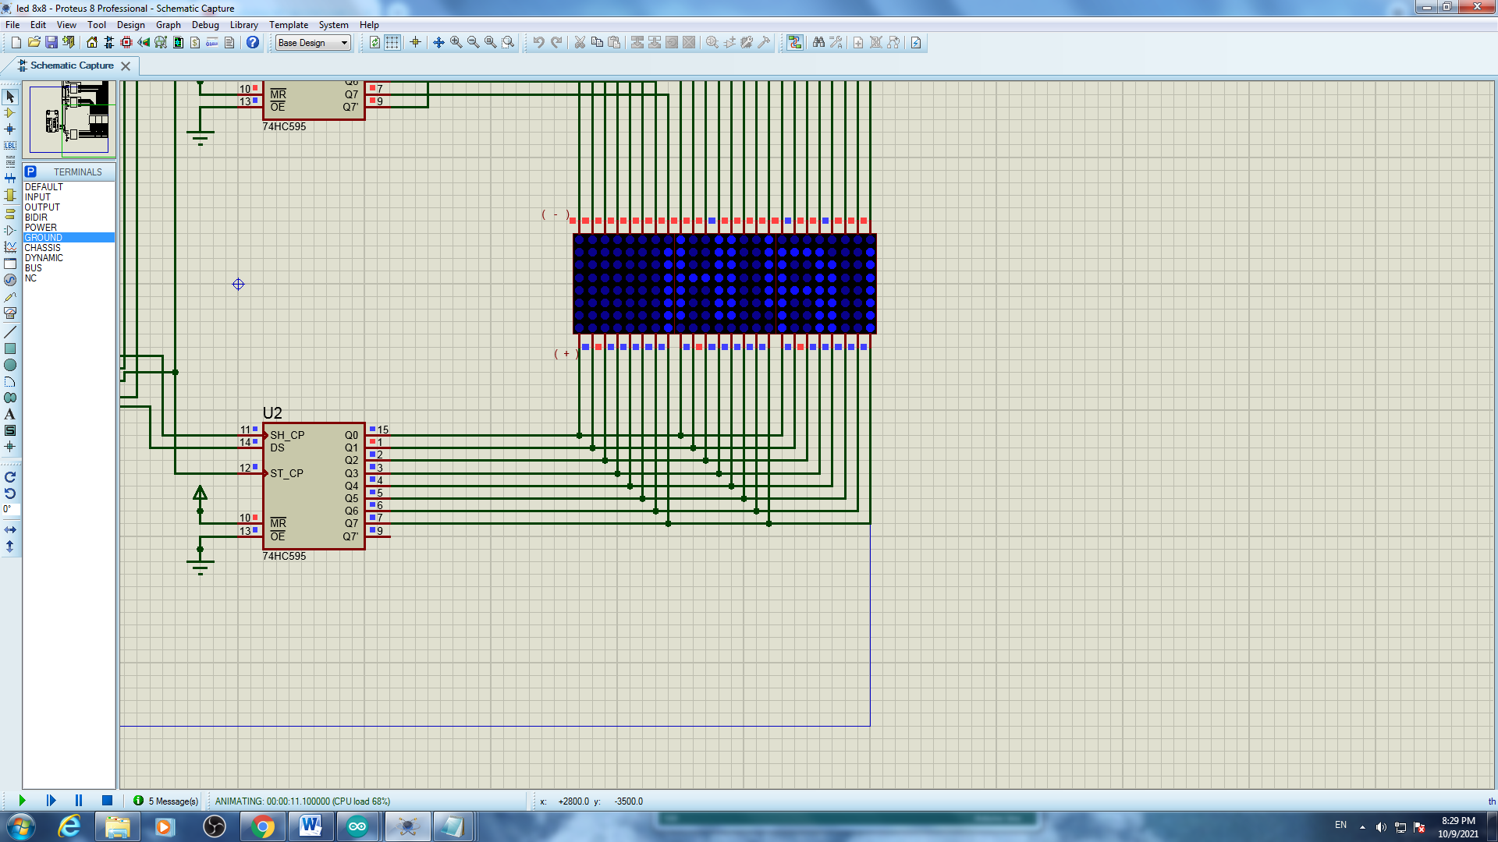

Kết quả

* Kết quả file Test 3

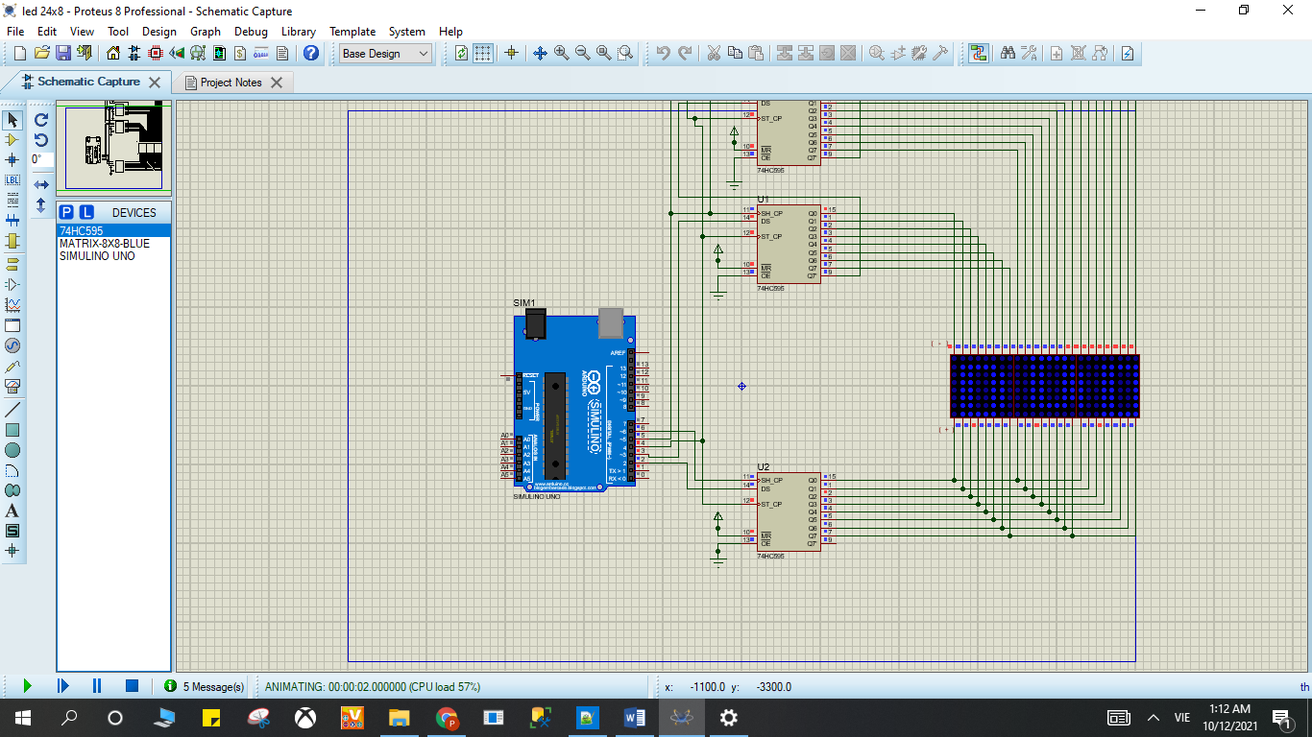

Kết quả

* Kết quả file Test 4

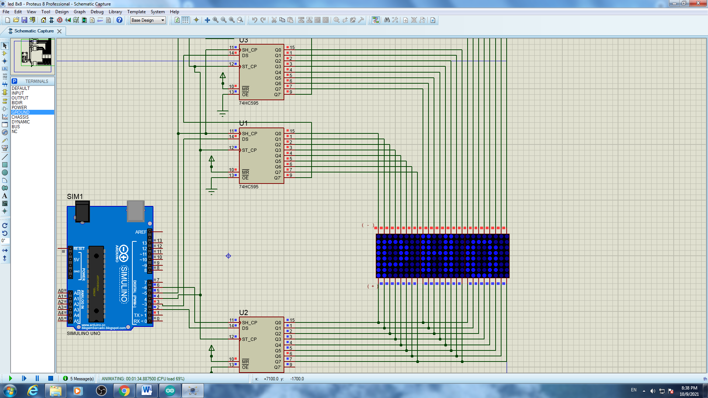

Kết quả

# Bài 10. 8 LED

## Mô tả

* Bài này thực hiện điều khiển 2 motor A và B quay từ trái sang phải rồi đổi chiều ngược lại

điều chỉnh 2 motor chạy ở mức độ tối đa 255

hoãn 1 giây, sau đó

điều chỉnh motor A chạy tốc độ từ 0 đến maximum rồi châm dần lại về 0 hoãn 1 giây sau đó tiếp tục vòng lặp

## Sơ đồ mạch

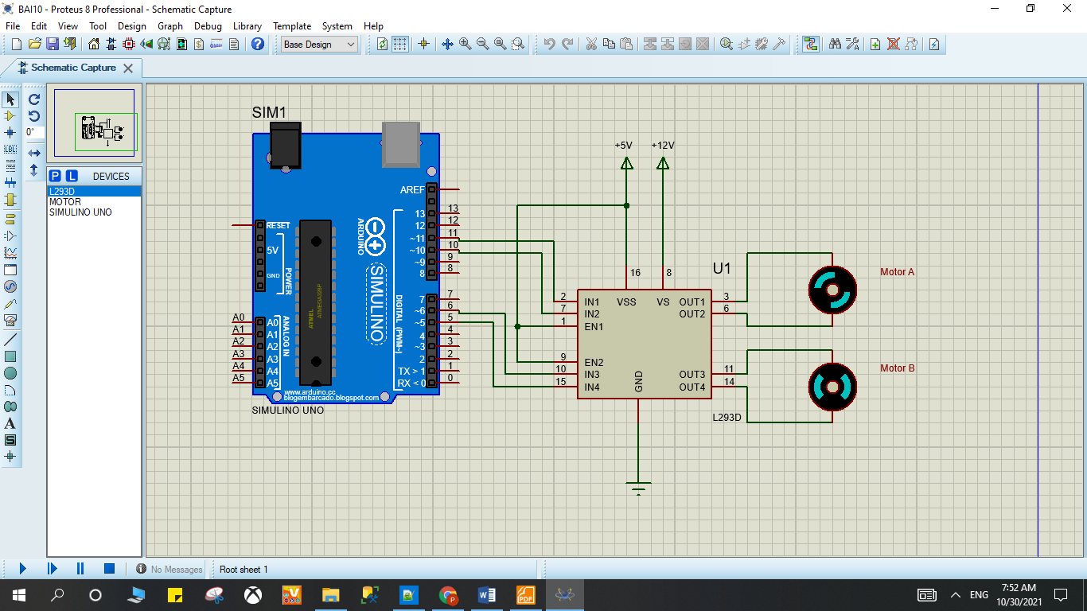

Sơ đồ kết nối của hệ thống 10

## Linh kiện

#### 1 mạch Arduino Uno

#### 2 Motor

#### 1 IC L293D

## Code chương trình

|  |
| --- |
| int A = 9;  int B = 3;  void setup()  {  pinMode(11, OUTPUT);  pinMode(10, OUTPUT);  pinMode(6, OUTPUT);  pinMode(5, OUTPUT);  pinMode(9, OUTPUT);  pinMode(3, OUTPUT);  digitalWrite(11, LOW);  digitalWrite(6, LOW);  digitalWrite(10, LOW);  digitalWrite(5, LOW);  }  void di()  {  analogWrite(A, 255);  analogWrite(B, 255);  digitalWrite(11, HIGH);  digitalWrite(6, HIGH);  digitalWrite(10, LOW);  digitalWrite(5, LOW);  delay(2000);    digitalWrite(11, LOW);  digitalWrite(6, LOW);  digitalWrite(10, HIGH);  digitalWrite(5, HIGH);  delay(2000);  digitalWrite(11, LOW);  digitalWrite(6, LOW);  digitalWrite(10, LOW);  digitalWrite(5, LOW);  }  // speed control motor A  void sc()  {  digitalWrite(11, LOW);  digitalWrite(10, HIGH);  for (int i=0;i<256;i++)  {  analogWrite(A,i);  delay(20);  }  for (int i=255;i>=0;--i)  {  analogWrite(A,i);  delay(20);  }  digitalWrite(11, LOW);  digitalWrite(10, LOW);  }  void loop()  {  di();  delay(1000);  sc();  delay(1000);  } |

## Kết quả chạy chương trình

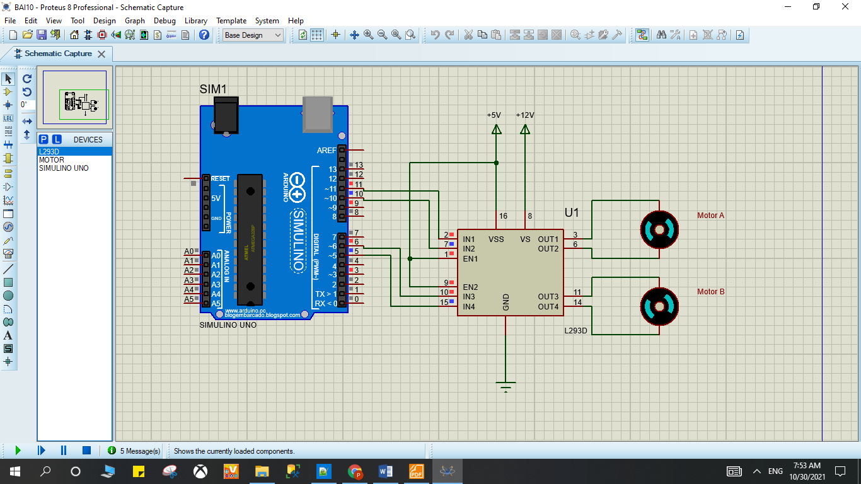

Kết quả

# Phần II. Các bài làm thêm

# Bài 1T. Turn the LED on and off with 2 buttons

## Mô tả

* Bài này thực hiện việc bật/tắt 1 đèn LED bằng 2 button, đèn LED được kết nối vào chân số 13 của board mạch, button thứ 1 trạng thái ON được kết nối vào chân số 3 của board mạch, button thứ trạng thái OFF được kết nối vào chân số 2 của board mạch, khi không bật button nào thì đèn tắt.

## Sơ đồ mạch và kết quả chạy chương trình

## 

Sơ đồ kết nối của hệ thống 11

## Linh kiện

#### 1 mạch Arduino Uno

#### 1 đèn LED-RED

#### 1 điện trở 220V

#### 2 Button

## Code chương trình

|  |
| --- |
| #define ON 3  #define OFF 2  #define led 13  // setup  void setup() {  pinMode(ON, INPUT_PULLUP);  pinMode(OFF, INPUT_PULLUP);  pinMode(led,OUTPUT);  }  void loop()  {  if(digitalRead(ON)==0){digitalWrite(led,1);}  if(digitalRead(OFF)==0){digitalWrite(led,0);}  } |

# **Bài 2T. Fire alarm system**

## Mô tả

* Bài này thực hiện việc báo động lên màn hình LCD chữ ‘Lua Chay’ khi có cháy xảy ra và hiển thị ‘An Toan’ khi lửa tắt, mô phỏng xảy ra cháy bằng cách bật tắt logictoggle.

## Sơ đồ mạch

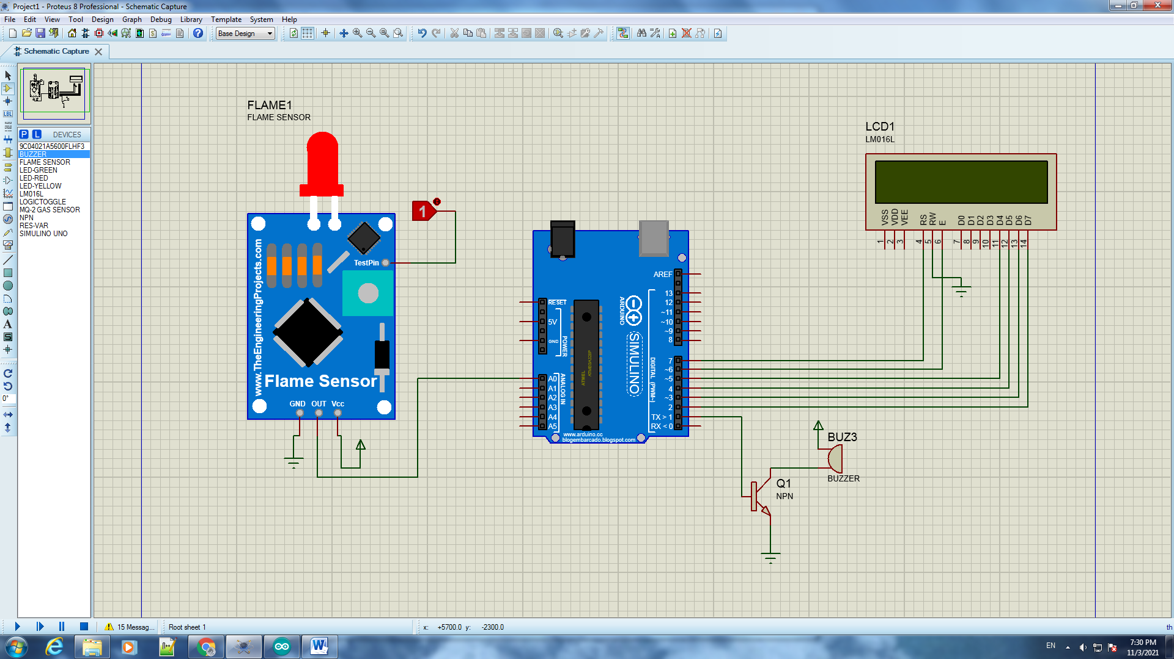

Sơ đồ kết nối của hệ thống 12

## Linh kiện

#### 1 mạch Arduino Uno

#### 1 Màn hình LCD LM016L

* 1 Logictoggle switch
* 1 Flame Sensor
* 1 DC operated buzzer điện trở 5V và tần số phát âm thanh 500Hz

## Code chương trình

|  |
| --- |
| #include <LiquidCrystal.h>  LiquidCrystal lcd(7, 6, 5, 4, 3, 2);  #define FlamePin A0  #define buzzer 1  void setup() {  lcd.begin(16, 2);  pinMode(FlamePin, INPUT_PULLUP);  pinMode(buzzer, OUTPUT);  }  void loop() {  int Flame = digitalRead(FlamePin);  if(Flame==HIGH)  {  digitalWrite(buzzer, HIGH);  lcd.setCursor(5, 0);  lcd.print("Lua");  lcd.setCursor(3, 1);  lcd.print("Chay");  delay(200);  lcd.clear();  delay(200);    }  else  {  digitalWrite(buzzer, LOW);  lcd.setCursor(5, 0);  lcd.print("An");  lcd.setCursor(3, 1);  lcd.print("Toan");  delay(1000);  lcd.clear();  }  } |

## Kết quả chạy chương trình

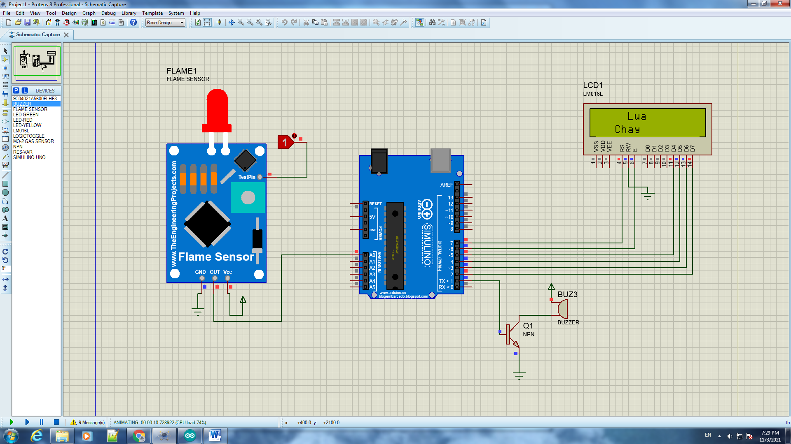

Kết quả Khi có lửa cháy

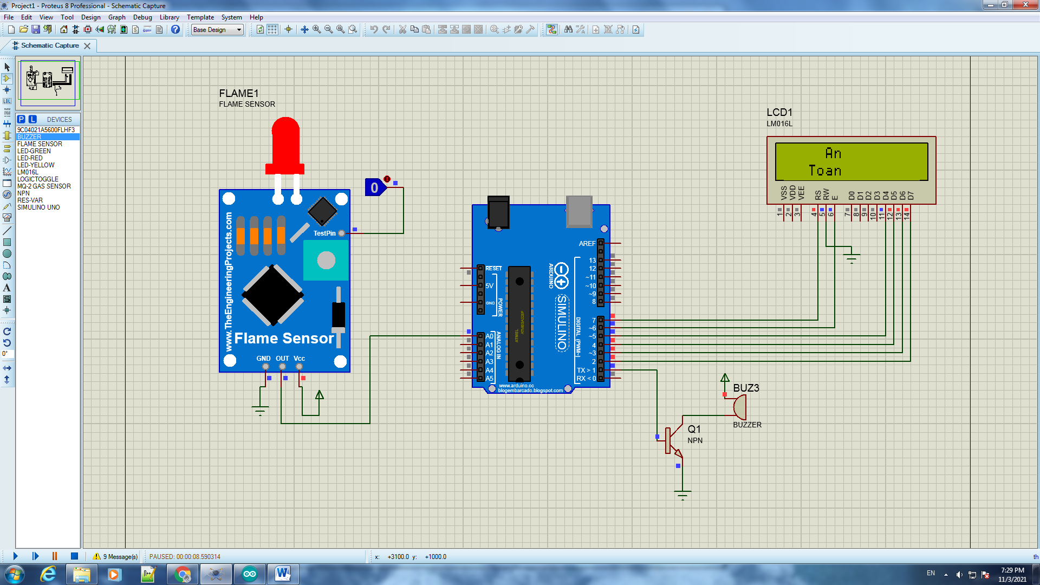

Kết quả Khi lửa tắt

# **Bài 3T. Gas leak alarm system**

## Mô tả

* Bài này thực hiện việc báo động lên màn hình LCD chữ ‘GAS RÒ RỈ’ khi cảm biến có khí gas rò rỉ ra xung quanh và hiển thị ‘An Toan’ khi cảm biến không còn phát hiện khí gas rò rỉ ra xung quanh, mô phỏng xảy ra rò rỉ gas bằng cách bật tắt logictoggle.

## Sơ đồ mạch

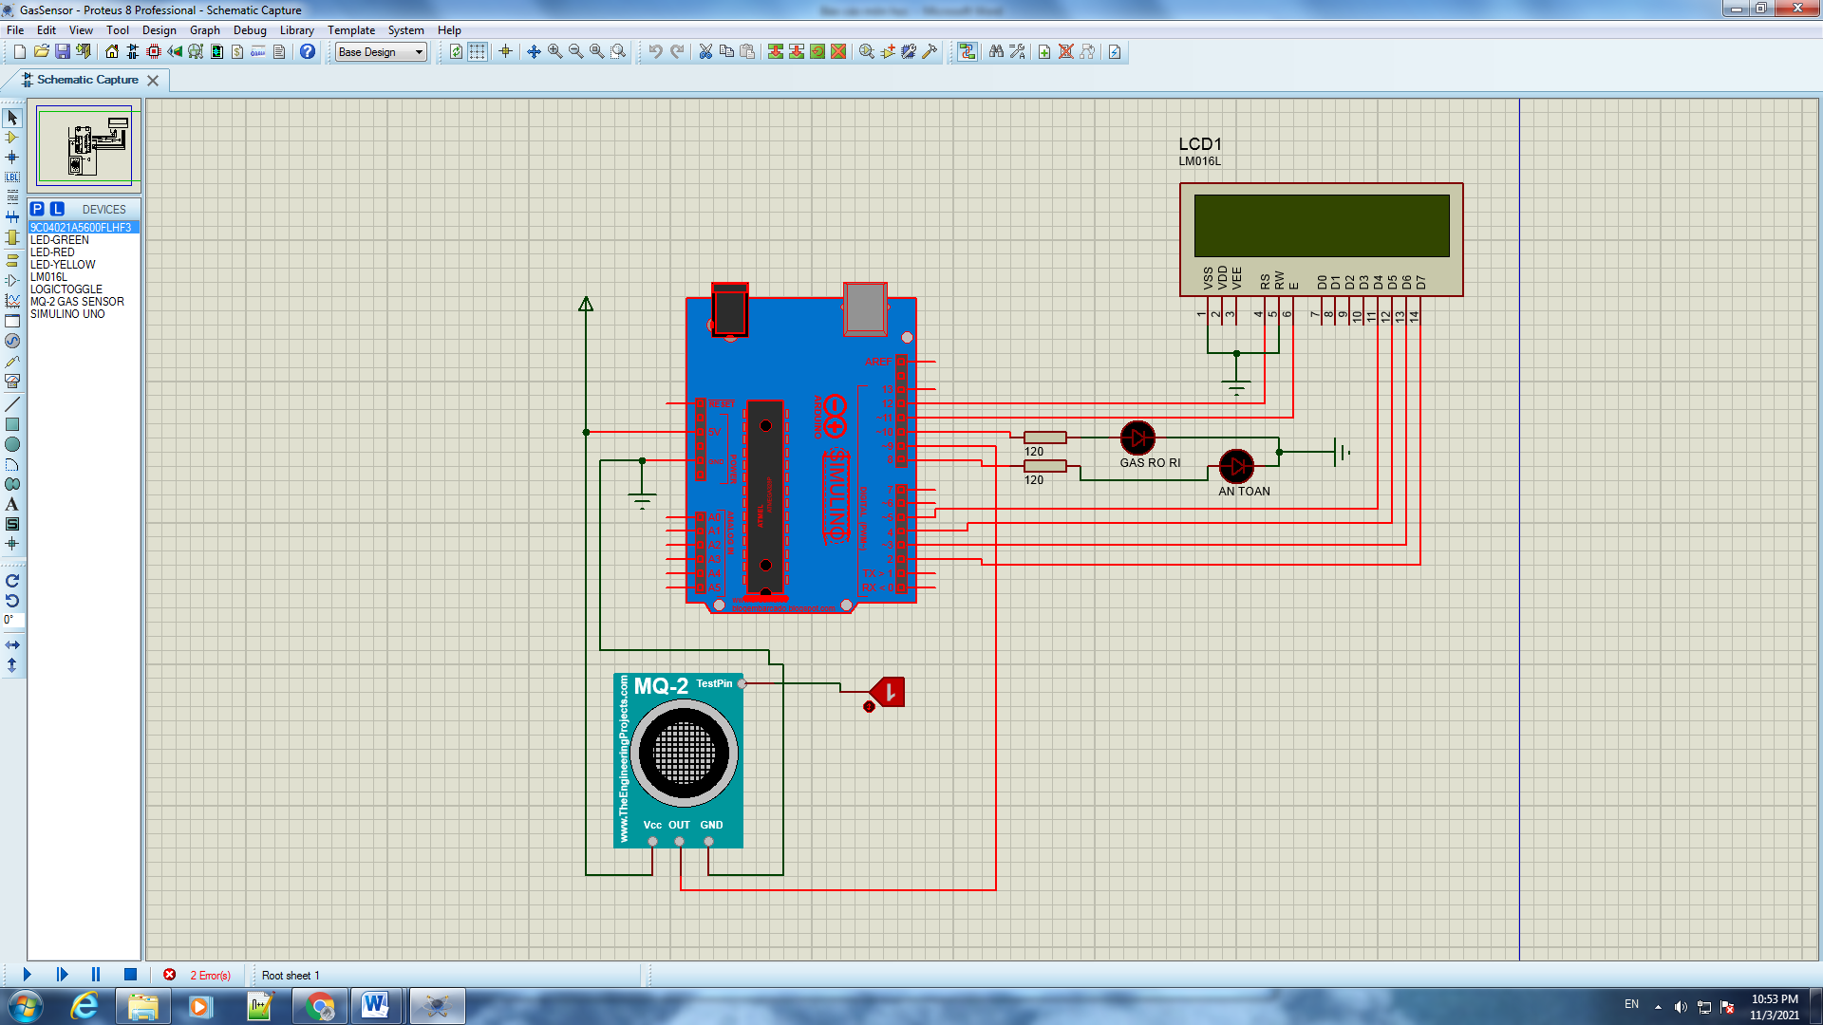

Sơ đồ kết nối của hệ thống 13

## Linh kiện

#### 1 mạch Arduino Uno

#### 1 Màn hình LCD LM016L

* 1 Logictoggle switch
* 1 MQ-2 GAS Sensor
* 2 đèn LED màu đỏ và vàng
* 2 điện trở 120Ω

## Code chương trình

|  |
| --- |
| #include<LiquidCrystal.h>  LiquidCrystal lcd(12 , 11 , 5 ,4 ,3 ,2);  int Gas = 9;  int redLed = 10;  int YLed = 8;  void setup() {  pinMode(Gas , INPUT);    }  void loop() {  if(digitalRead(Gas) == HIGH){  lcd.setCursor(0,0);  lcd.print(" GAS RO RI ");  digitalWrite(10, HIGH);  digitalWrite(8, LOW);  }  else{  lcd.setCursor(0,0);  lcd.print(" AN TOAN ");  digitalWrite(8, HIGH);  digitalWrite(10 ,LOW);  }  delay(500);  lcd.clear();  } |

## Kết quả chạy chương trình

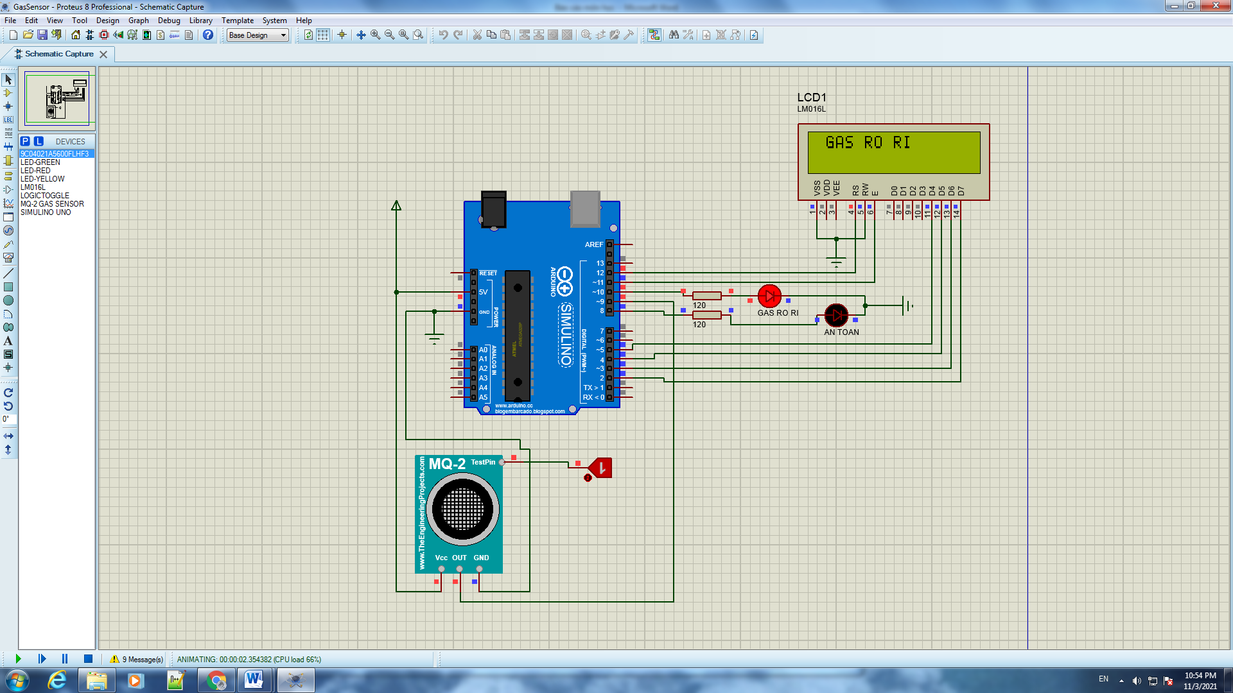

Kết quả khi gas rò rỉ

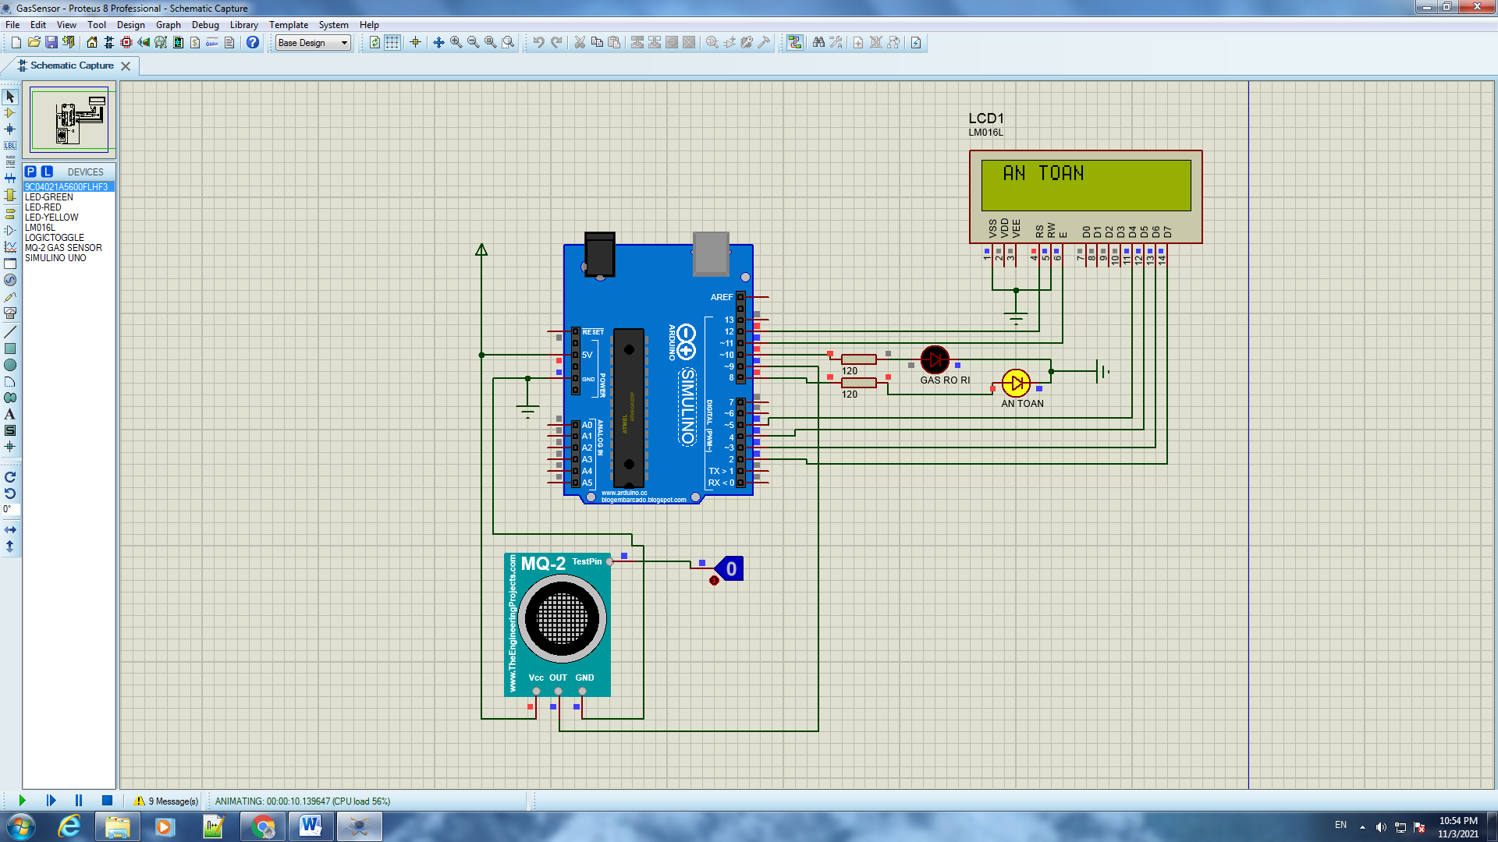

Kết quả không có gas rò rỉ

# **Bài 4T. LED 7 SEGMENT x2 ( CATHODE )**

## Mô tả

* Bài này thực hiện việc
* File test 1: hiển thị từ 00 đến 99 tự động trên màn hình LED 7 SEGMENT x2, việc hiển thị mỗi số cách nhau 0,1 giây
* File test 2: Hiển thị lần lượt các kí tự của tên sinh viên ‘ P H O N G’ lên màn hình LED

## Sơ đồ mạch

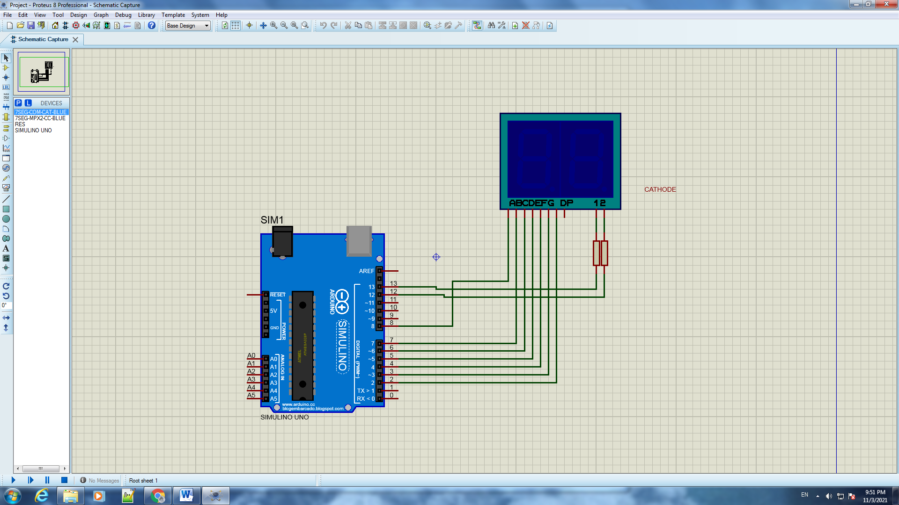

Sơ đồ kết nối của hệ thống 14

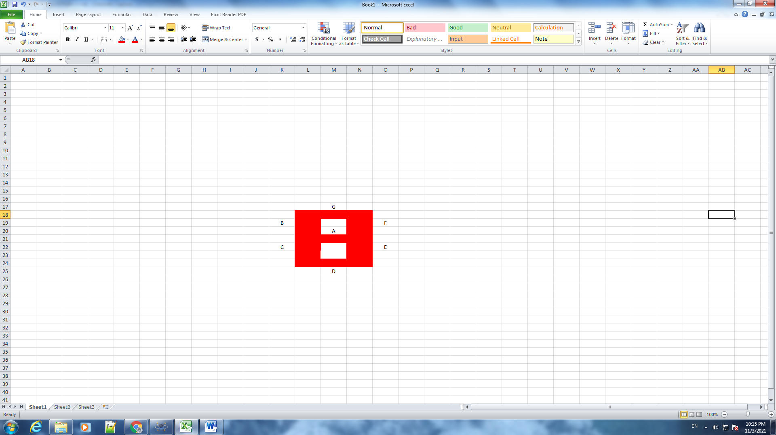

Sơ đồ kết nối của hệ thống 15

## Linh kiện

#### 1 mạch Arduino Uno

#### 1 Bảng 7SEG-MPX2-CC-BLUE (Cathode)

* 2 điện trở 10Ω

## Code chương trình

|  |
| --- |
| // File test 1:  int PIN_A = 2;  int PIN_B = 3;  int PIN_C = 4;  int PIN_D = 5;  int PIN_E = 6;  int PIN_F = 7;  int PIN_G = 8;  int POW_1 = 13;  int POW_2 = 12;  int i = 0;  int j = 0;  int n = 0;  int Arduino_Pins[7] = {PIN_A ,PIN_B, PIN_C, PIN_D, PIN_E, PIN_F, PIN_G};  int Segment_Pins[10][7] = {{0,1,1,1,1,1,1}, // số 0  {0,0,0,0,1,1,0},  {1,0,1,1,0,1,1},  {1,0,0,1,1,1,1},  {1,1,0,0,1,1,0},  {1,1,0,1,1,0,1},  {1,1,1,1,1,0,1},  {0,0,0,0,1,1,1},  {1,1,1,1,1,1,1},  {1,1,0,1,1,1,1}, // số 9  };  void setup() {  pinMode(PIN_A,OUTPUT);  pinMode(PIN_B,OUTPUT);  pinMode(PIN_C,OUTPUT);  pinMode(PIN_D,OUTPUT);  pinMode(PIN_E,OUTPUT);  pinMode(PIN_F,OUTPUT);  pinMode(PIN_G,OUTPUT);  pinMode(POW_1,OUTPUT);  pinMode(POW_2,OUTPUT);  }  void loop() {  for(i=0;i<10;i++){  digitalWrite(POW_1,0);  digitalWrite(POW_2,1);  for(j=0;j<7;j++){  digitalWrite(Arduino_Pins[j],Segment_Pins[n][j]);  }  delay(100);  digitalWrite(POW_1,1);  digitalWrite(POW_2,0);  for(j=0;j<7;j++){  digitalWrite(Arduino_Pins[j],Segment_Pins[i][j]);  }  delay(100);  if(i==9){  n++;  if(n>9){  n = 0;  }  }  }  }  //File Test 2:  int PIN_A = 2;  int PIN_B = 3;  int PIN_C = 4;  int PIN_D = 5;  int PIN_E = 6;  int PIN_F = 7;  int PIN_G = 8;  int POW_1 = 13;  int POW_2 = 12;  int i = 0;  int j = 0;  int n = 0;  int Arduino_Pins[7] = {PIN_A ,PIN_B, PIN_C, PIN_D, PIN_E, PIN_F, PIN_G};  int Segment_Pins[5][7] = {{1,1,1,0,0,1,1}, // chữ P  {1,1,1,0,1,1,0}, // CHỮ h  {0,1,1,1,1,1,1}, // chữ o  {0,1,1,0,1,1,1}, // chữ n  {0,1,1,1,1,0,1},// chữ g  };  void setup() {  pinMode(PIN_A,OUTPUT);  pinMode(PIN_B,OUTPUT);  pinMode(PIN_C,OUTPUT);  pinMode(PIN_D,OUTPUT);  pinMode(PIN_E,OUTPUT);  pinMode(PIN_F,OUTPUT);  pinMode(PIN_G,OUTPUT);  pinMode(POW_1,OUTPUT);  pinMode(POW_2,OUTPUT);  }  void loop() {  for(i=0;i<5;i++){  digitalWrite(POW_1,1);  digitalWrite(POW_2,0);  for(j=0;j<7;j++){  digitalWrite(Arduino_Pins[j],Segment_Pins[i][j]);  }  delay(500);  }  } |

## Kết quả chạy chương trình

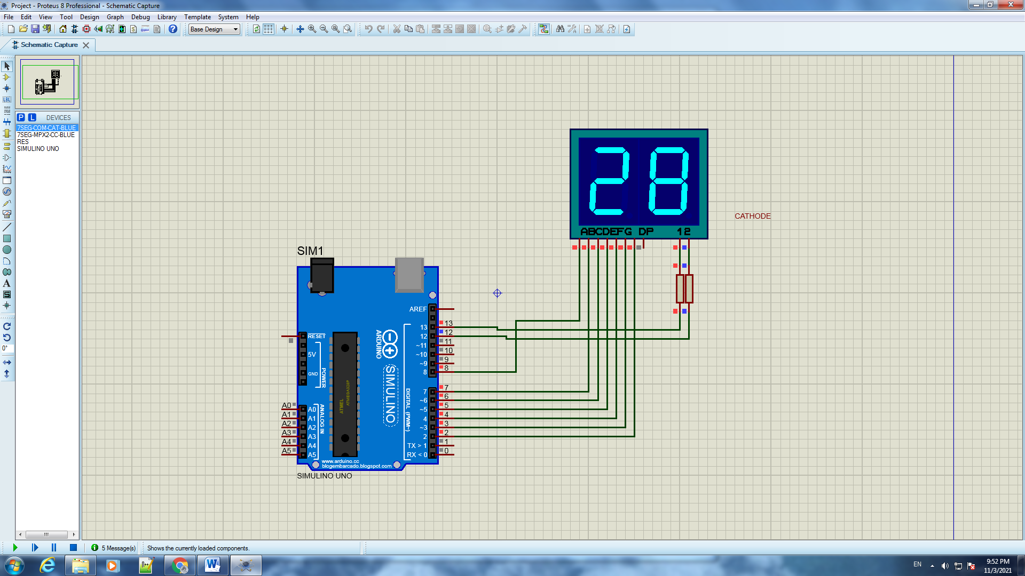

Kết quả .chạy file test 1

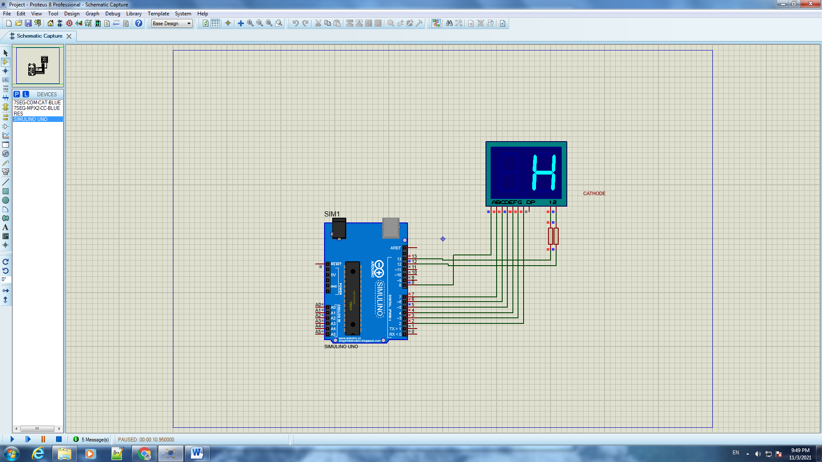

Kết quả chạy file test 2

# Phần III. Lập trình Nhúng nâng cao – giao tiếp GPIO

# Bài 1. Sequential light up 4 LEDs

## Mô tả

* Lập trình giao tiếp GPIO Sử dụng kit STM32F407VE Nguồn sung :HSI - 16MHz

Chương trình thực hiện việc làm sáng mô hình LED từ trên xuống dưới, các đèn LED kết nối với các cổng POD12,POD13,POD14,POD15 , các đèn D5, D6 , D7 sáng trong 0,5 giây, đèn D8 sáng trong 1,5 giây và lặp lại.

## Linh kiện

* 1 kit STM32F401VE
* 4 Điện trở 150Ω
* 4 đèn LED khác màu

## Sơ đồ mạch

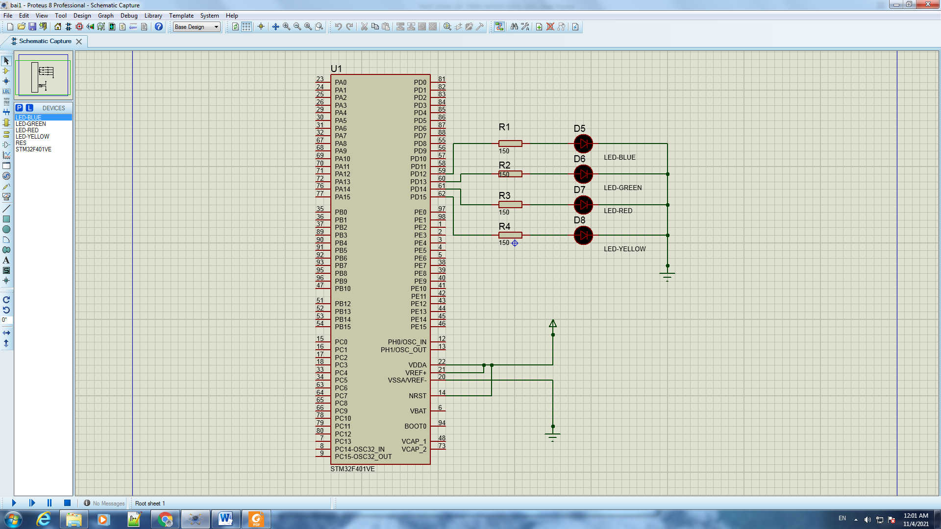

Sơ đồ kết nối của hệ thống 16

## Code chương trình

|  |
| --- |
| #include "main.h"  WWDG_HandleTypeDef hwwdg;  void SystemClock_Config(void);  static void MX_GPIO_Init(void);  int main(void)  {  HAL_Init();  SystemClock_Config();  MX_GPIO_Init();  while (1)  {  HAL_GPIO_TogglePin(GPIOD, GPIO_PIN_12);  HAL_Delay(500);  HAL_GPIO_TogglePin(GPIOD, GPIO_PIN_13);  HAL_Delay(500);  HAL_GPIO_TogglePin(GPIOD, GPIO_PIN_14);  HAL_Delay(500);  HAL_GPIO_TogglePin(GPIOD, GPIO_PIN_15);  HAL_Delay(1500);  }  /* USER CODE END 3 */  }  /**  * @brief System Clock Configuration  * @retval None  */  void SystemClock_Config(void)  {  RCC_OscInitTypeDef RCC_OscInitStruct = {0};  RCC_ClkInitTypeDef RCC_ClkInitStruct = {0};  /** Configure the main internal regulator output voltage  */  __HAL_RCC_PWR_CLK_ENABLE();  __HAL_PWR_VOLTAGESCALING_CONFIG(PWR_REGULATOR_VOLTAGE_SCALE1);  /** Initializes the RCC Oscillators according to the specified parameters  * in the RCC_OscInitTypeDef structure.  */  RCC_OscInitStruct.OscillatorType = RCC_OSCILLATORTYPE_HSI;  RCC_OscInitStruct.HSIState = RCC_HSI_ON;  RCC_OscInitStruct.HSICalibrationValue = RCC_HSICALIBRATION_DEFAULT;  RCC_OscInitStruct.PLL.PLLState = RCC_PLL_NONE;  if (HAL_RCC_OscConfig(&RCC_OscInitStruct) != HAL_OK)  {  Error_Handler();  }  /** Initializes the CPU, AHB and APB buses clocks  */  RCC_ClkInitStruct.ClockType = RCC_CLOCKTYPE_HCLK|RCC_CLOCKTYPE_SYSCLK  |RCC_CLOCKTYPE_PCLK1|RCC_CLOCKTYPE_PCLK2;  RCC_ClkInitStruct.SYSCLKSource = RCC_SYSCLKSOURCE_HSI;  RCC_ClkInitStruct.AHBCLKDivider = RCC_SYSCLK_DIV2;  RCC_ClkInitStruct.APB1CLKDivider = RCC_HCLK_DIV1;  RCC_ClkInitStruct.APB2CLKDivider = RCC_HCLK_DIV1;  if (HAL_RCC_ClockConfig(&RCC_ClkInitStruct, FLASH_LATENCY_0) != HAL_OK)  {  Error_Handler();  }  }  static void MX_GPIO_Init(void)  {  GPIO_InitTypeDef GPIO_InitStruct = {0};  /* GPIO Ports Clock Enable */  __HAL_RCC_GPIOH_CLK_ENABLE();  __HAL_RCC_GPIOD_CLK_ENABLE();  /*Configure GPIO pin Output Level */  HAL_GPIO_WritePin(GPIOD, GPIO_PIN_12|GPIO_PIN_13|GPIO_PIN_14|GPIO_PIN_15, GPIO_PIN_RESET);  /*Configure GPIO pins : PD12 PD13 PD14 PD15 */  GPIO_InitStruct.Pin = GPIO_PIN_12|GPIO_PIN_13|GPIO_PIN_14|GPIO_PIN_15;  GPIO_InitStruct.Mode = GPIO_MODE_OUTPUT_PP;  GPIO_InitStruct.Pull = GPIO_NOPULL;  GPIO_InitStruct.Speed = GPIO_SPEED_FREQ_HIGH;  HAL_GPIO_Init(GPIOD, &GPIO_InitStruct);  }  void Error_Handler(void)  {  }  #ifdef USE_FULL_ASSERT  void assert_failed(uint8_t *file, uint32_t line)  {  }  #endif |

## Kết quả chạy chương trình

# Bài 2. LED HEART

## Mô tả

* Lập trình giao tiếp GPIO Sử dụng kit STM32F407VE Nguồn sung :HSI - 8MHz

Chương trình thực hiện việc làm sáng mô hình LED hình trái tim với các thứ tự:

Chớp nháy 2 lần, sáng lần lượt theo kim đồng hồ rồi tắt tất cả, chờ 1 giây thực

hiện tiếp việc sáng tắt lần lượt ở các vị trí LED chẵn có khoảng cách nhau là 2,

chờ 2 giây, chớp nháy 2 lần rồi chờ 1,5 giây xong sáng theo vị trí chẵn theo chiều kim đồng hồ

và theo vị trí lẻ theo ngược chiều kim đồng hồ, chờ 1,5 giây rồi mô hình chớp nháy 1 lần

sau khi chờ 1 giây sẽ sáng theo đường chéo của mô hình rồi hoãn 1 giây, sau đó sáng lần lượt nửa

trên và nửa dưới trái tim kết hợp chớp nháy rồi thực hiện sáng chéo rồi tiếp tục vòng lặp

## Sơ đồ mạch

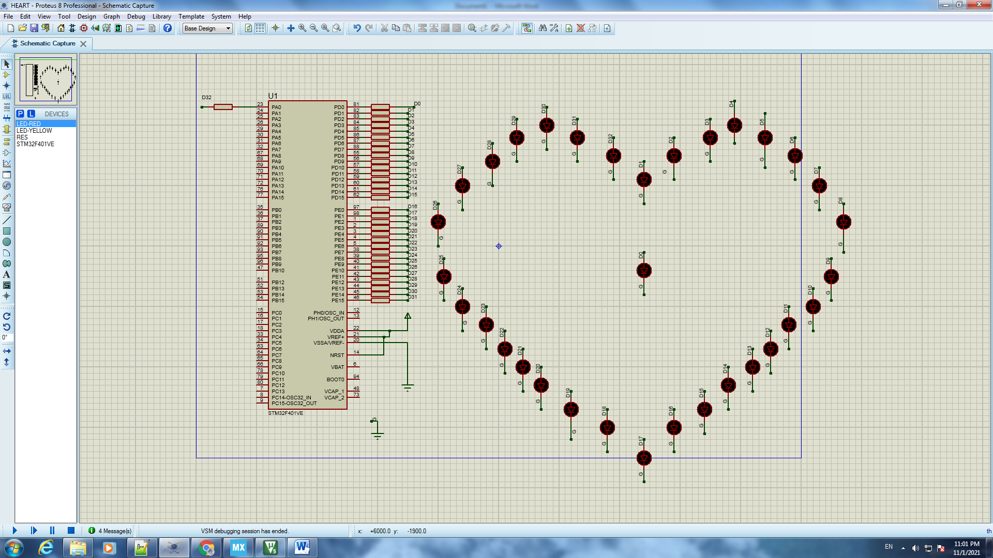

Sơ đồ kết nối của hệ thống 17

## Linh kiện

* 1 kit STM32F401VE
* 32 Điện trở 150Ω
* 32 đèn LED-RED

## Code chương trình

|  |
| --- |
| // Hàm main  #include "main.h"  void SystemClock_Config(void);  static void MX_GPIO_Init(void);  void sangall();  void tatall();  void sangll(); //sáng lan luot  void sangtatll(); //sáng tat lan luot  void chopnhay2lan();  void chopnhay();  void sang2ben();  void sangdacbiet();  void sangmotnua();  int main(void)  {  HAL_Init();  SystemClock_Config();  MX_GPIO_Init();    while (1)  {  chopnhay2lan();  sangll();  tatall();  HAL_Delay(1000);  sangtatll();  HAL_Delay(2000);  chopnhay2lan();  HAL_Delay(1500);  sang2ben();  HAL_Delay(1500);  chopnhay();  HAL_Delay(1000);  sangdacbiet();  sangmotnua();  }  }  void sangall(){  HAL_GPIO_WritePin (GPIOD, GPIO_PIN_0, GPIO_PIN_SET); // Led D1  HAL_GPIO_WritePin (GPIOD, GPIO_PIN_1, GPIO_PIN_SET);  HAL_GPIO_WritePin (GPIOD, GPIO_PIN_2, GPIO_PIN_SET);  HAL_GPIO_WritePin (GPIOD, GPIO_PIN_3, GPIO_PIN_SET);  HAL_GPIO_WritePin (GPIOD, GPIO_PIN_4, GPIO_PIN_SET);  HAL_GPIO_WritePin (GPIOD, GPIO_PIN_5, GPIO_PIN_SET);  HAL_GPIO_WritePin (GPIOD, GPIO_PIN_6, GPIO_PIN_SET);  HAL_GPIO_WritePin (GPIOD, GPIO_PIN_7, GPIO_PIN_SET);  HAL_GPIO_WritePin (GPIOD, GPIO_PIN_8, GPIO_PIN_SET);  HAL_GPIO_WritePin (GPIOD, GPIO_PIN_9, GPIO_PIN_SET);  HAL_GPIO_WritePin (GPIOD, GPIO_PIN_10, GPIO_PIN_SET);  HAL_GPIO_WritePin (GPIOD, GPIO_PIN_11, GPIO_PIN_SET);  HAL_GPIO_WritePin (GPIOD, GPIO_PIN_12, GPIO_PIN_SET);  HAL_GPIO_WritePin (GPIOD, GPIO_PIN_13, GPIO_PIN_SET);  HAL_GPIO_WritePin (GPIOD, GPIO_PIN_14, GPIO_PIN_SET);  HAL_GPIO_WritePin (GPIOD, GPIO_PIN_15, GPIO_PIN_SET);  HAL_GPIO_WritePin (GPIOE, GPIO_PIN_0, GPIO_PIN_SET);  HAL_GPIO_WritePin (GPIOE, GPIO_PIN_1, GPIO_PIN_SET);  HAL_GPIO_WritePin (GPIOE, GPIO_PIN_2, GPIO_PIN_SET);  HAL_GPIO_WritePin (GPIOE, GPIO_PIN_3, GPIO_PIN_SET);  HAL_GPIO_WritePin (GPIOE, GPIO_PIN_4, GPIO_PIN_SET);  HAL_GPIO_WritePin (GPIOE, GPIO_PIN_5, GPIO_PIN_SET);  HAL_GPIO_WritePin (GPIOE, GPIO_PIN_6, GPIO_PIN_SET);  HAL_GPIO_WritePin (GPIOE, GPIO_PIN_7, GPIO_PIN_SET);  HAL_GPIO_WritePin (GPIOE, GPIO_PIN_8, GPIO_PIN_SET);  HAL_GPIO_WritePin (GPIOE, GPIO_PIN_9, GPIO_PIN_SET);  HAL_GPIO_WritePin (GPIOE, GPIO_PIN_10, GPIO_PIN_SET);  HAL_GPIO_WritePin (GPIOE, GPIO_PIN_11, GPIO_PIN_SET);  HAL_GPIO_WritePin (GPIOE, GPIO_PIN_12, GPIO_PIN_SET);  HAL_GPIO_WritePin (GPIOE, GPIO_PIN_13, GPIO_PIN_SET);  HAL_GPIO_WritePin (GPIOE, GPIO_PIN_14, GPIO_PIN_SET);  HAL_GPIO_WritePin (GPIOE, GPIO_PIN_15, GPIO_PIN_SET);    HAL_GPIO_WritePin (GPIOA, GPIO_PIN_0, GPIO_PIN_SET);  }  void tatall(){  HAL_GPIO_WritePin (GPIOD, GPIO_PIN_0, GPIO_PIN_SET);  HAL_GPIO_WritePin (GPIOD, GPIO_PIN_1, GPIO_PIN_RESET);  HAL_GPIO_WritePin (GPIOD, GPIO_PIN_2, GPIO_PIN_RESET);  HAL_GPIO_WritePin (GPIOD, GPIO_PIN_3, GPIO_PIN_RESET);  HAL_GPIO_WritePin (GPIOD, GPIO_PIN_4, GPIO_PIN_RESET);  HAL_GPIO_WritePin (GPIOD, GPIO_PIN_5, GPIO_PIN_RESET);  HAL_GPIO_WritePin (GPIOD, GPIO_PIN_6, GPIO_PIN_RESET);  HAL_GPIO_WritePin (GPIOD, GPIO_PIN_7, GPIO_PIN_RESET);  HAL_GPIO_WritePin (GPIOD, GPIO_PIN_8, GPIO_PIN_RESET);  HAL_GPIO_WritePin (GPIOD, GPIO_PIN_9, GPIO_PIN_RESET);  HAL_GPIO_WritePin (GPIOD, GPIO_PIN_10, GPIO_PIN_RESET);  HAL_GPIO_WritePin (GPIOD, GPIO_PIN_11, GPIO_PIN_RESET);  HAL_GPIO_WritePin (GPIOD, GPIO_PIN_12, GPIO_PIN_RESET);  HAL_GPIO_WritePin (GPIOD, GPIO_PIN_13, GPIO_PIN_RESET);  HAL_GPIO_WritePin (GPIOD, GPIO_PIN_14, GPIO_PIN_RESET);  HAL_GPIO_WritePin (GPIOD, GPIO_PIN_15, GPIO_PIN_RESET);    HAL_GPIO_WritePin (GPIOE, GPIO_PIN_0, GPIO_PIN_RESET);  HAL_GPIO_WritePin (GPIOE, GPIO_PIN_1, GPIO_PIN_RESET);  HAL_GPIO_WritePin (GPIOE, GPIO_PIN_2, GPIO_PIN_RESET);  HAL_GPIO_WritePin (GPIOE, GPIO_PIN_3, GPIO_PIN_RESET);  HAL_GPIO_WritePin (GPIOE, GPIO_PIN_4, GPIO_PIN_RESET);  HAL_GPIO_WritePin (GPIOE, GPIO_PIN_5, GPIO_PIN_RESET);  HAL_GPIO_WritePin (GPIOE, GPIO_PIN_6, GPIO_PIN_RESET);  HAL_GPIO_WritePin (GPIOE, GPIO_PIN_7, GPIO_PIN_RESET);  HAL_GPIO_WritePin (GPIOE, GPIO_PIN_8, GPIO_PIN_RESET);  HAL_GPIO_WritePin (GPIOE, GPIO_PIN_9, GPIO_PIN_RESET);  HAL_GPIO_WritePin (GPIOE, GPIO_PIN_10, GPIO_PIN_RESET);  HAL_GPIO_WritePin (GPIOE, GPIO_PIN_11, GPIO_PIN_RESET);  HAL_GPIO_WritePin (GPIOE, GPIO_PIN_12, GPIO_PIN_RESET);  HAL_GPIO_WritePin (GPIOE, GPIO_PIN_13, GPIO_PIN_RESET);  HAL_GPIO_WritePin (GPIOE, GPIO_PIN_14, GPIO_PIN_RESET);  HAL_GPIO_WritePin (GPIOE, GPIO_PIN_15, GPIO_PIN_RESET);    HAL_GPIO_WritePin (GPIOA, GPIO_PIN_0, GPIO_PIN_RESET);  }  void sangll(){  HAL_GPIO_WritePin (GPIOD, GPIO_PIN_0, GPIO_PIN_SET);  HAL_Delay(100);  HAL_GPIO_WritePin (GPIOD, GPIO_PIN_1, GPIO_PIN_SET);  HAL_Delay(100);  HAL_GPIO_WritePin (GPIOD, GPIO_PIN_2, GPIO_PIN_SET);  HAL_Delay(100);  HAL_GPIO_WritePin (GPIOD, GPIO_PIN_3, GPIO_PIN_SET);  HAL_Delay(100);  HAL_GPIO_WritePin (GPIOD, GPIO_PIN_4, GPIO_PIN_SET);  HAL_Delay(100);  HAL_GPIO_WritePin (GPIOD, GPIO_PIN_5, GPIO_PIN_SET);  HAL_Delay(100);  HAL_GPIO_WritePin (GPIOD, GPIO_PIN_6, GPIO_PIN_SET);  HAL_Delay(100);  HAL_GPIO_WritePin (GPIOD, GPIO_PIN_7, GPIO_PIN_SET);  HAL_Delay(100);  HAL_GPIO_WritePin (GPIOD, GPIO_PIN_8, GPIO_PIN_SET);  HAL_Delay(100);  HAL_GPIO_WritePin (GPIOD, GPIO_PIN_9, GPIO_PIN_SET);  HAL_Delay(100);  HAL_GPIO_WritePin (GPIOD, GPIO_PIN_10, GPIO_PIN_SET);  HAL_Delay(100);  HAL_GPIO_WritePin (GPIOD, GPIO_PIN_11, GPIO_PIN_SET);  HAL_Delay(100);  HAL_GPIO_WritePin (GPIOD, GPIO_PIN_12, GPIO_PIN_SET);  HAL_Delay(100);  HAL_GPIO_WritePin (GPIOD, GPIO_PIN_13, GPIO_PIN_SET);  HAL_Delay(100);  HAL_GPIO_WritePin (GPIOD, GPIO_PIN_14, GPIO_PIN_SET);  HAL_Delay(100);  HAL_GPIO_WritePin (GPIOD, GPIO_PIN_15, GPIO_PIN_SET);  HAL_Delay(100);    HAL_GPIO_WritePin (GPIOE, GPIO_PIN_0, GPIO_PIN_SET);  HAL_Delay(100);  HAL_GPIO_WritePin (GPIOE, GPIO_PIN_1, GPIO_PIN_SET);  HAL_Delay(100);  HAL_GPIO_WritePin (GPIOE, GPIO_PIN_2, GPIO_PIN_SET);  HAL_Delay(100);  HAL_GPIO_WritePin (GPIOE, GPIO_PIN_3, GPIO_PIN_SET);  HAL_Delay(100);  HAL_GPIO_WritePin (GPIOE, GPIO_PIN_4, GPIO_PIN_SET);  HAL_Delay(100);  HAL_GPIO_WritePin (GPIOE, GPIO_PIN_5, GPIO_PIN_SET);  HAL_Delay(100);  HAL_GPIO_WritePin (GPIOE, GPIO_PIN_6, GPIO_PIN_SET);  HAL_Delay(100);  HAL_GPIO_WritePin (GPIOE, GPIO_PIN_7, GPIO_PIN_SET);  HAL_Delay(100);  HAL_GPIO_WritePin (GPIOE, GPIO_PIN_8, GPIO_PIN_SET);  HAL_Delay(100);  HAL_GPIO_WritePin (GPIOE, GPIO_PIN_9, GPIO_PIN_SET);  HAL_Delay(100);  HAL_GPIO_WritePin (GPIOE, GPIO_PIN_10, GPIO_PIN_SET);  HAL_Delay(100);  HAL_GPIO_WritePin (GPIOE, GPIO_PIN_11, GPIO_PIN_SET);  HAL_Delay(100);  HAL_GPIO_WritePin (GPIOE, GPIO_PIN_12, GPIO_PIN_SET);  HAL_Delay(100);  HAL_GPIO_WritePin (GPIOE, GPIO_PIN_13, GPIO_PIN_SET);  HAL_Delay(100);  HAL_GPIO_WritePin (GPIOE, GPIO_PIN_14, GPIO_PIN_SET);  HAL_Delay(100);  HAL_GPIO_WritePin (GPIOE, GPIO_PIN_15, GPIO_PIN_SET);  HAL_Delay(100);  HAL_GPIO_WritePin (GPIOA, GPIO_PIN_0, GPIO_PIN_SET);  HAL_Delay(100);  }  void sangtatll(){  HAL_GPIO_WritePin (GPIOD, GPIO_PIN_0, GPIO_PIN_SET);  HAL_Delay(1000);  HAL_GPIO_WritePin (GPIOD, GPIO_PIN_0, GPIO_PIN_RESET);      HAL_GPIO_WritePin (GPIOD, GPIO_PIN_2, GPIO_PIN_SET);  HAL_Delay(1000);  HAL_GPIO_WritePin (GPIOD, GPIO_PIN_2, GPIO_PIN_RESET);  HAL_GPIO_WritePin (GPIOD, GPIO_PIN_4, GPIO_PIN_SET);  HAL_Delay(1000);  HAL_GPIO_WritePin (GPIOD, GPIO_PIN_4, GPIO_PIN_RESET);  HAL_GPIO_WritePin (GPIOD, GPIO_PIN_6, GPIO_PIN_SET);  HAL_Delay(1000);  HAL_GPIO_WritePin (GPIOD, GPIO_PIN_6, GPIO_PIN_RESET);  HAL_GPIO_WritePin (GPIOD, GPIO_PIN_8, GPIO_PIN_SET);  HAL_Delay(1000);  HAL_GPIO_WritePin (GPIOD, GPIO_PIN_8, GPIO_PIN_RESET);  HAL_GPIO_WritePin (GPIOD, GPIO_PIN_10, GPIO_PIN_SET);  HAL_Delay(1000);  HAL_GPIO_WritePin (GPIOD, GPIO_PIN_10, GPIO_PIN_RESET);  HAL_GPIO_WritePin (GPIOD, GPIO_PIN_12, GPIO_PIN_SET);  HAL_Delay(1000);  HAL_GPIO_WritePin (GPIOD, GPIO_PIN_12, GPIO_PIN_RESET);  HAL_GPIO_WritePin (GPIOD, GPIO_PIN_14, GPIO_PIN_SET);  HAL_Delay(1000);  HAL_GPIO_WritePin (GPIOD, GPIO_PIN_14, GPIO_PIN_RESET);  HAL_GPIO_WritePin (GPIOE, GPIO_PIN_0, GPIO_PIN_SET);  HAL_Delay(1000);  HAL_GPIO_WritePin (GPIOE, GPIO_PIN_0, GPIO_PIN_RESET);  HAL_GPIO_WritePin (GPIOE, GPIO_PIN_2, GPIO_PIN_SET);  HAL_Delay(1000);  HAL_GPIO_WritePin (GPIOE, GPIO_PIN_2, GPIO_PIN_RESET);  HAL_GPIO_WritePin (GPIOE, GPIO_PIN_4, GPIO_PIN_SET);  HAL_Delay(1000);  HAL_GPIO_WritePin (GPIOE, GPIO_PIN_4, GPIO_PIN_RESET);  HAL_GPIO_WritePin (GPIOE, GPIO_PIN_6, GPIO_PIN_SET);  HAL_Delay(1000);  HAL_GPIO_WritePin (GPIOE, GPIO_PIN_6, GPIO_PIN_RESET);  HAL_GPIO_WritePin (GPIOE, GPIO_PIN_8, GPIO_PIN_SET);  HAL_Delay(1000);  HAL_GPIO_WritePin (GPIOE, GPIO_PIN_8, GPIO_PIN_RESET);  HAL_GPIO_WritePin (GPIOE, GPIO_PIN_10, GPIO_PIN_SET);  HAL_Delay(1000);  HAL_GPIO_WritePin (GPIOE, GPIO_PIN_10, GPIO_PIN_RESET);  HAL_GPIO_WritePin (GPIOE, GPIO_PIN_12, GPIO_PIN_SET);  HAL_Delay(1000);  HAL_GPIO_WritePin (GPIOE, GPIO_PIN_12, GPIO_PIN_RESET);    HAL_GPIO_WritePin (GPIOE, GPIO_PIN_14, GPIO_PIN_SET);  HAL_Delay(1000);  HAL_GPIO_WritePin (GPIOD, GPIO_PIN_14, GPIO_PIN_RESET);    HAL_GPIO_WritePin (GPIOA, GPIO_PIN_0, GPIO_PIN_SET);  HAL_Delay(1000);  HAL_GPIO_WritePin (GPIOA, GPIO_PIN_0, GPIO_PIN_RESET);  }  void sang2ben(){  HAL_GPIO_WritePin (GPIOD, GPIO_PIN_0, GPIO_PIN_SET);  HAL_GPIO_WritePin (GPIOE, GPIO_PIN_15, GPIO_PIN_SET);  HAL_Delay(1000);  HAL_GPIO_WritePin (GPIOE, GPIO_PIN_15, GPIO_PIN_RESET);  HAL_GPIO_WritePin (GPIOD, GPIO_PIN_0, GPIO_PIN_RESET);      HAL_GPIO_WritePin (GPIOD, GPIO_PIN_2, GPIO_PIN_SET);  HAL_GPIO_WritePin (GPIOE, GPIO_PIN_13, GPIO_PIN_SET);  HAL_Delay(1000);  HAL_GPIO_WritePin (GPIOE, GPIO_PIN_13, GPIO_PIN_RESET);  HAL_GPIO_WritePin (GPIOD, GPIO_PIN_2, GPIO_PIN_RESET);    HAL_GPIO_WritePin (GPIOD, GPIO_PIN_4, GPIO_PIN_SET);  HAL_GPIO_WritePin (GPIOE, GPIO_PIN_11, GPIO_PIN_SET);  HAL_Delay(1000);  HAL_GPIO_WritePin (GPIOE, GPIO_PIN_11, GPIO_PIN_RESET);  HAL_GPIO_WritePin (GPIOD, GPIO_PIN_4, GPIO_PIN_RESET);      HAL_GPIO_WritePin (GPIOD, GPIO_PIN_6, GPIO_PIN_SET);  HAL_GPIO_WritePin (GPIOE, GPIO_PIN_9, GPIO_PIN_SET);  HAL_Delay(1000);  HAL_GPIO_WritePin (GPIOE, GPIO_PIN_9, GPIO_PIN_RESET);  HAL_GPIO_WritePin (GPIOD, GPIO_PIN_6, GPIO_PIN_RESET);    HAL_GPIO_WritePin (GPIOD, GPIO_PIN_8, GPIO_PIN_SET);  HAL_GPIO_WritePin (GPIOE, GPIO_PIN_7, GPIO_PIN_SET);  HAL_Delay(1000);  HAL_GPIO_WritePin (GPIOE, GPIO_PIN_7, GPIO_PIN_RESET);  HAL_GPIO_WritePin (GPIOD, GPIO_PIN_8, GPIO_PIN_RESET);    HAL_GPIO_WritePin (GPIOD, GPIO_PIN_10, GPIO_PIN_SET);  HAL_GPIO_WritePin (GPIOE, GPIO_PIN_5, GPIO_PIN_SET);  HAL_Delay(1000);  HAL_GPIO_WritePin (GPIOE, GPIO_PIN_5, GPIO_PIN_RESET);  HAL_GPIO_WritePin (GPIOD, GPIO_PIN_10, GPIO_PIN_RESET);    HAL_GPIO_WritePin (GPIOD, GPIO_PIN_12, GPIO_PIN_SET);  HAL_GPIO_WritePin (GPIOE, GPIO_PIN_3, GPIO_PIN_SET);  HAL_Delay(1000);  HAL_GPIO_WritePin (GPIOE, GPIO_PIN_3, GPIO_PIN_RESET);  HAL_GPIO_WritePin (GPIOD, GPIO_PIN_12, GPIO_PIN_RESET);    HAL_GPIO_WritePin (GPIOD, GPIO_PIN_14, GPIO_PIN_SET);  HAL_GPIO_WritePin (GPIOE, GPIO_PIN_1, GPIO_PIN_SET);  HAL_Delay(1000);  HAL_GPIO_WritePin (GPIOE, GPIO_PIN_1, GPIO_PIN_RESET);  HAL_GPIO_WritePin (GPIOD, GPIO_PIN_14, GPIO_PIN_RESET);    HAL_GPIO_WritePin (GPIOE, GPIO_PIN_0, GPIO_PIN_SET);  HAL_GPIO_WritePin (GPIOD, GPIO_PIN_15, GPIO_PIN_SET);  HAL_Delay(1000);  HAL_GPIO_WritePin (GPIOD, GPIO_PIN_15, GPIO_PIN_RESET);  HAL_GPIO_WritePin (GPIOE, GPIO_PIN_0, GPIO_PIN_RESET);    HAL_GPIO_WritePin (GPIOE, GPIO_PIN_2, GPIO_PIN_SET);  HAL_GPIO_WritePin (GPIOD, GPIO_PIN_13, GPIO_PIN_SET);  HAL_Delay(1000);  HAL_GPIO_WritePin (GPIOD, GPIO_PIN_13, GPIO_PIN_RESET);  HAL_GPIO_WritePin (GPIOE, GPIO_PIN_2, GPIO_PIN_RESET);    HAL_GPIO_WritePin (GPIOE, GPIO_PIN_4, GPIO_PIN_SET);  HAL_GPIO_WritePin (GPIOD, GPIO_PIN_11, GPIO_PIN_SET);  HAL_Delay(1000);  HAL_GPIO_WritePin (GPIOD, GPIO_PIN_11, GPIO_PIN_RESET);  HAL_GPIO_WritePin (GPIOE, GPIO_PIN_4, GPIO_PIN_RESET);    HAL_GPIO_WritePin (GPIOE, GPIO_PIN_6, GPIO_PIN_SET);  HAL_GPIO_WritePin (GPIOD, GPIO_PIN_9, GPIO_PIN_SET);  HAL_Delay(1000);  HAL_GPIO_WritePin (GPIOD, GPIO_PIN_9, GPIO_PIN_RESET);  HAL_GPIO_WritePin (GPIOE, GPIO_PIN_6, GPIO_PIN_RESET);    HAL_GPIO_WritePin (GPIOE, GPIO_PIN_8, GPIO_PIN_SET);  HAL_GPIO_WritePin (GPIOD, GPIO_PIN_7, GPIO_PIN_SET);  HAL_Delay(1000);  HAL_GPIO_WritePin (GPIOD, GPIO_PIN_7, GPIO_PIN_RESET);  HAL_GPIO_WritePin (GPIOE, GPIO_PIN_8, GPIO_PIN_RESET);    HAL_GPIO_WritePin (GPIOE, GPIO_PIN_10, GPIO_PIN_SET);  HAL_GPIO_WritePin (GPIOD, GPIO_PIN_5, GPIO_PIN_SET);  HAL_Delay(1000);  HAL_GPIO_WritePin (GPIOD, GPIO_PIN_5, GPIO_PIN_RESET);  HAL_GPIO_WritePin (GPIOE, GPIO_PIN_10, GPIO_PIN_RESET);    HAL_GPIO_WritePin (GPIOE, GPIO_PIN_12, GPIO_PIN_SET);  HAL_GPIO_WritePin (GPIOD, GPIO_PIN_3, GPIO_PIN_SET);  HAL_Delay(1000);  HAL_GPIO_WritePin (GPIOD, GPIO_PIN_3, GPIO_PIN_RESET);  HAL_GPIO_WritePin (GPIOE, GPIO_PIN_12, GPIO_PIN_RESET);    HAL_GPIO_WritePin (GPIOE, GPIO_PIN_14, GPIO_PIN_SET);  HAL_GPIO_WritePin (GPIOD, GPIO_PIN_1, GPIO_PIN_SET);  HAL_Delay(1000);  HAL_GPIO_WritePin (GPIOD, GPIO_PIN_1, GPIO_PIN_RESET);  HAL_GPIO_WritePin (GPIOE, GPIO_PIN_14, GPIO_PIN_RESET);    HAL_GPIO_WritePin (GPIOA, GPIO_PIN_0, GPIO_PIN_SET);  HAL_GPIO_WritePin (GPIOD, GPIO_PIN_0, GPIO_PIN_SET);  HAL_Delay(1000);  HAL_GPIO_WritePin (GPIOD, GPIO_PIN_0, GPIO_PIN_RESET);  HAL_GPIO_WritePin (GPIOA, GPIO_PIN_0, GPIO_PIN_RESET);  }  void chopnhay2lan(){  sangall();  HAL_Delay(500);  tatall();  HAL_Delay(500);  sangall();  HAL_Delay(500);  tatall();  HAL_Delay(500);  }  void chopnhay(){  sangall();  HAL_Delay(500);  tatall();  HAL_Delay(500);  }  void sangdacbiet(){  HAL_GPIO_WritePin (GPIOD, GPIO_PIN_0, GPIO_PIN_SET); // Led D1  HAL_GPIO_WritePin (GPIOD, GPIO_PIN_1, GPIO_PIN_SET);  HAL_GPIO_WritePin (GPIOD, GPIO_PIN_2, GPIO_PIN_SET);  HAL_GPIO_WritePin (GPIOD, GPIO_PIN_3, GPIO_PIN_SET);  HAL_GPIO_WritePin (GPIOD, GPIO_PIN_4, GPIO_PIN_SET);  HAL_GPIO_WritePin (GPIOD, GPIO_PIN_5, GPIO_PIN_SET);  HAL_GPIO_WritePin (GPIOD, GPIO_PIN_6, GPIO_PIN_SET);  HAL_GPIO_WritePin (GPIOD, GPIO_PIN_7, GPIO_PIN_SET);  HAL_GPIO_WritePin (GPIOE, GPIO_PIN_1, GPIO_PIN_SET);  HAL_GPIO_WritePin (GPIOE, GPIO_PIN_2, GPIO_PIN_SET);  HAL_GPIO_WritePin (GPIOE, GPIO_PIN_3, GPIO_PIN_SET);  HAL_GPIO_WritePin (GPIOE, GPIO_PIN_4, GPIO_PIN_SET);  HAL_GPIO_WritePin (GPIOE, GPIO_PIN_5, GPIO_PIN_SET);  HAL_GPIO_WritePin (GPIOE, GPIO_PIN_6, GPIO_PIN_SET);  HAL_GPIO_WritePin (GPIOE, GPIO_PIN_7, GPIO_PIN_SET);  HAL_GPIO_WritePin (GPIOE, GPIO_PIN_8, GPIO_PIN_SET);  HAL_GPIO_WritePin (GPIOE, GPIO_PIN_9, GPIO_PIN_SET);  tatall();  HAL_Delay(1000);  HAL_GPIO_WritePin (GPIOD, GPIO_PIN_8, GPIO_PIN_SET);  HAL_GPIO_WritePin (GPIOD, GPIO_PIN_9, GPIO_PIN_SET);  HAL_GPIO_WritePin (GPIOD, GPIO_PIN_10, GPIO_PIN_SET);  HAL_GPIO_WritePin (GPIOD, GPIO_PIN_11, GPIO_PIN_SET);  HAL_GPIO_WritePin (GPIOD, GPIO_PIN_12, GPIO_PIN_SET);  HAL_GPIO_WritePin (GPIOD, GPIO_PIN_13, GPIO_PIN_SET);  HAL_GPIO_WritePin (GPIOD, GPIO_PIN_14, GPIO_PIN_SET);  HAL_GPIO_WritePin (GPIOD, GPIO_PIN_15, GPIO_PIN_SET);  HAL_GPIO_WritePin (GPIOE, GPIO_PIN_0, GPIO_PIN_SET);  HAL_GPIO_WritePin (GPIOE, GPIO_PIN_10, GPIO_PIN_SET);  HAL_GPIO_WritePin (GPIOE, GPIO_PIN_11, GPIO_PIN_SET);  HAL_GPIO_WritePin (GPIOE, GPIO_PIN_12, GPIO_PIN_SET);  HAL_GPIO_WritePin (GPIOE, GPIO_PIN_13, GPIO_PIN_SET);  HAL_GPIO_WritePin (GPIOE, GPIO_PIN_14, GPIO_PIN_SET);  HAL_GPIO_WritePin (GPIOE, GPIO_PIN_15, GPIO_PIN_SET);  HAL_GPIO_WritePin (GPIOA, GPIO_PIN_0, GPIO_PIN_SET);  tatall();  HAL_Delay(1000);  }  void sangmotnua(){  HAL_GPIO_WritePin (GPIOD, GPIO_PIN_0, GPIO_PIN_SET); // Led D0  HAL_GPIO_WritePin (GPIOD, GPIO_PIN_1, GPIO_PIN_SET);  HAL_GPIO_WritePin (GPIOD, GPIO_PIN_2, GPIO_PIN_SET);  HAL_GPIO_WritePin (GPIOD, GPIO_PIN_3, GPIO_PIN_SET);  HAL_GPIO_WritePin (GPIOD, GPIO_PIN_4, GPIO_PIN_SET);  HAL_GPIO_WritePin (GPIOD, GPIO_PIN_5, GPIO_PIN_SET);  HAL_GPIO_WritePin (GPIOD, GPIO_PIN_6, GPIO_PIN_SET);  HAL_GPIO_WritePin (GPIOD, GPIO_PIN_7, GPIO_PIN_SET);  HAL_GPIO_WritePin (GPIOD, GPIO_PIN_8, GPIO_PIN_SET);  HAL_GPIO_WritePin (GPIOE, GPIO_PIN_10, GPIO_PIN_SET);  HAL_GPIO_WritePin (GPIOE, GPIO_PIN_11, GPIO_PIN_SET);  HAL_GPIO_WritePin (GPIOE, GPIO_PIN_12, GPIO_PIN_SET);  HAL_GPIO_WritePin (GPIOE, GPIO_PIN_13, GPIO_PIN_SET);  HAL_GPIO_WritePin (GPIOE, GPIO_PIN_14, GPIO_PIN_SET);  HAL_GPIO_WritePin (GPIOE, GPIO_PIN_15, GPIO_PIN_SET);  HAL_GPIO_WritePin (GPIOA, GPIO_PIN_0, GPIO_PIN_SET);  tatall();  HAL_Delay(1000);  HAL_GPIO_WritePin (GPIOD, GPIO_PIN_0, GPIO_PIN_SET);  HAL_GPIO_WritePin (GPIOD, GPIO_PIN_9, GPIO_PIN_SET);  HAL_GPIO_WritePin (GPIOD, GPIO_PIN_10, GPIO_PIN_SET);  HAL_GPIO_WritePin (GPIOD, GPIO_PIN_11, GPIO_PIN_SET);  HAL_GPIO_WritePin (GPIOD, GPIO_PIN_12, GPIO_PIN_SET);  HAL_GPIO_WritePin (GPIOD, GPIO_PIN_13, GPIO_PIN_SET);  HAL_GPIO_WritePin (GPIOD, GPIO_PIN_14, GPIO_PIN_SET);  HAL_GPIO_WritePin (GPIOD, GPIO_PIN_15, GPIO_PIN_SET);  HAL_GPIO_WritePin (GPIOE, GPIO_PIN_0, GPIO_PIN_SET);  HAL_GPIO_WritePin (GPIOE, GPIO_PIN_1, GPIO_PIN_SET);  HAL_GPIO_WritePin (GPIOE, GPIO_PIN_2, GPIO_PIN_SET);  HAL_GPIO_WritePin (GPIOE, GPIO_PIN_3, GPIO_PIN_SET);  HAL_GPIO_WritePin (GPIOE, GPIO_PIN_4, GPIO_PIN_SET);  HAL_GPIO_WritePin (GPIOE, GPIO_PIN_5, GPIO_PIN_SET);  HAL_GPIO_WritePin (GPIOE, GPIO_PIN_6, GPIO_PIN_SET);  HAL_GPIO_WritePin (GPIOE, GPIO_PIN_7, GPIO_PIN_SET);  HAL_GPIO_WritePin (GPIOE, GPIO_PIN_8, GPIO_PIN_SET);  HAL_GPIO_WritePin (GPIOE, GPIO_PIN_9, GPIO_PIN_SET);  tatall();  HAL_Delay(200);  chopnhay();  HAL_Delay(1200);  sangdacbiet();  }  void SystemClock_Config(void)  {  RCC_OscInitTypeDef RCC_OscInitStruct = {0};  RCC_ClkInitTypeDef RCC_ClkInitStruct = {0};  /** Configure the main internal regulator output voltage  */  __HAL_RCC_PWR_CLK_ENABLE();  __HAL_PWR_VOLTAGESCALING_CONFIG(PWR_REGULATOR_VOLTAGE_SCALE1);  /** Initializes the RCC Oscillators according to the specified parameters  * in the RCC_OscInitTypeDef structure.  */  RCC_OscInitStruct.OscillatorType = RCC_OSCILLATORTYPE_HSI;  RCC_OscInitStruct.HSIState = RCC_HSI_ON;  RCC_OscInitStruct.HSICalibrationValue = RCC_HSICALIBRATION_DEFAULT;  RCC_OscInitStruct.PLL.PLLState = RCC_PLL_NONE;  if (HAL_RCC_OscConfig(&RCC_OscInitStruct) != HAL_OK)  {  Error_Handler();  }  /** Initializes the CPU, AHB and APB buses clocks  */  RCC_ClkInitStruct.ClockType = RCC_CLOCKTYPE_HCLK|RCC_CLOCKTYPE_SYSCLK  |RCC_CLOCKTYPE_PCLK1|RCC_CLOCKTYPE_PCLK2;  RCC_ClkInitStruct.SYSCLKSource = RCC_SYSCLKSOURCE_HSI;  RCC_ClkInitStruct.AHBCLKDivider = RCC_SYSCLK_DIV2;  RCC_ClkInitStruct.APB1CLKDivider = RCC_HCLK_DIV1;  RCC_ClkInitStruct.APB2CLKDivider = RCC_HCLK_DIV1;  if (HAL_RCC_ClockConfig(&RCC_ClkInitStruct, FLASH_LATENCY_0) != HAL_OK)  {  Error_Handler();  }  }  /**  * @brief GPIO Initialization Function  * @param None  * @retval None  */  static void MX_GPIO_Init(void)  {  GPIO_InitTypeDef GPIO_InitStruct = {0};  /* GPIO Ports Clock Enable */  __HAL_RCC_GPIOE_CLK_ENABLE();  __HAL_RCC_GPIOA_CLK_ENABLE();  __HAL_RCC_GPIOD_CLK_ENABLE();  /*Configure GPIO pin Output Level */  HAL_GPIO_WritePin(GPIOE, GPIO_PIN_2|GPIO_PIN_3|GPIO_PIN_4|GPIO_PIN_5  |GPIO_PIN_6|GPIO_PIN_7|GPIO_PIN_8|GPIO_PIN_9  |GPIO_PIN_10|GPIO_PIN_11|GPIO_PIN_12|GPIO_PIN_13  |GPIO_PIN_14|GPIO_PIN_15|GPIO_PIN_0|GPIO_PIN_1, GPIO_PIN_RESET);  /*Configure GPIO pin Output Level */  HAL_GPIO_WritePin(GPIOA, GPIO_PIN_0, GPIO_PIN_RESET);  /*Configure GPIO pin Output Level */  HAL_GPIO_WritePin(GPIOD, GPIO_PIN_8|GPIO_PIN_9|GPIO_PIN_10|GPIO_PIN_11  |GPIO_PIN_12|GPIO_PIN_13|GPIO_PIN_14|GPIO_PIN_15  |GPIO_PIN_0|GPIO_PIN_1|GPIO_PIN_2|GPIO_PIN_3  |GPIO_PIN_4|GPIO_PIN_5|GPIO_PIN_6|GPIO_PIN_7, GPIO_PIN_RESET);  /*Configure GPIO pins : PE2 PE3 PE4 PE5  PE6 PE7 PE8 PE9  PE10 PE11 PE12 PE13  PE14 PE15 PE0 PE1 */  GPIO_InitStruct.Pin = GPIO_PIN_2|GPIO_PIN_3|GPIO_PIN_4|GPIO_PIN_5  |GPIO_PIN_6|GPIO_PIN_7|GPIO_PIN_8|GPIO_PIN_9  |GPIO_PIN_10|GPIO_PIN_11|GPIO_PIN_12|GPIO_PIN_13  |GPIO_PIN_14|GPIO_PIN_15|GPIO_PIN_0|GPIO_PIN_1;  GPIO_InitStruct.Mode = GPIO_MODE_OUTPUT_PP;  GPIO_InitStruct.Pull = GPIO_NOPULL;  GPIO_InitStruct.Speed = GPIO_SPEED_FREQ_LOW;  HAL_GPIO_Init(GPIOE, &GPIO_InitStruct);  /*Configure GPIO pin : PA0 */  GPIO_InitStruct.Pin = GPIO_PIN_0;  GPIO_InitStruct.Mode = GPIO_MODE_OUTPUT_PP;  GPIO_InitStruct.Pull = GPIO_NOPULL;  GPIO_InitStruct.Speed = GPIO_SPEED_FREQ_LOW;  HAL_GPIO_Init(GPIOA, &GPIO_InitStruct);    GPIO_InitStruct.Pin = GPIO_PIN_8|GPIO_PIN_9|GPIO_PIN_10|GPIO_PIN_11  |GPIO_PIN_12|GPIO_PIN_13|GPIO_PIN_14|GPIO_PIN_15  |GPIO_PIN_0|GPIO_PIN_1|GPIO_PIN_2|GPIO_PIN_3  |GPIO_PIN_4|GPIO_PIN_5|GPIO_PIN_6|GPIO_PIN_7;  GPIO_InitStruct.Mode = GPIO_MODE_OUTPUT_PP;  GPIO_InitStruct.Pull = GPIO_NOPULL;  GPIO_InitStruct.Speed = GPIO_SPEED_FREQ_LOW;  HAL_GPIO_Init(GPIOD, &GPIO_InitStruct);  }  void Error_Handler(void)  {  }  #ifdef USE_FULL_ASSERT  void assert_failed(uint8_t *file, uint32_t line)  {  }  #endif |

## Kết quả chạy chương trình

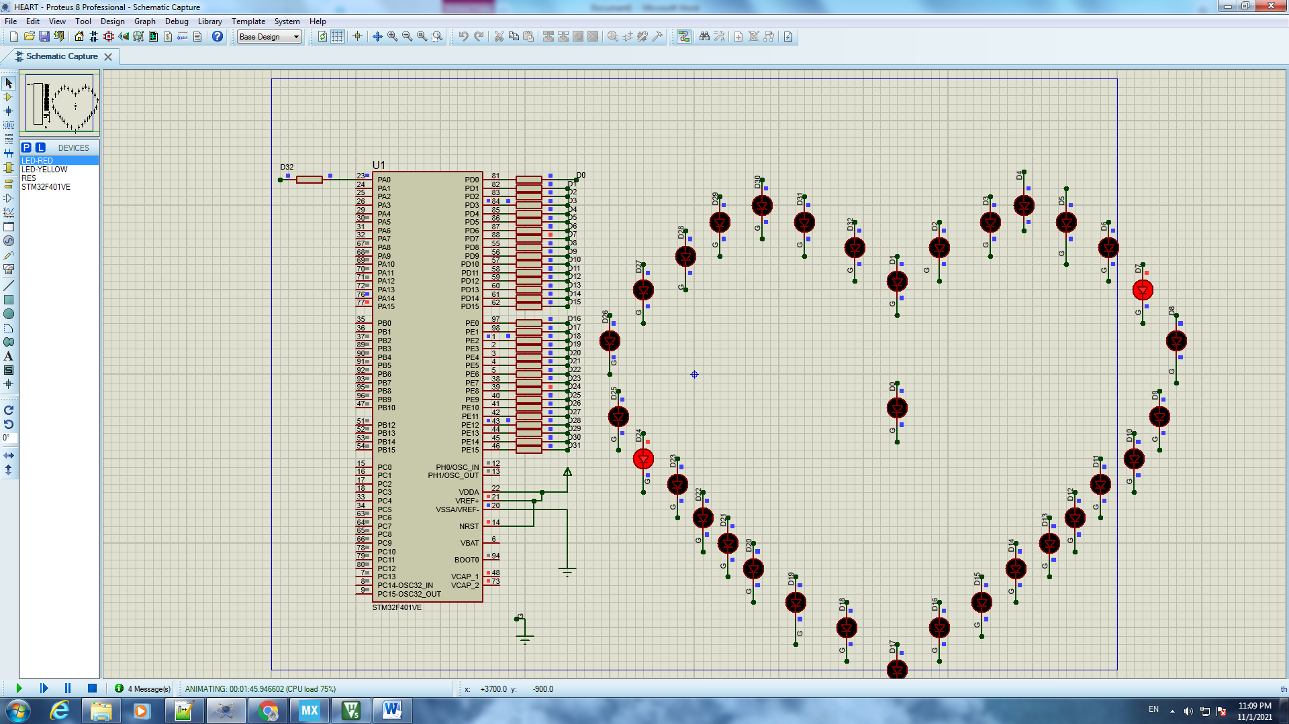

Kết quả

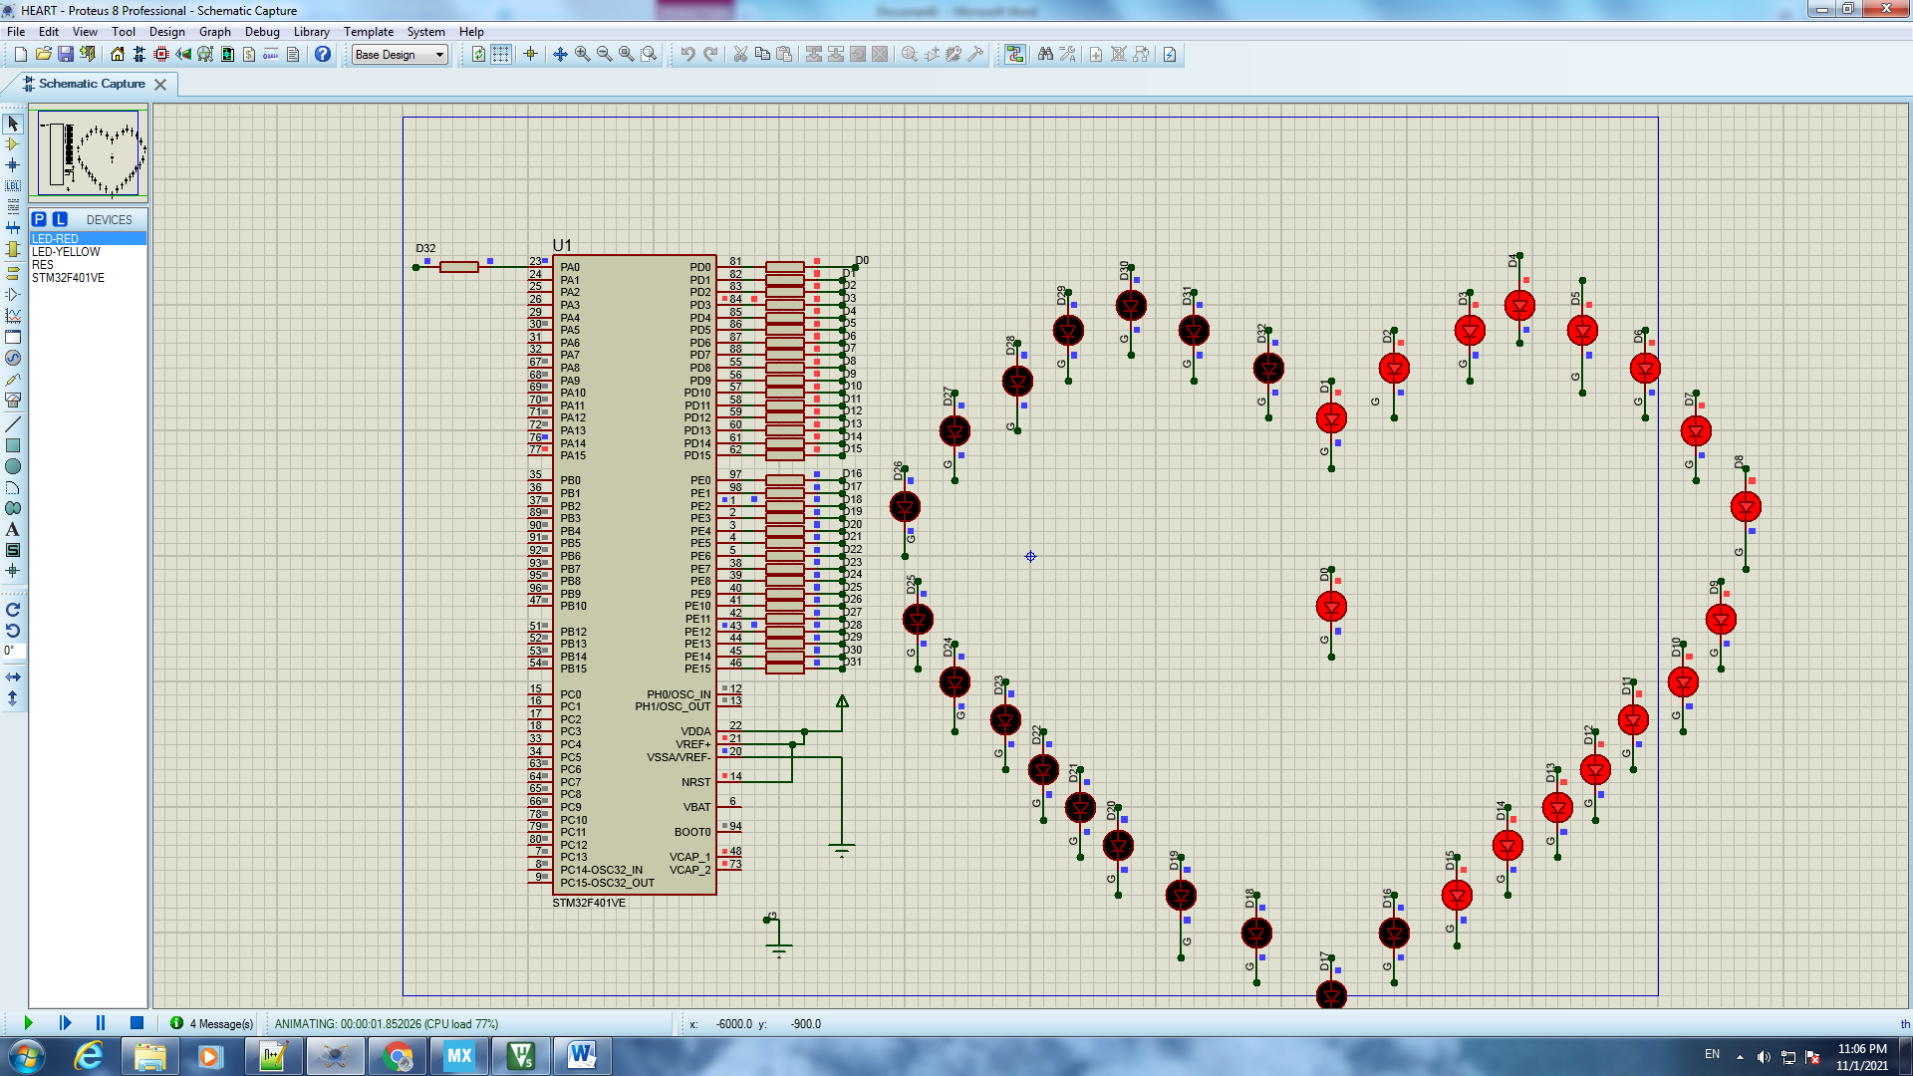

Kết quả

# IV. Link liên kết các kho lưu trữ

Kho tinkercad : https://www.tinkercad.com/users/kUFa3qBF6IZ-toan-phong?category=circuits&sort=likes&view_mode=default

Kho GitHub: https://github.com/phongctt60cntt/ProjectLapTrinhNhung/tree/master

# V. Mục Lục

Phần I. Lập trình với Arduino Uno 2

Bài 1: Blinking LED 2

❖ Mô tả 2

❖ Sơ đồ mạch 2

❖ Linh kiện 2

❖ Code chương trình 2

❖ Kết quả chạy chương trình 3

Bài 2: Turn on LED with button 3

❖ Mô tả 3

❖ Sơ đồ mạch 4

❖ Linh kiện 4

❖ Code chương trình 4

❖ Kết quả chạy chương trình 5

Bài 3. LED RGB 5

❖ Mô tả 5

❖ Sơ đồ mạch 5

6

❖ Linh kiện 6

❖ Code chương trình 6

❖ Kết quả chạy chương trình 7

Bài 4. LED 7-Segment 7

❖ Mô tả 7

❖ Sơ đồ mạch 7

❖ Linh kiện 8

❖ Code chương trình 8

❖ Kết quả chạy chương trình 11

Bài 5. Temperature Sensor 11

❖ Mô tả 11

❖ Sơ đồ mạch 11

❖ Linh kiện 12

❖ Code chương trình 12

❖ Kết quả chạy chương trình 13

Bài 6. 8 LED 14

❖ Mô tả 14

❖ Sơ đồ mạch 15

❖ Linh kiện 15

❖ Code chương trình 15

❖ Kết quả chạy chương trình 16

Bài 7. Keypad 16

❖ Mô tả 16

❖ Sơ đồ mạch 16

❖ Linh kiện 17

❖ Code chương trình 17

❖ Kết quả chạy chương trình 18

Bài 8. LED MATRIX 8x8 19

❖ Mô tả 19

❖ Sơ đồ mạch 19

❖ Linh kiện 20

❖ Code chương trình 20

❖ Kết quả chạy chương trình 30

Bài 9 : LED MATRIX 24x8 34

❖ Mô tả 34

❖ Linh kiện 34

❖ Sơ đồ mạch 35

❖ Code chương trình 35

❖ Kết quả chạy chương trình 83

Bài 10. 8 LED 85

❖ Mô tả 86

❖ Sơ đồ mạch 86

❖ Linh kiện 86

❖ Code chương trình 86

❖ Kết quả chạy chương trình 88

Phần II. Các bài làm thêm 88

Bài 1T. Turn the LED on and off with 2 buttons 88

❖ Mô tả 88

❖ Sơ đồ mạch và kết quả chạy chương trình 89

89

❖ Linh kiện 89

❖ Code chương trình 89

Bài 2T. Fire alarm system 90

❖ Mô tả 90

❖ Sơ đồ mạch 90

❖ Linh kiện 90

❖ Code chương trình 91

❖ Kết quả chạy chương trình 92

Bài 3T. Gas leak alarm system 92

❖ Mô tả 93

❖ Sơ đồ mạch 93

❖ Linh kiện 93

❖ Code chương trình 94

❖ Kết quả chạy chương trình 94

Bài 4T. LED 7 SEGMENT x2 ( CATHODE ) 96

❖ Mô tả 96

❖ Sơ đồ mạch 96

❖ Linh kiện 97

❖ Code chương trình 97

❖ Kết quả chạy chương trình 99

Phần III. Lập trình Nhúng nâng cao – giao tiếp GPIO 101

Bài 1. Sequential light up 4 LEDs 101

❖ Mô tả 101

❖ Linh kiện 101

❖ Sơ đồ mạch 101

❖ Code chương trình 102

❖ Kết quả chạy chương trình 104

Bài 2. LED HEART 104

❖ Mô tả 104

❖ Sơ đồ mạch 105

❖ Linh kiện 105

❖ Code chương trình 105

❖ Kết quả chạy chương trình 116

IV. Link liên kết các kho lưu trữ 117

V. Mục Lục 118